AVOCADOS & PAPAYAS

YIELD: From 0 avocados to 200+ !!!!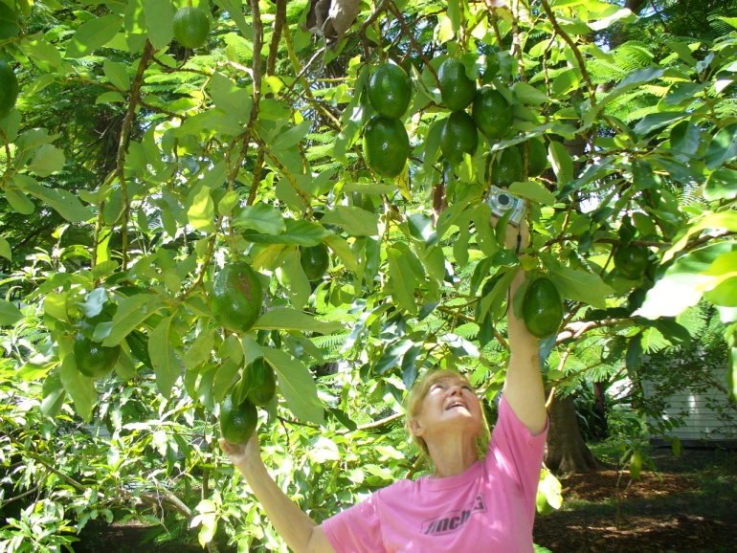In 1998, blight destroyed most avocado trees in Lee County. Ms. Bohannon’s (Past President, Tropical Fruit Council) tree was barren for 11 years. In 2009, she BioWashed her barren tree twice. Yield soared to 200+ avocados!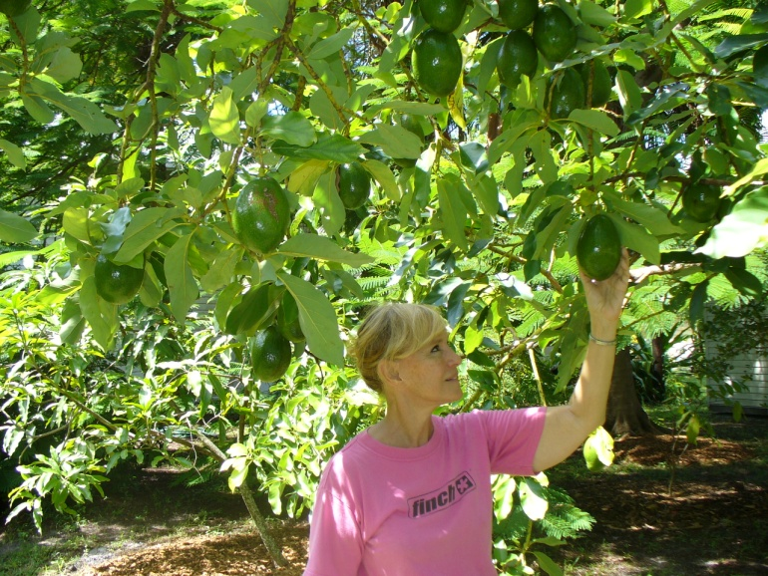
Antonio Gutierez BioWashed 25 acres of young papaya trees. He earned an estimated $1,000,000.00 in a single season!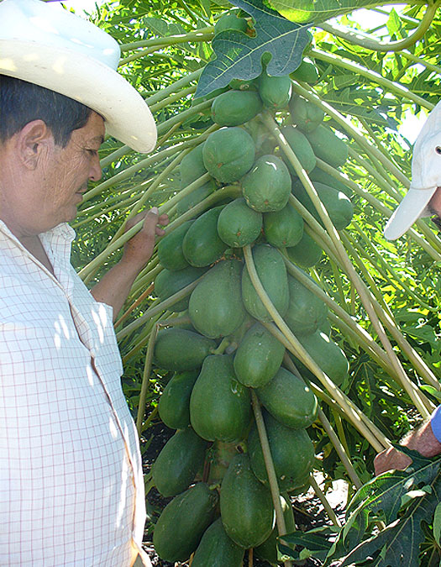 His BioWashed trees produced between 60 and 100 papayas. His season extended an extra 6 months!

QUICK CASH: Mike Wallace, Island Botanicals BioWashed a portion of his trees. His BioWashed trees were producing income within 7 months!
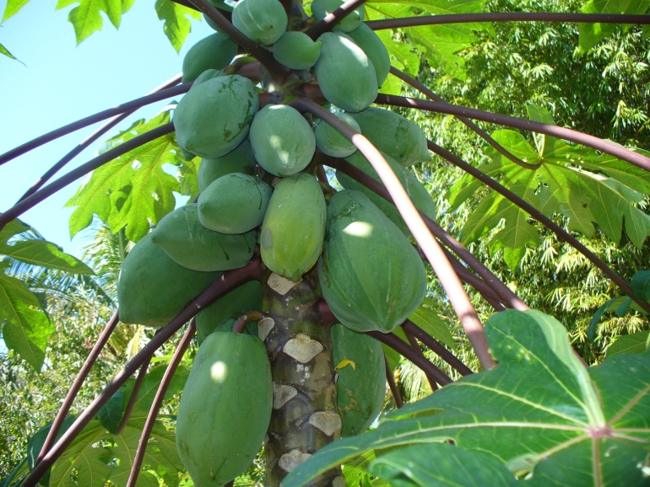Mike Wallace holding a BioWashed and a non-BioWashed tree. 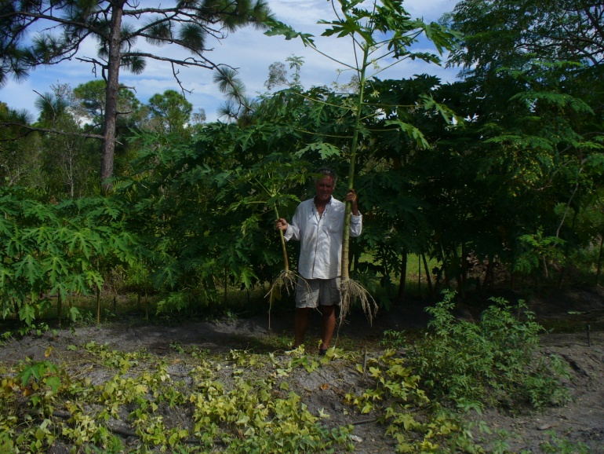The difference between increased cation exchange and no-increased cation exchange.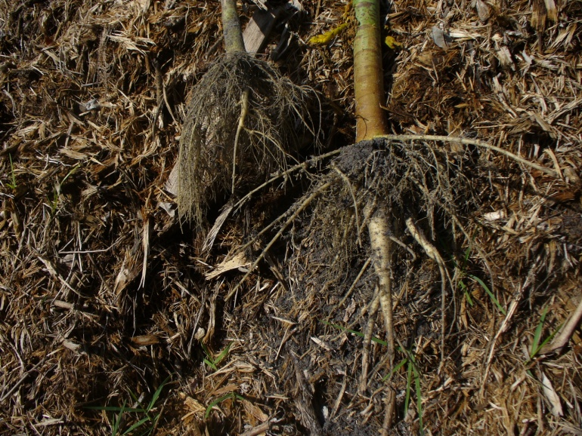
Smart growers are BioWashing!!!
To locate your local BioWash dealer, check
www.1stBioWash.com
or call
888-578-9600

