In 1998, blight devastated the avocado trees in Ft Myers.
Madeline Bohannon’s tree bore no fruit for 11 years.
In 2009, she drenched her tree with BioWash.
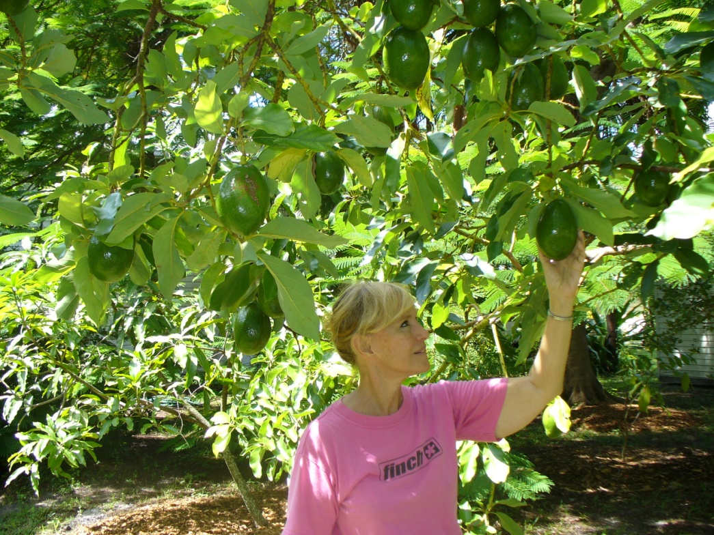

The tree came alive and yielded more than 200 large, delicious avocados!

