Attendees:  Jane Anderson  Bart Halling  Pat Pelstring  Kathy Sullivan  Sheri Wallace  Erin Wombacher  Absent:  Location: Jane’ house | Agenda:  - Approve July Minutes  - Approve Financials (see handout)  - CarpFest needs - Bart  - Milfoil Survey & Treatment  - Carp Bowfishing Proposal  - Oktoberfest update - Erin  - Blog posts from board for newsletter - will we do this?  - Engaging Skippers - Speaker notes by Sheri (emailed & see link)

Document Links
Last Board Meeting Minutes
Skipper Talking Points
Milfoil Survey
Carp Bowfishing Proposal - Draft

Meeting Notes

Financials were reviewed. Kathy had shared her concerns with the current bank we are utilizing. She investigated 3 other options; Bridgewater, Wings, Blaze, Aspire, and Minnesota Lakes. Based on what she found during her investigation, she is requesting that all financials be moved to Bridgewater. In addition she recommended that the account have 3 authorized users - Jane, Sheri, and Kathy. A motion was made to approve her recommendations for the move and authorized users. Motion was seconded, and approved.

Carp Fest - Permit was approved. Parking is in process. Porta Potties are being delivered Friday. Insurance is in place. All 3 bands are booked, and ready. Event is being promoted via social media and email. We have 2 large banners to promote the event. Jane will ask Claudia at The Langdon to see if we can put a sign up in front of her store; in lieu we will find someone to set up her rain barrels. The financial goal for us this year will be determined based on the cost for a Netting through Carp Solutions. We will have 3 forms of payment - Paypal, Venmo, and check

Milfoil Survey and Treatment - We had a survey completed. There are 3 areas that we are unable to treat due to lilypads. But there are a total of 6 sections of the bay that could benefit from Eurasian Watermilfoil treatment. A motion was made to approve funding to treat for the milfoil in all 6 sections. Motion was seconded, and carried.

Bowfishing Proposal - Jane presented the proposal that she intends to present to the LMCD requesting the After-Dark Carp Bowfishing be open for 8 weeks starting in April. We reviewed the proposal and advised of any recommended edits.

Oktoberfest - Erin gave an update on the status of Oktoberfest. Kaia plans to head up the games for the event. She has already spoken with Phil regarding the wine pull, and Phil has agreed to gather donations for the silent auction. Pat and Kaia are considering whether to donate their Montana home again. Erin has already started speaking with residents of Harrisons Bay to volunteer at the event, in addition she plans to reach out to MWHS to ask for DECA to volunteer. She will also utilize Anna’s talent to promote the event through social media and other marketing tactics. The plan for food is to use the same menu as the last 2 years. Erin also plans to try to sell tickets at Jubilee. Sheri agreed to assist with the technology piece, however would need time in advance to set it up and also to educate people on checking people out.

Blog Posts - at the previous meeting, Sheri asked Board Members to submit a blog post. Sheri received 1 blog post. It was decided to postpone discussion on the Blog Posts until next meeting.

Engaging Skippers - Board members were asked to connect with their Skippers regarding talking points, and engaging their neighbors.

Kathy - Christine & Lisa Dierbeck
Erin - Sarah & Phil
Jane - Johnston, Latour, and Kevitt
Pat - Kaia
Bart - Kari and Rileys
Sheri - Eric, Venus’ area

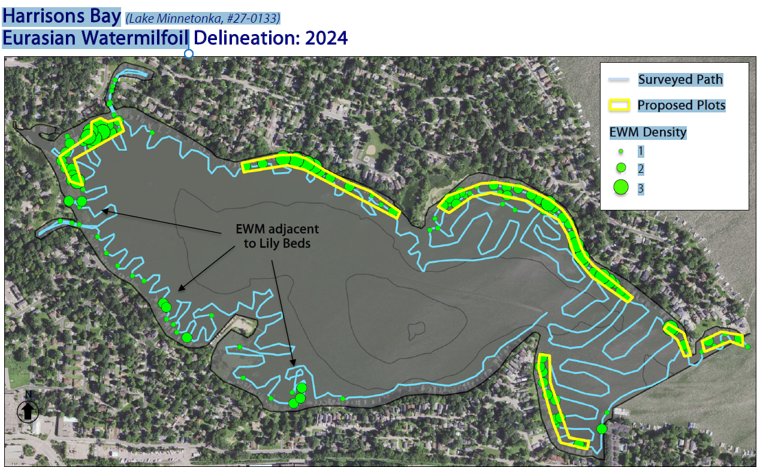
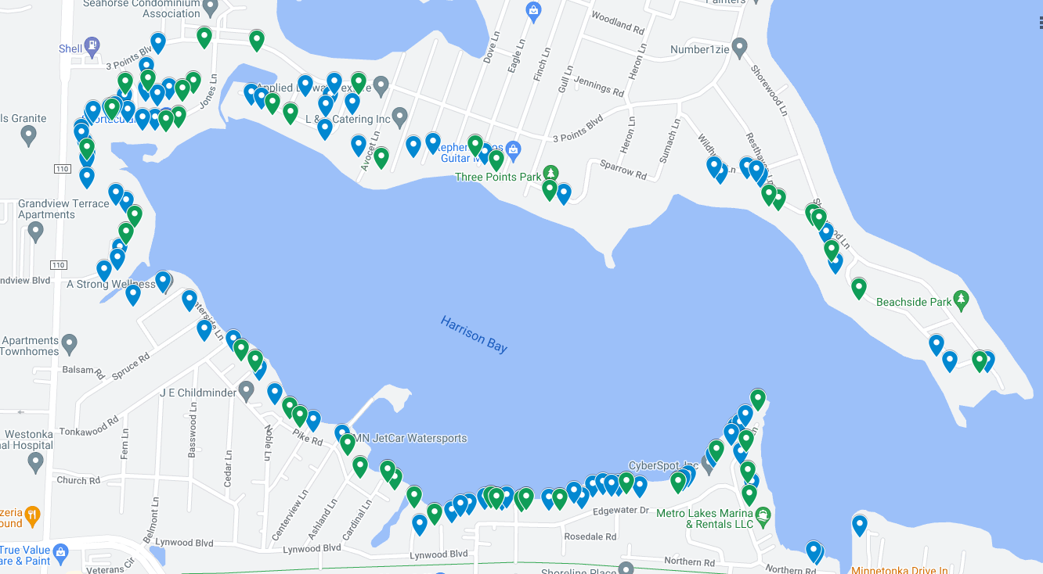

Donation Recap

August 4
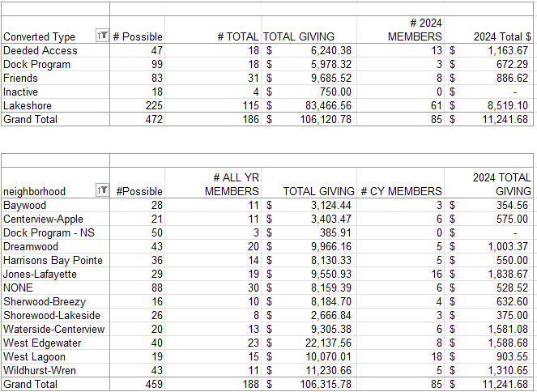

July 7
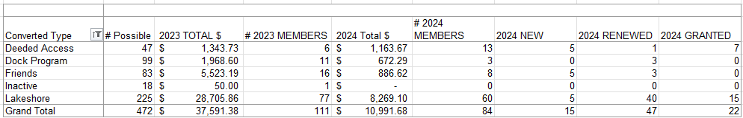

Goals for 2024
The goal is to have more fun and less stress regarding fundraising events. These included:
- A member had suggested having a corn-hole tournament (Or community Event)
- Community tie up in the bay (Or Community Event) - Monthly Happy Hr & Game night?
- Carpfest - moving it to June 15
- Educational event for the Rain Garden (May 18, 2024) on Apple Lane
- Advocacy for Cardinal Lane
- Rain Barrel education, sale, and distribution (144 rain barrels)
- July 4th Boat Parade
- Planned Happy Hours
- Bow Fishing event (June 15)
- LMCD Open Bow Fishing

Approved Budget for 2024 (12.11.2023)

Category | 2024 Budget Amount | 2023 Actual | Notes
Administration (Includes tech & insurance | 1,200 | 1,150
Communication  (Printed Education Materials) | 2,000 | 2,078 | May Newsletter was $785
Fundraising  (incl digital fees & event) | 2,500 | 1,763
Carp * dependent on long term strategy - gathering data | 10,000 | 1,835 | We raised 3597 in revenue, additional 8300 for PIT (3) antenna grants in P.C.
Soak it Up (H2OQ) | 3,000 | 2,126 | We raised 2,098 in revenue
AIS | 15,000 | 10,118
Community (includes welcome bags, events & volunteer appreciation | 2,500 | 332
Advocacy/Education Membership | 150 | 150 | MN Rivers & Lakes Membership
Total | 36,350 | 19,552

