Attendees:  Jane Anderson  Pat Pelstring  Bill Wallace  Sheri Wallace  Erin Wombacher  Bart Halling  Location: Bart’s house | Agenda:  - Ed Rockwell’s presentation to City Council  - Assignment of Board Members to talk with city council members  - Update on Petition  - Communication - How do we make sure everyone knows what we do and what’s at stake if we don’t  - Proposal Review and assignments  - Next Steps

Links
LID Proposal - May 3rd - Draft
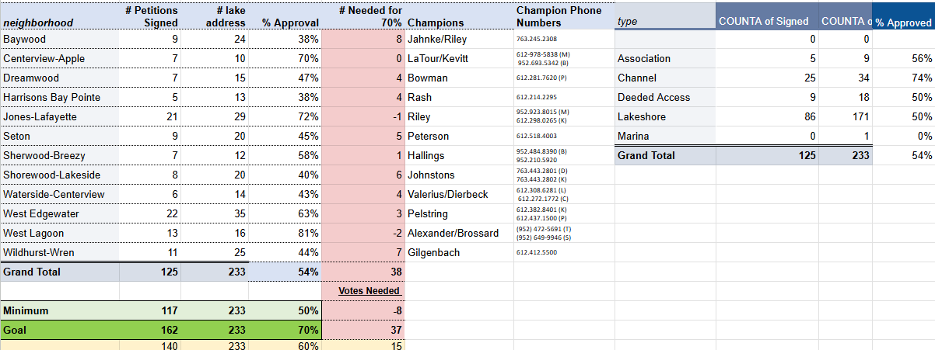
Currently have 33 people who have given in the past that have not indicated yes or no to petition.

- Ed Rockwell’s presentation to City Council
- Assignment of Board Members to talk with city council members
- Update on Petition
- Communication - How do we make sure everyone knows what we do and what’s at stake if we don’t
- Proposal Review and assignments
- Next Steps

Meeting started with reviewing agenda items.
- Discussion began with review of Ed Rockwell’s presentation at the City Council meeting in April. Perception of his presentation was discussed:
  - His “facts” were all web based, including Wikipedia
  - He mentioned he spoke with James Johnson, as though James was in agreement with him (furthest from the truth). James Johnson works for Fresh Water (survey). He stated what we are doing in treating the lake is appropriate for a recreational body of water. James further shared that the DNR debunked the false testimony that diquot is bad for the environment.
  - He stated the chemicals we were using could have the “butterfly effect” on our eco-system affecting fowl and fish, and ultimately the people using the bay (both residents and non-residents)
  - He stated that the DNR recommends cutting the weeds versus chemical treatment
  - He stated that James Johnson advised we have very little curly leaf and milfoil, If we get rid of all of our weeds, the fish will leave the bay.
Sherri proposed that during the June 10 meeting, we also invite the City Council members to a Work Session with experts who have assisted us in this journey including James Johnson, DNR, head of the LID committee’s for St. Alban’s Bay and Carmen’s Bay, etc.
It was also proposed that the Board Members also connect with City Council members to have open and educated discussions prior to the June 10 meeting. Board members were assigned to the various City Council Members.

- We are at 54% for signed petitions. We need an additional 15 signatures to get to 60%.
Discussion strategized on targeting residents to connect with, educate, and discuss the their signature.
Idea presented -
- Open House at Back Channel Brewing
- Email - personalized thanking them for their past support, could we count on them for this pivotal
moment for HBA?
- texting residents
- yard signs (motion was made, seconded, and carried)
- Continued door knocking

3) Next Steps -
Pursue the additional 33 residents we have not been able to connect with regarding the LID
Invite the City Council Members to a Work Session to have experts available to answer questions
Pursuing individual meetings between the HBA Board Members and members of the City Council
Continued door knocking to reach 60%
Open House on May 27 at Back Channel
By June 10 - have the proposal complete (current draft distributed at meeting)
Board to review the proposal and respond with Sherri by May 11, 2025
All petitions with signatures ready for presentation
Suggestion - ask all Skippers to be present at the Public Hearing to give testimonial on importance of the LID
Sherri to do a draft review of the proposal with Kathleen Metzger

