Attendees:  Jane Anderson  Phil Bowman  Sheri Wallace  Absent:  Bart Halling  Pat Pelstring  Bill Wallace  Erin Wombacher  Location: Sheri’s house  https://zoom.us/j/5094532775?pwd=SVBSYWZ3YkJXa1FCdTlxQkVtaGVuZz09&omn=99585213467  Meeting ID: 509 453 2775  Passcode: 836494 | Agenda:  - Approve Minutes  - Approve Financials (see donation recap on Page 2)  - HBA Board Term  - Membership Drive update - deferred  - connecting with Skippers  - Carp - deferred  - Bow Fishing Update - Bart  - Tracking migration?  - Mikes Green Fin Fertilizer Order  - Rain Barrel Sales update  - Annual Association Meeting - Set Date and discuss draft outline  - https://docs.google.com/document/d/1a6KxpU9O8BfHl3VpZk4gtc4KxkoHhEIG_HAi99GtrnY/edit?usp=sharing

Document Links
Last Board Meeting Minutes
Finance Report
Donation Report

Meeting Notes
- Nominations for new board members due by May 15th. Sheri will put the nomination form on website. After May 15th, voting will be sent to members. First meeting for new board members in June
- Rescheduling June board meeting for June 3rd

- We did not have a quorum for the meeting so we focused our efforts on the presentation for the annual meeting on April 29th and deferred the rest of the agenda.
- Next meeting, Tuesday April 16. Please work on your presentation slides for discussion.

Donation Recap

April 10 Membership

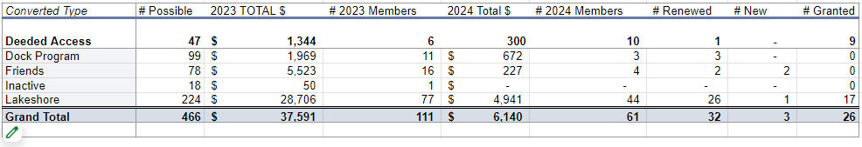

Goals for 2024
The goal is to have more fun and less stress regarding fundraising events. These included:
- A member had suggested having a corn-hole tournament (Or community Event)
- Community tie up in the bay (Or Community Event) - Monthly Happy Hr & Game night?
- Carpfest - moving it to June 15
- Educational event for the Rain Garden (May 18, 2024) on Apple Lane
- Advocacy for Cardinal Lane
- Rain Barrel education, sale, and distribution (144 rain barrels)
- July 4th Boat Parade
- Planned Happy Hours
- Bow Fishing event (June 15)
- LMCD Open Bow Fishing

Approved Budget for 2024 (12.11.2023)

Category | 2024 Budget Amount | 2023 Actual | Notes
Administration (Includes tech & insurance | 1,200 | 1,150
Communication  (Printed Education Materials) | 2,000 | 2,078 | May Newsletter was $785
Fundraising  (incl digital fees & event) | 2,500 | 1,763
Carp * dependent on long term strategy - gathering data | 10,000 | 1,835 | We raised 3597 in revenue, additional 8300 for PIT (3) antenna grants in P.C.
Soak it Up (H2OQ) | 3,000 | 2,126 | We raised 2,098 in revenue
AIS | 15,000 | 10,118
Community (includes welcome bags, events & volunteer appreciation | 2,500 | 332
Advocacy/Education Membership | 150 | 150 | MN Rivers & Lakes Membership
Total | 36,350 | 19,552

