``
Attendees:  Jane Anderson  Phil Bowman  Bart Halling  Kathy Sullivan  Sheri Wallace - on phone  Absent:  Erin Wombacher  Location: Phil’s house  https://zoom.us/j/5094532775?pwd=SVBSYWZ3YkJXa1FCdTlxQkVtaGVuZz09&omn=99585213467  Meeting ID: 509 453 2775  Passcode: 836494 | Agenda:  - Approve Minutes (March & April)  - Approve Financials (see donation recap on Page 2)  - Board Nominations  - Rain Garden Planting Event  - Carp  - Bow Fishing Update - Jane  - Carp Fest Planning - Bart & Kari  - Hometown Hero’s Tournament - Jane  - Rain Barrel Distribution  - Annual Association Meeting - Posted on Website

Document Links
Last Board Meeting Minutes
March Board Minutes
Finance Report
Donation Report

Meeting Notes
- March and April Meeting Minutes
- Sheri discussed the location of all the linked documents
- Approval to renew the Liability Insurance Policy
- Approved Financial Reports
- Bowfishing Ordinance Change
  - Jane met with Jim at LMCD
  - Need to simplify the proposal and conduct a workshop with LMCD board
  - Limit to a couple nights a week and shorter season
  - Limit to our three bays
  - Pilot study
  - Jane will try to make revisions in next couple weeks
- Hometown Heros
  - Will not conduct the tournament this year
- Carp Fest
  - Permit applications in the works
  - Sheriff and City have been notified
  - Middle School Parking - Bart will contact Westonka School District
  - 5/28 City Council Meeting review of permit
  - Bands - all 3 performers have been contacted. Music meeting next week to discuss set-up
  - Needs
    - Bobbers with QR tags
    - Sheri needs to print QR codes
    - Paypal + Venmo - how do we get regular updates
    - Work with Venmo to separate accounts - Sheri
    - Promotion
      - Blog/Facebook Posts - Bart & Kari
      - Banners - do we need a date sticker? - Sheri
        - True Value - put on their fence - Jane
        - Langdon? - Claudia
      - Videos to promote - Bart/Jane
      - Article for the Laker - Sheri to send Bart Emma’s email
      - Portapotties - Kari is researching
      - BYOB and neighbors will do pulled pork
    - Facebook Live Event
    - Decided to save rain barrel for Oktoberfest raffle
- Erin Update
  - Oktoberfest for September 30th at Back Channel
  - Reserved a spot for Spirit of Lakes

- Loren Davis - adding him as the Skipper for the Dock Program

- Phil’s last meeting - Special thanks for his help in creating the association
  - Phil will contact Ethan Berke about a possible board spot

- Reminder of Happy Hour tomorrow

- Next meeting - June 3rd. To see all the association events and meetings you can link to the google calendar
  - https://calendar.google.com/calendar/u/0/r?cid=aGFycmlzb25zYmF5YXNzb2NAZ21haWwuY29t

- Adjourned meeting - 8:43 pm

Donation Recap

May 13, 2024

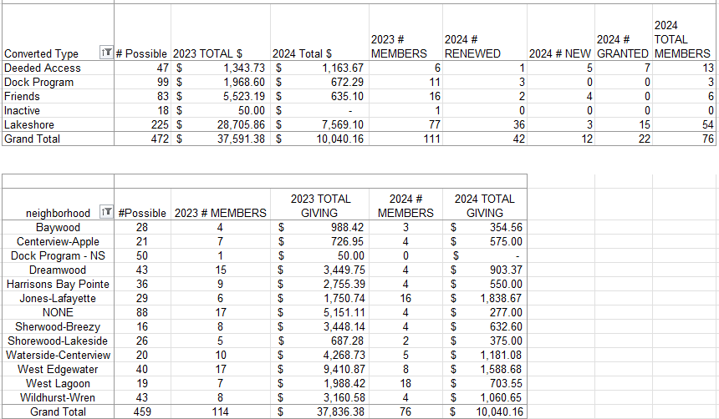

April 10 Membership

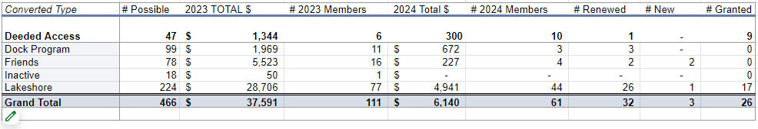

Goals for 2024
The goal is to have more fun and less stress regarding fundraising events. These included:
- A member had suggested having a corn-hole tournament (Or community Event)
- Community tie up in the bay (Or Community Event) - Monthly Happy Hr & Game night?
- Carpfest - moving it to June 15
- Educational event for the Rain Garden (May 18, 2024) on Apple Lane
- Advocacy for Cardinal Lane
- Rain Barrel education, sale, and distribution (144 rain barrels)
- July 4th Boat Parade
- Planned Happy Hours
- Bow Fishing event (June 15)
- LMCD Open Bow Fishing

Approved Budget for 2024 (12.11.2023)

Category | 2024 Budget Amount | 2023 Actual | Notes
Administration (Includes tech & insurance | 1,200 | 1,150
Communication  (Printed Education Materials) | 2,000 | 2,078 | May Newsletter was $785
Fundraising  (incl digital fees & event) | 2,500 | 1,763
Carp * dependent on long term strategy - gathering data | 10,000 | 1,835 | We raised 3597 in revenue, additional 8300 for PIT (3) antenna grants in P.C.
Soak it Up (H2OQ) | 3,000 | 2,126 | We raised 2,098 in revenue
AIS | 15,000 | 10,118
Community (includes welcome bags, events & volunteer appreciation | 2,500 | 332
Advocacy/Education Membership | 150 | 150 | MN Rivers & Lakes Membership
Total | 36,350 | 19,552

