Attendees:  Jane Anderson  Phil Bowman  Pat Pelstring  Bill Wallace  Sheri Wallace  Absent:  Bart Halling  Erin Wombacher  Location: Jane’s house  https://zoom.us/j/5094532775?pwd=SVBSYWZ3YkJXa1FCdTlxQkVtaGVuZz09&omn=99585213467  Meeting ID: 509 453 2775  Passcode: 836494 | Agenda:  - Welcome Pat Pelstring  - Approve Minutes from Feb 19th  - Approve Financials (see donation recap on Page 2)  - Membership Drive  - email from Bart  - membership list for Skippers  - Bow Fishing Update  - Poll results  - Annual Association Meeting - Set Date and discuss draft outline  - https://docs.google.com/document/d/1a6KxpU9O8BfHl3VpZk4gtc4KxkoHhEIG_HAi99GtrnY/edit?usp=sharing  - H2OQ Update  - Rain Barrels Sales  - May 18 Rain Garden Planting Workshop  - Mikes Green Fin Fertilizer Order

Document Links
Last Board Meeting Minutes
Finance Report

Meeting Notes
- Meeting started with a boat ride coordinated by Jane. Such a treat. We welcomed Pat Pelstring to the board and to become the new treasurer after the Annual Association Meeting. Bill will begin the transfer and we will take a member vote at the Annual meeting.
- The meeting minute from previous minutes were approved.
- Bill provided a financial recap and financials were approved
- Membership Drive - the following steps were approved for a membership drive over the next few weeks
  - Sheri will draft talking points for Skippers (elevator speech) letters along with neighborhood list went to all skippers on March 28
  - Jane will assign 2 skippers per board member
  - Each board member will call their skipper and discuss our membership drive, the letter that will be sent, list of neighborhood people and talking points -
  - Bart will provide draft of email to Sheri by March 15 and Sheri will automate the personalized email creation - personalized letters were sent from the association to all previous year members and non-members on March 20
  - After a couple weeks, board members will follow up with the skippers
- ANNUAL MEETING SCHEDULED FOR MONDAY, APRIL 29 from 7 pm - 8 pm
  - Preparation due at next board meeting on April 8
    - Each Board member needs to review our previous annual meeting presentation and make changes to their assigned section
    - Develop a poll question for your section
  - Assignments:
    - Intro - Sheri
    - Weed Treatment - Phil
    - Events for 2024 - Erin
    - Carp - Jane & Bart
    - H20Q - Sheri
    - Finance - Bill
    - Partnerships - Jane
- H2OQ Update - Sheri
  - Rain Barrels
    - Over 100 rain barrels have been sold
    - Distribution event on May 4th 9-12 at parking garage
    - Jake Savstrom will have a demo rain barrel install
  - Cardinal Lane
    - Sheri met with Jess Dickson to discuss rain barrels and rain gardens
    - Sent a recap of Cardinal Lane issues and asked for next steps
    - Jesse recommended presenting issues at Dock Commission meeting on March 21. We are on the agenda but need a board member to present. Pat Pelstring indicated that he will likely be at the meeting. He is reviewing that write up. Next option is Erin
  - Apple Lane
    - Will have a Rain Garden Planting educational workshop on Saturday, May 18. This will be a free workshop for first 25 to register.
- Mikes Fertilizer order - will be done ordered on March 15 for delivery before April 1.
- Meeting adjourned at 9 pm.

Donation Recap

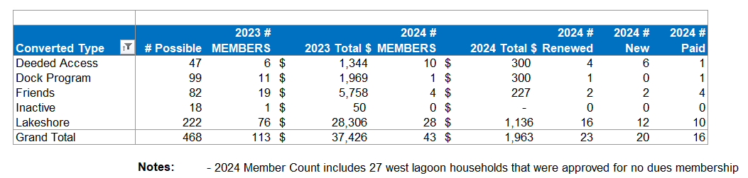

Goals for 2024
The goal is to have more fun and less stress regarding fundraising events. These included:
- A member had suggested having a corn-hole tournament (Or community Event)
- Community tie up in the bay (Or Community Event) - Monthly Happy Hr & Game night?
- Carpfest - moving it to June 15
- Educational event for the Rain Garden (May 18, 2024) on Apple Lane
- Advocacy for Cardinal Lane
- Rain Barrel education, sale, and distribution (144 rain barrels)
- July 4th Boat Parade
- Planned Happy Hours
- Bow Fishing event (June 15)
- LMCD Open Bow Fishing

Approved Budget for 2024 (12.11.2023)

Category | 2024 Budget Amount | 2023 Actual | Notes
Administration (Includes tech & insurance | 1,200 | 1,150
Communication  (Printed Education Materials) | 2,000 | 2,078 | May Newsletter was $785
Fundraising  (incl digital fees & event) | 2,500 | 1,763
Carp * dependent on long term strategy - gathering data | 10,000 | 1,835 | We raised 3597 in revenue, additional 8300 for PIT (3) antenna grants in P.C.
Soak it Up (H2OQ) | 3,000 | 2,126 | We raised 2,098 in revenue
AIS | 15,000 | 10,118
Community (includes welcome bags, events & volunteer appreciation | 2,500 | 332
Advocacy/Education Membership | 150 | 150 | MN Rivers & Lakes Membership
Total | 36,350 | 19,552

