Attendees:  Jane Anderson  Bart Halling  Pat Pelstring  Kathy Sullivan  Sheri Wallace  Erin Wombacher  Absent:  Location: Sheri’s house | Agenda:  - Approve June Minutes  - Approve Financials (see donation recap on Page 2)  - Blog posts from board for newsletter  - Engaging Skippers  - Discuss recognition of partners from last meeting  - CarpFest revised date - Bart  - Spirit of Lakes Parade  - Carp Bowfishing Proposal -set date and communicate to LMCD  - Oktoberfest update

Document Links
Last Board Meeting Minutes

Meeting Notes

Jane made a motion to approve the June 3 meeting notes; Bart seconded. Motion carried

A review of the financials was completed. Erin made a motion to approve the finances; Jane seconded. Motion carried.

Blog Posts - Sheri plans to write on the rain barrels and rain gardens. Erin will write about Oktoberfest. Bart will do Carp harvest and strategy. Kathy will write a blog regarding the financials, including membership comparison including the map.

Engaging Skippers - Jane proposed that we speak with our Skippers regarding engaging their neighbors for membership and event participation. The skipper list assigned is as follows:

Jane: Johnstons & Kevit/LaTour

Pat P: Kaia Pelstring

Sheri: Dierbeck/Valerious

Bart: Halling & Riley

Kathy - Jahnke

Erin: Gilginbach

An idea to help engage the Skippers was to invite them to a float. The goal is to have fun, thank you, get their feedback and also alert them to the declining participation in membership - can they help. Plan is to do Monday, July 15 at 6:30 pm. Jane will send a text to the Skippers.

Carpfest Update - an alternative date was proposed to reschedule Carpfest. A date proposed was August 10. Bart will confirm with the bands.

Spirit of the Lakes - July 20. We will use Erin’s truck, Bart will ask the Abiders if they can play, Sheri is going to get numbers to update the banners, Jane will post on the Facebook Post - “calling all Harrison Bay members”, Sheri will send an email out, Jane will be the Carp Queen, Erin will get candy.

Carp Bowfishing Proposal - Jane has written a one page proposal (at the request of the Executive Director of the LMCD) in order for the Executive Board of the LMCD to review and for us to ask permission for a Bowfishing event.

Oktoberfest - Oktoberfest is 9/30 this year. Erin will be reaching out people to volunteer to form committees including games & fun, food, Phil to do the wine pull, silent auction, and grills. Goal is to increase participation/attendance.

Milfoil concern - It was brought to our attention that residents on Harrison Bay has been spotting milfoil. Jane and Sheri did a informal survey of the area and confirmed they found 4-5 spots around the bay impacted by milfoil. Sheri has reached out to PLM, and this is something being spotted around the lake. Jane made a motion to approve PLM to treat the milfoil, motion was seconded. Motion carried.

Donation Recap

July 7
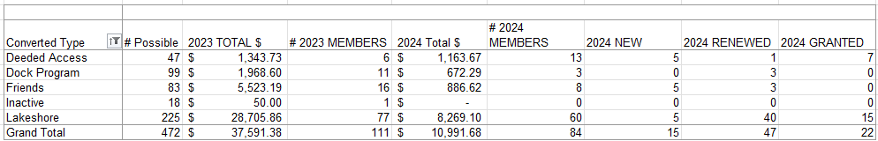

June 3

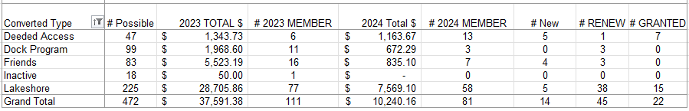

Goals for 2024
The goal is to have more fun and less stress regarding fundraising events. These included:
- A member had suggested having a corn-hole tournament (Or community Event)
- Community tie up in the bay (Or Community Event) - Monthly Happy Hr & Game night?
- Carpfest - moving it to June 15
- Educational event for the Rain Garden (May 18, 2024) on Apple Lane
- Advocacy for Cardinal Lane
- Rain Barrel education, sale, and distribution (144 rain barrels)
- July 4th Boat Parade
- Planned Happy Hours
- Bow Fishing event (June 15)
- LMCD Open Bow Fishing

Approved Budget for 2024 (12.11.2023)

Category | 2024 Budget Amount | 2023 Actual | Notes
Administration (Includes tech & insurance | 1,200 | 1,150
Communication  (Printed Education Materials) | 2,000 | 2,078 | May Newsletter was $785
Fundraising  (incl digital fees & event) | 2,500 | 1,763
Carp * dependent on long term strategy - gathering data | 10,000 | 1,835 | We raised 3597 in revenue, additional 8300 for PIT (3) antenna grants in P.C.
Soak it Up (H2OQ) | 3,000 | 2,126 | We raised 2,098 in revenue
AIS | 15,000 | 10,118
Community (includes welcome bags, events & volunteer appreciation | 2,500 | 332
Advocacy/Education Membership | 150 | 150 | MN Rivers & Lakes Membership
Total | 36,350 | 19,552

