Attendees:  Jane Anderson  Bart Halling  Pat Pelstring  Bill Wallace  Sheri Wallace  Erin Wombacher  Location: Jane’s house | Agenda:  - Approve May 5 Minutes  - Financial Review  - Approve Agenda  - Proposal Approval  - City of Mound Presentation  - Review Draft  - Assign responsibilities  - Schedule run through

Links
Minutes for 5/2/2025 Meeting

Petition Signature Status as of 5/27/2025
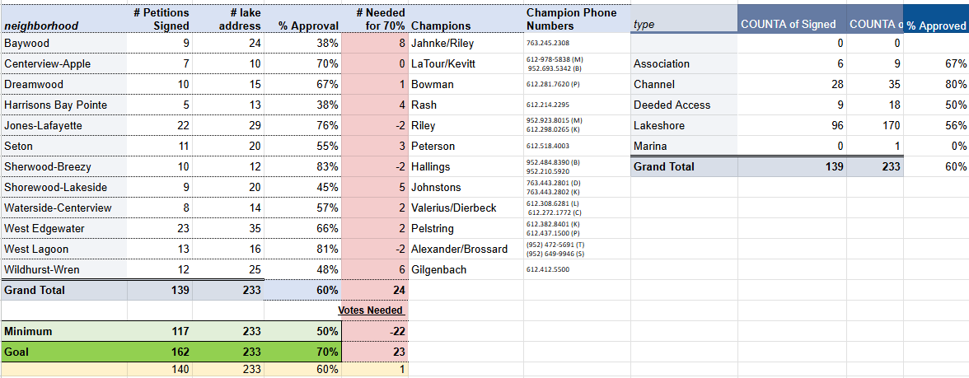

Notes

- May Minutes review and approval – first/second and all in favor (unanimous approval)
- No finance update other than a couple transactions (payment for Spring 2025 treatment and several donations). Details can be shared as needed.
- Agenda approved for 20250602 board meeting – no changes.
- City of Mound Presentation…focus areas as follows
  - Arm the council with facts and SME background/analysis
  - Package for the 6/10 meeting is due tomorrow 6/3 – Sheri completing for submission, needs any final changes to the proposal ASAP
  - Biggest concerns potentially from the council
    - Enough support in the community?
    - What kind of work effort and resources are required from the city?
    - What kind of controls are structured around the assessment and spending?
- Feedback on proposal –
  - Wherever it states “our” treatments or “our” surveys – I would see if we can reword to state “the survey the HBA contracted with ________ to complete” or the “treatment that the HBA contracted with _______ to complete within approved and licensed guidelines. Sounds too much like we did the treatments. Need to be clear that we worked with the experts to not only 1) determine where and what to treat but also 2) how to treat and with which DNR approved chemicals/products.
  - Consolidated property value was stated as “$1,056,111” – but that should be the “average” property value. Maybe include what the % is of the annual proposed lid assessment? = 150/1,056,111 = 0.014%
  - Max conversation – residents are in charge of the annual max through the vote each year on budget and projects, but still may be helpful to have a max assessment that needs community approval to change
  - New language for proposal – “The annual LID assessment shall not exceed maximums, by category as follows :

    - Lakeshore = $300
    - Channel/Deeded Access = $200
    - Non-lake abutting Association = $100
    - Marina = $1000
Any change to these maximum assessment limits must be proposed and approved by a minimum of 51% of all properties included in the LID – and communicated to the LGU (City of Mound).
  - We should include a breakdown table of all of the current petition results – not just the 60% approved result. Show other metric categories like “no response” and “not able to contact”.
  - Neutrals = 8
  - No Response = 21%
  - No Contacts = ?
  - Active no = 13%
  - Active review of the boundary list and the map…looks good from board perspective. Should be part of the LID board responsibility annually in the by laws.
  - Call out active support of healthy fishery practices – that our engaged experts and contractors will operate within guidelines to support the fishery.
- City Council meetings
  - Working to close the loop with all of the city council members and insure they are informed of intention for the LID – fielding any questions.
  - Confirmation of key meetings that have happened already – updates provided to the group.
  - Concerns about how much time the city council will need to invest in managing the LID – very minimal resources and time – 8 hours up front set up and limited to no ongoing (2 hours annually)
  - Some council members would like to remain neutral – but don’t have major concerns
  - Recommended follow up after the 6/10 meeting with council members – thank them for consideration and ask if there are any question or follow up discussions.
  - Pat/Bart to offer conversation with Metro Lakes as a follow up.
- Motion to approve proposal – with changes – all in favor no objections.
- Presentation
  - Approach – general tone = gratitude for partnership
  - Add “impaired bay list” from MPCA on the first slide – goal to remove Harrisons Bay from the impaired list!
  - Why a LID – add a main WHY reason that gets to “preserve and enhance the long term community and property values around the bay”
  - Add pictures and visuals to some of the slides – Jane to take first attempt
  - Promote healthy fish and native aquatic wildlife populations
  - Add “established key partnerships”
    - City of Mound
    - MN DNR
    - MCPA
    - LMCD
    - Minnehaha Creek Watershed District
    - MASRC
    - Carp Solutions
    - Two Mikes
    - Carmens Bay LID
    - St Albans Bay LID
  - Property Breakdown
    - Call out the value of the city – parks, dock program, launches, common docks, beach
  - Additional Questions to address
    - How many LIDs are there statewide?
    - How long have LIDs been around?
    - Who manages the LID program and statues statewide?
  - Encouraging the City Council to have a work session with SMEs on each of the topics that may be of concern
  - What about the community concerns? Top list and how the LID proposal mitigates:
    - Un-controlled spending and increases in LID tax assessments
    - Use of unapproved treatment techniques and approaches
  - Presentation time – 15 minutes on the agenda
  - Next Monday night 6/9 is the Stubbs Bay presentation for the LID establishment.
  - Need coaching for Joan from a LID sharing perspective
    - Have not had to increase the annual assessment
    - Have had years that there was no assessment
    - Overwhelming support from the LID community
    - Initial reasons for the LID
    - Same chemicals that our contractors are using – PLM/Patrick
  - Next Steps –
    - Jane updates to slides
    - Notes to board
    - Sheri

