``
Attendees:  Jane Anderson  Bart Halling  Pat Pelstring  Kathy Sullivan  Sheri Wallace  Erin Wombacher  Absent:  Location: Bart’s house | Agenda:  - Approve May Minutes  - Approve Financials (see donation recap on Page 2)  - New Board Elected  - Ongoing HBA Responsibilities  - Deliver yard signs for contributors over $275  - Event signs???  - Monthly financial Reports and PO Box  - CarpFEST(See last meeting action items below)  - Review other events scheduled  - Spring communication

Document Links
Last Board Meeting Minutes
Finance Report
Donation Report

Previous Meeting To Do Notes
- Carp Fest
  - City Permit & Sheriff Permit
  - Middle School Parking - Bart will contact Westonka School District
  - Band Meeting
  - Needs
    - Bobbers with QR tags
    - Sheri needs to print QR codes
    - Paypal + Venmo - how do we get regular updates
    - Work with Venmo to separate accounts - Sheri
    - Promotion
      - Blog/Facebook Posts - Bart & Kari
      - Banners - True Value - put on their fence - Jane, Langdon? - Claudia
      - Videos to promote - Bart/Jane
      - Article for the Laker - Sheri to send Bart Emma’s email
      - Portapotties - Kari is researching
      - BYOB and neighbors will do pulled pork
    - Facebook Live Event?

- Dock Program Skipper - Loren Davis - Sheri will invite to Happy Hour

Meeting Notes

Meeting started with introduction of the new Board Members for HBA, including Kathy Sullivan (Treasurer) and Pat Pelstring.

A motion was made to approve the May meeting minutes. Motion was seconded, and approved by all.
A review of the Financials was completed, with a suggestion to add year-of-year comparisons.
A motion was made to approve the May meeting notes. Motion was seconded, and approved by all.
The bios and photos for the new HBA Board is now online. We still have openings for 2 Skippers. Currently trying to recruit.
Ongoing HBA Responsibilities -
Jane delivers yard signs
Kathy is the Treasurer
Erin is the Secretary
Pat is responsible for picking up the event placards for distribution (from his home)

Sheri presented a postcard that was recycled from past distribution, with a label listing all of our events. Sheri will be ordering 1000 postcards for distribution at CarpFest and at Spirit of the Lakes.
Bart suggested that we recognize our partners (Minute Man, True Value, etc.) for all of their support. The Board agreed, and will add this to next month’s meeting.
CarpFest -
Bart distributed 2 documents detailing the event; 1 recapping the CarpFest Music Meeting on 5/20, 1 to Sarah Smith requesting a permit.
Bart shared that he had a great meeting with Julie and Karl, and connected with the other 2 bands.
Concert starts at 2 and will go until 6.
Karl will be providing the power.

Bart will take care of signage placement, including in front of the Langdon.

Bart will be at the City Council Meeting on 6/11 to answer any questions regarding the permit request.

Sheri will be ordering placards for sign placements.

Bart’s family will assist with setting up a FB live event on the HBA Facebook page.

#CarpFest24 will be the hashtag

Fourth of July -
Historically, Sheri managed the sign up and assigned numbers. Phil had volunteered last year to take photos for 2024. Sheri will connect with Phil. Photos will be uploaded to Harrisons Bay immediately. Boats with the most likes will win.

Spirit of the Lakes -
Ideally, the winners (will go in order of number of likes) of the Fourth of July boat parade will be given the opportunity to be in the parade. If any of the winners decline, Sheri has volunteered her boat. Details will be discussed at the July Board meeting.

Oktoberfest - Erin presented her strategy for this year’s Oktoberfest. Volunteers will start getting recruited after Spirit of the Lakes.

Spring Communication - Sheri presented that we do Blog posts of what we presented at our annual meeting. The Spring Newsletter will be emailed out. Readers will be given a link to “click here to learn more” on what we presented.
Each Board Member was asked to write a Blog post on what we presented at the Annual Meeting in 2024. Sheri would like the post by June 19.

Kathy presented feedback that she received at the last happy hour. One item was boating while Loon’s have babies. Jane shared that is a LMCD issue.

Jane also brought up Bow Fishing on Harrison’s Bay. We were not approved this year LMCD, but was educated on what the LMCD would like to see in next year’s application.

Donation Recap

June 3

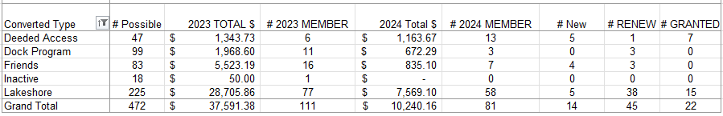

May 13, 2024

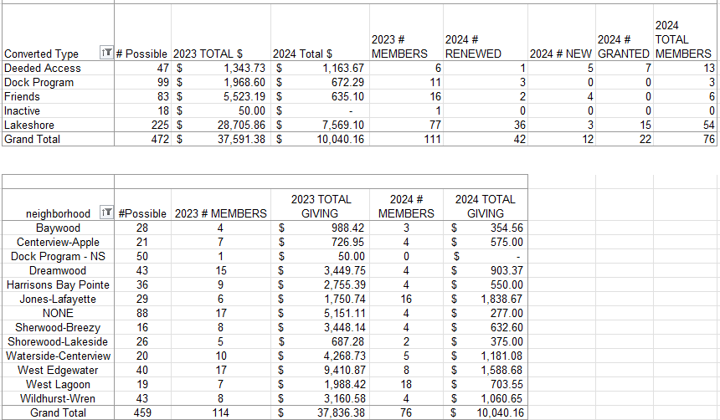

Goals for 2024
The goal is to have more fun and less stress regarding fundraising events. These included:
- A member had suggested having a corn-hole tournament (Or community Event)
- Community tie up in the bay (Or Community Event) - Monthly Happy Hr & Game night?
- Carpfest - moving it to June 15
- Educational event for the Rain Garden (May 18, 2024) on Apple Lane
- Advocacy for Cardinal Lane
- Rain Barrel education, sale, and distribution (144 rain barrels)
- July 4th Boat Parade
- Planned Happy Hours
- Bow Fishing event (June 15)
- LMCD Open Bow Fishing

Approved Budget for 2024 (12.11.2023)

Category | 2024 Budget Amount | 2023 Actual | Notes
Administration (Includes tech & insurance | 1,200 | 1,150
Communication  (Printed Education Materials) | 2,000 | 2,078 | May Newsletter was $785
Fundraising  (incl digital fees & event) | 2,500 | 1,763
Carp * dependent on long term strategy - gathering data | 10,000 | 1,835 | We raised 3597 in revenue, additional 8300 for PIT (3) antenna grants in P.C.
Soak it Up (H2OQ) | 3,000 | 2,126 | We raised 2,098 in revenue
AIS | 15,000 | 10,118
Community (includes welcome bags, events & volunteer appreciation | 2,500 | 332
Advocacy/Education Membership | 150 | 150 | MN Rivers & Lakes Membership
Total | 36,350 | 19,552

