Attendees:  Jane Anderson  Pat Pelstring - via phone  Kathy Sullivan  Sheri Wallace  Erin Wombacher  Absent: Bart Halling  Location: Erin’s house | Agenda:  - Approve August Minutes - please review prior to meeting  - Approve Financials (Financials will be available at the meeting)  - Blog posts from board for newsletter - will we do this?  - Carpfest Debrief  - Fundraising Event - Erin  - October LID discussion  - Milfoil Survey & Treatment  Zoom Link  https://zoom.us/j/5094532775?pwd=SVBSYWZ3YkJXa1FCdTlxQkVtaGVuZz09&omn=93119799025  Meeting ID: 509 453 2775  Passcode: 836494

Document Links
Last Board Meeting Minutes
Skipper Talking Points
Milfoil Survey
Carp Bowfishing Proposal - Draft
Newsletter Blog Posts

Meeting Notes

Finances -

We are moving our account from Cortrust to Bridgewater Bank. Currently have $54,000 with a couple of pending expenses for treatments. Kathy proposed that we speak with a broker to see if there are any short term money market accounts to get a 5% interest. This was agreed to as long as moving money will be simple.

Finances were reviewed. A motion was made to approve the finances, with a motion to second. All approved.

Blog Posts -

Articles have been written, and the plan is to go ahead and publish them. The plan is to break the articles in sections and distribute it.

It was also decided to publish the article on wake boats that Bart had sent out earlier this summer, as a “knowledge is power”. Sheri is going to draft the article and forward to the Board Members to approve.

Carp Fest Debrief -

- Great event again – but hoped to have better attendance on land and greater success with fundraising.
- What worked…
  - Having 3 bands was great – all 3 of them really enjoyed playing and said they would love to participate again if we continue with the event.
  - Benny James was an awesome edition – had a log of great feedback on him form those in attendance, maybe a good one to use for smaller HBA events throughout the season.
  - Food on land worked well – Lea’s provided amazing smoked pork nachos with all the fixins – 4 full pork butts gone by end of the night.
  - Beverages worked well – some BYOB’d, rest provided by Hallings and Leas onsite (waters, sodas, beer, wine)
  - Sound was good – feedback that it carried well out into the bay for boaters, etc.
  - Great having HBA representation out on the water with bobbers and making the rounds (but exhausting for Sheri/Jane – more fun and less work next year)
  - Porta potties – good to have, but with the size of crowd we had on shore – probably not necessary? $400 expense (Bart to submit receipt)
  - Signage was great – nice to have overflow parking at Grandview, but only a few used
  - Printed materials and framed placards on site were awesome – lots of people interested in knowing more about the carp initiative
  - Great having lots of help with gear transport up the hill after the event
  - Sharing a bit about the carp initiative in between bands
  - Carp Queen appearance was off the charts!
- What didn’t work so well…
  - Fundraising – so tough, not great participation, not seeing the kind of passion we did last year. Think people have a hard time linking CARP to water quality – the weed control efforts had an immediate, visible impact and made the bay more usable for boaters – think people are just not as concerned about the carp impact – or can’t envision the benefit from reducing the numbers. Need a vision. Also concerns that we are one bay – if we spend a bunch of HBA assets and $$$ on carp removal, they could just migrate in from other bays. Think we need a whole lake initiative (much bigger funding task than what we can independently take on inside HBA). Good rationale support for the broader initiative with LMCD.
  - Rescheduled date was tough – think we lost a little momentum on our promotion efforts – but that did get us a chance to promote at parade.
- Overall impressions – love it as an annual event. Glad to host (as are the Leas) – but may want to think through a venue change that is more approachable for a bigger group? Maybe Centerview beach with an actual stage and 270 degree viewing from the lake. People at the beach, in the water, anchored up in boats. Bring a couple food trucks in and a Backchannel brewing beer tent? Would be a cool partnering opportunity with the City of Mound. Good opportunity to draw in the dock rental program community (many on centerview docks). Something to think about. From a fundraising perspective – might be better to focus on grant $$$ or other area funding sources to get some more bang and drive more substantial resources into the carp initiative? Lot of work to barely cover costs on the event. Maybe it turns into a celebration of other fundraising efforts and bowfishing success? Could still take a goodwill donation to help cover costs.

Fundraising Event - Oktoberfest/Erin

Due to concerns over attendance, and risk for responsibility for Back Channel expenses, a decision was made not to host Oktoberfest.

Instead, a Harrisons Bay Block Party will be hosted at Wombacher’s on May 18. The idea is to have a Bag Competition, selling a hotdog meal for $10 (fundraising), and fostering community event. More details will be planned.

October LID Discussion -

LID - Lake Improvement District - is a taxed $200 a year (or whatever we determine) to take care of the Bay and its water quality. The meeting is scheduled October 21 with Kathleen from the DNR, and a representative from Carmens Bay to answer questions regarding a LID, how to execute it, and paperwork involved. Sheri has already started a document with questions. Board Members, Skippers, and the Mayor have been invited to attend.

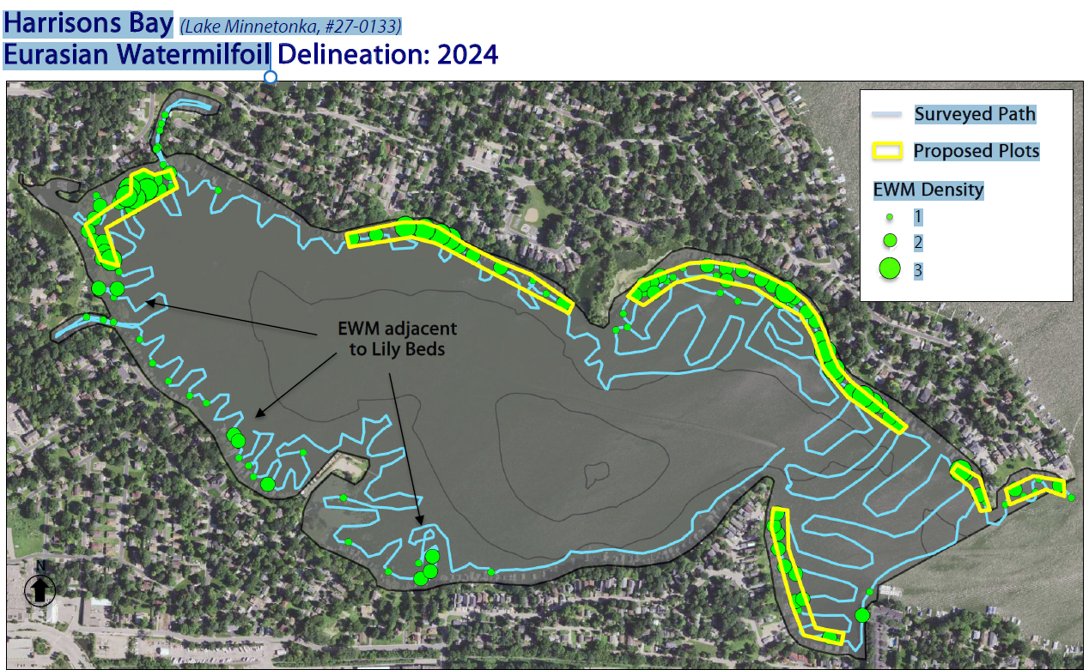

Donation Recap
After HBA email on September 5th we received 5 additional memberships and raised $938
September 5
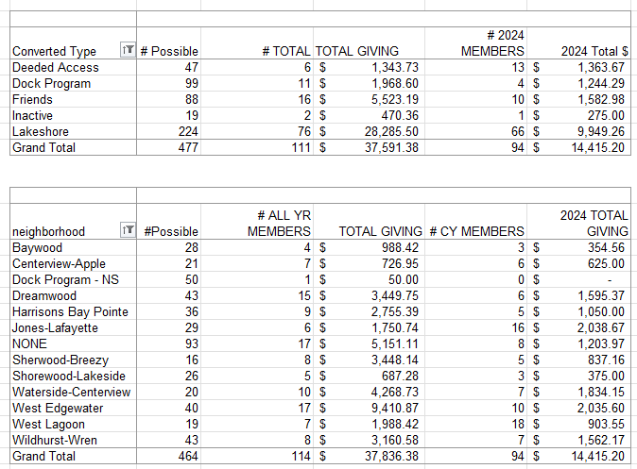
August 4
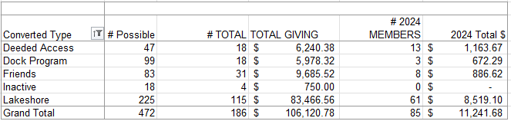

Goals for 2024
The goal is to have more fun and less stress regarding fundraising events. These included:
- A member had suggested having a corn-hole tournament (Or community Event)
- Community tie up in the bay (Or Community Event) - Monthly Happy Hr & Game night?
- Carpfest - moving it to June 15
- Educational event for the Rain Garden (May 18, 2024) on Apple Lane
- Advocacy for Cardinal Lane
- Rain Barrel education, sale, and distribution (144 rain barrels)
- July 4th Boat Parade
- Planned Happy Hours
- Bow Fishing event (June 15)
- LMCD Open Bow Fishing

Approved Budget for 2024 (12.11.2023)

Category | 2024 Budget Amount | 2023 Actual | Notes
Administration (Includes tech & insurance | 1,200 | 1,150
Communication  (Printed Education Materials) | 2,000 | 2,078 | May Newsletter was $785
Fundraising  (incl digital fees & event) | 2,500 | 1,763
Carp * dependent on long term strategy - gathering data | 10,000 | 1,835 | We raised 3597 in revenue, additional 8300 for PIT (3) antenna grants in P.C.
Soak it Up (H2OQ) | 3,000 | 2,126 | We raised 2,098 in revenue
AIS | 15,000 | 10,118
Community (includes welcome bags, events & volunteer appreciation | 2,500 | 332
Advocacy/Education Membership | 150 | 150 | MN Rivers & Lakes Membership
Total | 36,350 | 19,552

