RICK ROSER
Aboriginal Events Management
ABN 92283142828
Indigenous Art I Art Supplies I Workshops I Murals I Installations
rickroser@bigpond.com
PH 0422275601
PRICE LIST
Resources Pack and Replacement Elements for top-up

This pricing list is only available to my valuable clients who have previously purchased the Resources Pack.

*Postage will be quoted based on location and order size.
**Discount available for multiple products in the one order.

Item |  | Size | Price (excl GST)
1. Resources Pack – Complete | 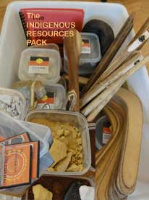 | Rolling container | $990
2. Resources Booklet – including The Brave Ant colouring-in book | 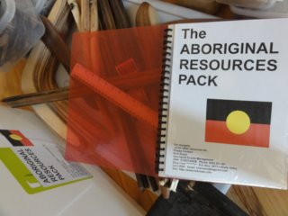 | 1 booklet | $19
3. Emu Feathers + beeswax | 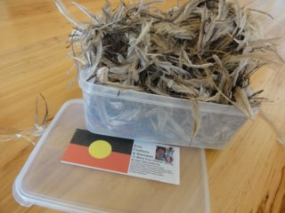 | 5 litre container +  2 x beeswax | $90
4. Returning boomerangs | 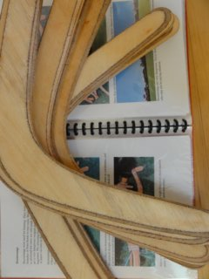 | 10 | $60
5. Stone Tools for hafted stone axe + beeswax | 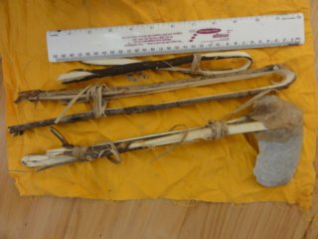 | For 3 axes +  1 x beeswax | $60
6. Stone flakes, scrapers and core stone | 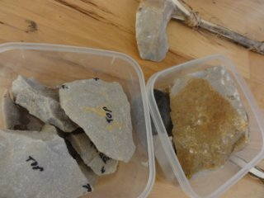 | 2 x small containers | $40
7. Hammer and grindstones | 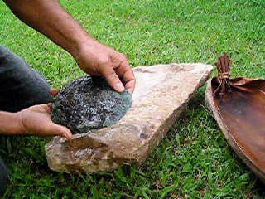 | 2 x 1 litre containers | $40
8. Bark for string making | 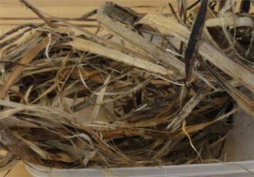 | 1 x 5 litre container | $90
9. String making DVD | 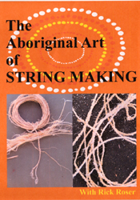 | 1 | $40
10. White ochre | 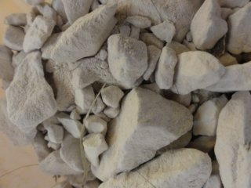 | 1kg | $90
11. Yellow ochre | 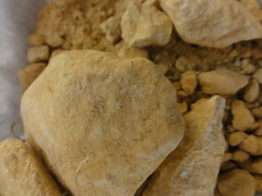 | 1kg | $90
12. Red ochre | 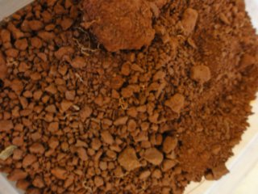 | 1kg | $90
13. Ochre pack | 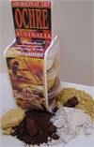 | Approx. 150g | $38.50
14. Aboriginal Art of Ochre painting DVD | 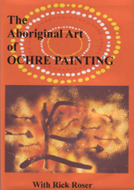 | 1 | $40
15. Fire sticks - Traditional  NB: Firemaker not included! | 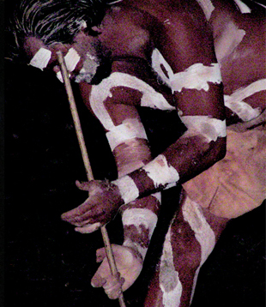 | 1 set | $60
16. Fire sticks – Practice | 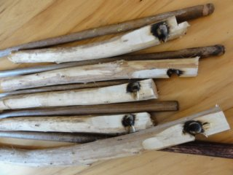 | 5 sets | $60
17. The Aboriginal Art of Fire making DVD | 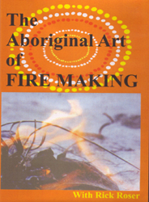 | 1 | $40
18. CD Rom Aboriginal Art and Culture Resources Kit | 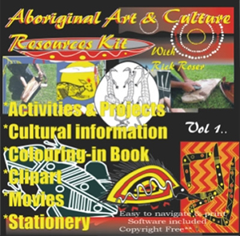 | 1 | $140
19. Clap sticks | 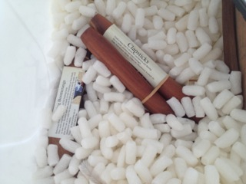 | 1 pair | $40
20. Palm leaf Piccabean Basket | 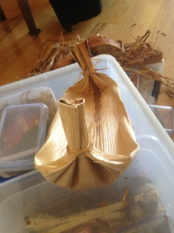 | Small – approx. 20cm | $25
21. Palm leaves for making piccabean basket | 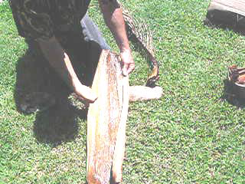 | 3 sheets | $30
22. Digging stick | 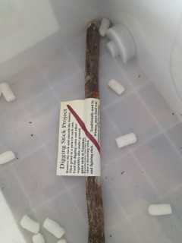 | 1 | $10
23. Message stick | 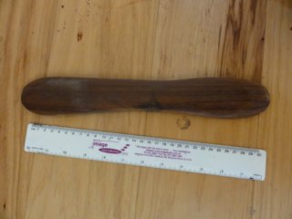 | 1 | $20

