Schedule
Horizon Daycare/Preschool is open Monday-Friday from 6:00am to 5:00pm. The latest drop off time is 9am. We will be closed for the following holidays: Good Friday, Memorial Day, 4th of July, Labor Day, Thanksgiving, the day after Thanksgiving, Christmas Eve, and Christmas Day, New Year’s Eve, and New Year’s Day. Leading up to the holiday we may be closed additional days, please read newsletters for those dates. Weekly payment is still due regardless of these holidays.

Our daily schedule:
Arrival: 6am-9am (this time depends on chosen schedule) Drop off cannot be after 9am unless previously approved by director.
Breakfast: 8-8:30
Large Group 8:30-8:45
Plan-do-review 8:45-9:45
Outside Time 9:45-10:25
Lunch 10:30-11
Reading/Literature 11-11:30
Rest time 11:30-1:30
Snack 1:30-1:45
Small Group 1:45-3:05
Room reset and get ready for home 3:05-3:25
Outside Time 3:25-Pick up
We will be using HighScope Curriculum.

New to 2025
We are asking that children bring a water bottle or sippy cup, and a blanket to school each day. Please make sure that your child’s cup is labeled with their first and last name in permanent marker/sticker. These items can be left in their cubbies throughout the week and taken home each Friday (or last day for the week).

Mission Statement/Philosophy
The mission of Horizon Daycare/Preschool is to cultivate a community of families and teachers working together to provide a high quality, safe, stimulating, and positive environment that enhances and fosters the physical, emotional, cognitive, creative, and social development of individual children, through play-based learning and discovery. The mission will be implemented by practicing an emergent and constructivist curriculum; called High Scope, that inspires children to learn through active engagement.

Admission
Before your child attends Horizon Daycare/Preschool all required forms from licensing must be filled out completely. First week’s payment is also due the Friday before care begins. Yearly forms must be completely filled out and returned before January 31st for your child to continue attending.

Communication
Horizon Daycare/Preschool receives at least 2 hours of training per year on special needs and/or cultural competencies, so your child receives the best, well-rounded care that is inclusive for all difference among families and children. Horizon Daycare/Preschool is committed to meeting the needs of all children, regardless of special healthcare needs or disabilities.
We welcome people, value diversity and are committed to equality. We are committed to a culture of teamwork and collaboration. We strive for excellence through continuous improvements. We provide books and teach about all different children in our daycare. Upon enrollment, each family will be asked to fill out a questionnaire to inform us about the traditions and routines in your family and with your child.
We will do assessments and screenings on your children three times a year. The assessment is E- Lap and Lap 3, anecdotal notes, and the screening is Ages and Stages. We will schedule conferences two times a year with you to discuss the assessments and screening results. We also communicate by newsletter and provide copies for everyone involved in your child’s life (i.e., other parent, grandparents, aunts, uncles, etc.) to meet your diverse needs. Please let us know if you would like someone else, who will be picking up your child, to receive a newsletter.
When your child is ready to transition out of daycare and into school, we provide a packet of information including dates about kindergarten round-up/registration for Ionia Schools and articles from the Michigan Department of Education to inform all that are involved.
Licensing Notebook
This center maintains a licensing notebook of all licensing inspection reports, special investigation reports and all related corrective action plans. The notebook will be available to parents for review during regular business hours. Licensing inspection and special investigation reports from at least the past two years are available on the Bureau of Community and Health Systems website at www.michigan.gov/michildcare.
Cultural & Competence
The purpose of the cultural competence plan is to meet the needs of every family. Our cultural and competence plan is important to children, families, and staff because it helps inform and meet the difference of everyone. The tools and resources being used by Horizon Daycare/Preschool are Great Start to Quality, NAEYC, books, toys, and trainings. Our staff receives at least two hours of specialized training, additional from the twenty-four continuing education hours each year. Our daycare utilizes resources from Great Start and NAEYC to train our staff and meet the needs of each individual family. Our classrooms use books and toys to help communicate the cultural differences to the children in our care. Our plan meets the needs of children, families, and staff by providing information and care to each individual family. This information will be shared with children, families, and staff by two conferences each year, monthly newsletters, and an app used daily.
Special needs plan
The purpose of the special needs plan is to ensure we meet the needs of each individual child. Our special needs plan is important to children, families, and staff because it gives each child a chance to succeed. We use tools and resources such as Early On, High scope curriculum, Ages and Stages screening tools, and E-Lap for assessments. If a child has a significant delay, we refer them out to Early on for additional resources. Horizon Daycare/Preschool uses the assessment and screening tools to ensure your child is on track and meeting their milestones. If kiddos need some extra help, we work those tasks into our daily lesson plans. This plan meets the needs of children, families, and staff by providing everyone with the necessary tools to keep children on track physically and mentally. This information will be shared with children, families, and staff by conferences twice a year, newsletters monthly, and a daily app provided by Horizon Daycare/Preschool.
Nutrition Plan
The purpose of this written nutrition plan is to inform families of how your child will receive nutrition while in our care. Our nutrition plan is important to children, families, and staff because it provides all the necessary information needed. The tools and resources being used are MyPlate, MidMichigan food program, and garden curriculum. We use a curriculum and MyPlate to communicate with parents and children the importance of nutrition. Our plan meets the needs of children, families, and staff by providing the information and food necessary to meet their body’s needs. This information will be shared with children, families, and staff by monthly newsletter, two conferences a year, and a daily app. Meal plans are attached for review and signature.
Breast Feeding Support
Breast feeding is very important for a baby in the first six months of life. Breast milk provides better nutrition, protection from illness, better health, more bonding with mom and much more. We provide a quiet, private space to breast feed when needed. Mom is welcome any time of the day to breastfeed.
Food Service Policy
Horizon Daycare/Preschool will provide all meals needed for the day, please refer to our daily schedule on the first page. If your child is an infant, you are required to bring, breast milk/formula and baby food. Our meals will be in accordance with the Nutrition Standards for CACFP Meals and Snacks. To meet your child’s special dietary needs please send in food required. Our food schedule will be posted at each entrance and available on the app.
Registration Fee
At the time of enrollment there will be a $100 non-refundable registration fee. This fee covers the time it takes to put new students into the system and file paperwork for enrollment. This fee is due at the time of enrollment or to hold a future enrollment slot.
Medication
If your child is on medication and it needs to be administered while they are at daycare/preschool, the medicine must be in the original container and labeled with the child’s name, doctor’s name, name of medication, dosage, and when to be taken. Teachers will also have a form for you to sign giving permission to give the medication to your child. A child-care staff member will administer the medication at the time specified, and a written record kept.
Property Damage
Respectful treatment of all property, toys and furniture is expected. Willful destruction of property will be charged to the parent at the cost of replacement value. Payment must be made within two weeks from the date you received the invoice, if payment is not made on time, your child may not return.
Releasing your child
Be sure to include all adults that may pick up your child on the form called: Child Information Record. Please inform them that they will need to show their photo ID when picking up your children. I do not mean to offend them; this is simply a measure taken for the child’s protection.

Termination of Daycare
If you decide to stop bringing your child to Horizon Daycare/Preschool, we require a four-week written notice. This will give us time to find a child to fill your child’s spot. Payment is due for the four-week period whether the child is brought to daycare/preschool. After the last day care is received, belonging need to be picked up within a week or they will be donated. Any outstanding fees must be paid on or before the child’s last day. If it becomes necessary for me to resort to legal action to collect fees, the parents will be responsible for legal fees incurred on my part. Horizon Daycare/Preschool may terminate your child’s care without notice if any of the following are true (but not limited to):
- Failure of a parent to pay
- Failure to complete required forms
- Lack of parental cooperation
- Failure of a child to adjust to the daycare after a reasonable about of time
- My inability to meet the child’s needs without additional staff
- Defamation of the facility or staff. Defamation causes significant damage to a business and its employees. It is expected that families bring concerns to the Director immediately, and not to any social media outlets. If it is seen or proven that a family in our care is making defamatory remarks, this is grounds for immediate termination.

Illness
Parents will be notified when indicators of changes in a child’s health are present, including but not limited to: If he has thrown up, has a fever or has diarrhea within the last 24 hours, please keep them home. If your child has green discharge from their nose, they must be on an antibiotic for 24 hours before he can attend daycare/preschool. If your child is not feeling well, please do not give them Tylenol to mask the symptoms. If your child throws up the night before and seems fine the next day, they are more than likely still contagious to others. You must wait 24 hours.
Illnesses are defined as:
- Green discharge from nose or eyes
- Fever of 100 degrees by forehead
- Conjunctivitis (pink eye) or cold in the eye, including discharge
- Crying and complaining for a long time more than usual
- Unusual rash, with the exception of a diaper rash
- Severe cough /cold
- Vomiting: any vomiting
- Diarrhea: if the child has 2 loose or watery stools, even if there are no other signs of illness
- Head lice
- Contagious illness of any sort which results in child being too ill to participate in daily activities.

I will not accept your child for care if any of the above symptoms are present or have been present within the last 24 hours. If your child shows any of the symptoms while in care, I will remove him/her from the group and put a message on the ProCare app, after five minutes of no response, I will notify the first parent listed on the child information record, cell phone first, then work phone. After 5 minutes of no response, I will contact the second parent listed on the child information record. After ten minutes of no response, I will start contacting the emergency contacts, in order, that are listed on the child information record, or authorized adult to pick up your child. All contacts made will be a phone call and a voicemail left, if available. Parents have 1 hour from time of notification to pick up your child. After 1 hour, I will add an additional $5.00 per minute fee to your bill. Your child may return 24 hours after symptoms are gone. Illnesses due to Covid, please see current CDC instructions.

Health Plan
The purpose of the health plan is to ensure the safety of all staff, children, and family. Our health plan is important to children, families, and staff because it adds extra security to everyone’s health. Our program’s process for updating health records is to renew paperwork every 1st of every year. If renewal forms are not returned by January 31st your child may not be in attendance until forms are completed. Our staff encourage parents to stay-up to date on their child’s well-child checks and immunizations by educating and giving information timely. Our program provides information on local pediatricians, health care centers, immunization recommendations, developmental milestones, and health screenings by handouts and verbal information.

Injuries and Other Emergencies
Minor cuts and abrasions suffered while at daycare/preschool will receive proper care specifically; they will be washed with soap and warm water and properly bandaged. Treatment will be logged in the ProCare app. I am also required to log any injuries I observe on your child which have occurred outside of my care.
If a medical emergency arises, I will try to contact a parent first, unless doing so endangers your child’s life. In that case I will take the necessary steps, putting your child first (calling hospital, doctor, poison control, etc.) If need be, I will call the ambulance and contact you as soon as I can. If the first parent listed on the child information record is unable to be reached, I will follow the same protocol as for illnesses.

Discipline Policy
Positive methods of discipline that encourage self-control, self-direction, self-esteem, and cooperation will be used. Discipline is most effective when it is consistent, reinforces desired behavior and offers natural and logical consequences. Discipline helps children gain control over their behavior. Children act best when they know the rules and know they are expected to follow them.
Positive methods of discipline create a constructive and supportive social group and reduce incidents of aggression. Positive discipline methods will help guide a child toward self-discipline and independence. The positive discipline methods that will be used include:
- Redirecting or distracting a child from the unacceptable activity to a constructive one.
- Planning ahead to prevent problems
- Encouraging, teaching and modeling appropriate behavior.
- Setting consistent, clear rules.
- Talking to the child about the feelings he/she is having.
- Offering alternative solutions to the problem.
- Involving children in solving problems.
- Tailoring the method of discipline to the individual child.
- Removing the child from the source of conflict
- Offer time in the calming area.
Below are some of the guidelines we would appreciate you following for the safety of your child both inside and out.
Tennis shoes should be worn to the center daily in the summertime a pair, should also be in their bags during winter months. We understand that children's feet can occasionally get warm wearing tennis shoes; however, to keep their feet from injury we require shoes be worn. Crocs, sandals, and rain boots are a safety concern. The stones in our play area can be hot, sharp, and uncomfortable to walk on if they get into these types of shoes. Not having shoes on is not safe. We appreciate your understanding and diligence in keeping your child's feet safe and comfortable. For children in the two and up rooms please understand that we are often working on assisting your child in potty training. In regard to this we would like to remind you that one-piece clothing items minimize your child's success in this area. If they tell us they need the potty, often it is at the last minute and getting off a jumper might make them miss this awesome opportunity for success, causing frustration for them. All age children should have in the center, a spare set of weather appropriate clothing. This is in case your child has an accident, gets muddy or wet to a degree that it would not be comfortable for them to remain in for the day. When diapers, wipes and clothing are needed a message will be put in the ProCare app. If your child does not have a spare set of clothing, diapers or wipes available for more than two days in any week, the center will purchase them to be delivered and used for the days they are needed. If this occurs, understand that the amount of the purchase will be added to your financial responsibility account and that payment must be made when making your tuition payment for the week. This is to include:
1-Pair of underwear
1-Pair of pants or shorts
1-Shirt
1-Pair of socks
*If your child is potty training and not utilizing pull-ups there should be multiple pairs of underwear, shorts or pants and socks.
Winter clothing is required when those months are upon us. Boots, coats, snow gloves, hats, and snow pants.

Classroom Transitions
As your child ages, they will transition to a different classroom. If your child is ahead with their skills, they may transition early. Normally transitions happen at one years old, two and three years old.

Attendance
Childcare rates are based on enrollment, not attendance, due to staying within licensing ratios and giving the best care possible. Schedules must be written in 30-minute increments. If your child is scheduled for a full day, and you pick him/her up early or call to keep him/her home, you will be charged full price for that day.

Enter Schedule here: Initial Start Date:
Monday: Do you receive DHS assistance to help cover the cost of childcare? Yes___ No___
Tuesday:
Wednesday:
Thursday:
Friday:

If care exceeds agreed upon scheduled time, overtime will be charged. My employees are scheduled in and out at certain times of the day based on your enrollment times, and we have state required ratios we must abide by. Overtime fees before________am/pm, or after___________am/pm, shall be considered overtime; and will be paid at the rate of $5.00 extra per minute late, on top of the regular fees. Repeated times of your child being picked up late will result in termination. Overtime fees must be paid at the end of the week care was provided along with regular payment. If your scheduled dates or times need to be changed, I require a two-week written notice, and it is upon availability.

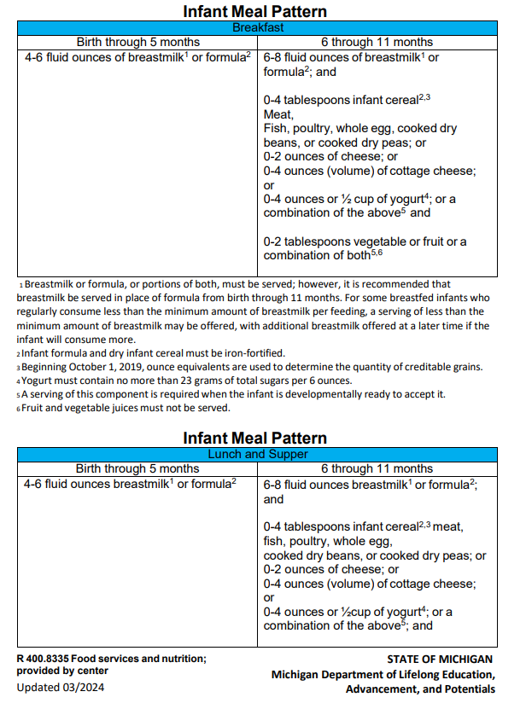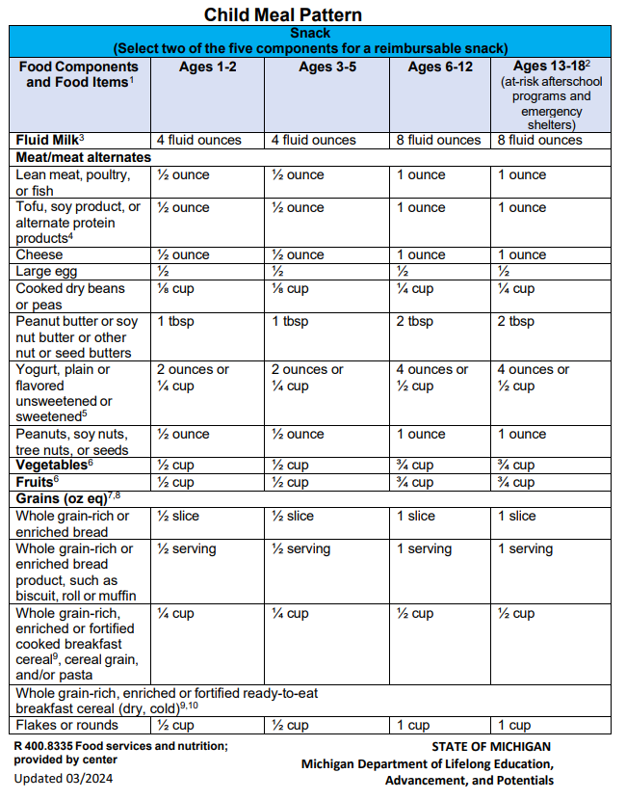

Fees
Rates are up to 8 hours $50 per day, after 8 hours it is $6.25 for each additional hour. Payment is due by 5:00pm on Friday each week, for the following week, regardless of attendance. If you are a new family, payment must be made the Friday before their start date. Payments need to be set up from a bank account to avoid charging you extra processing fees and to save on late payment fees due to forgetfulness in our busy lives. If you do happen to use a credit card to pay on the app, a fee of 3% will be added for fees. A $20.00 late fee will be added to your account each day payment is late, including weekends. Returned checks and ACH returns will be charged a fee of $35. Friday is considered late if paid after 5:00pm. If payment is not made by Monday, your child will not be able to return until payment is made. If DHS is your form of payment, you are responsible for covering the remaining amount of my weekly rate; same rules apply. We count on our paycheck as much as you count on yours, so please pay on time. For all receipts and yearly tax information see: myprocare.com on your web browser and sign in. (This is not your ProCare app).

Disclaimer
I/We hereby agree to comply with the rules and regulations of Horizon Daycare/Preschool, regarding fees, attendance, health, and other items specified in the Parent’s Handbook and Contract issued by Horizon Daycare. I am aware of the scheduled childcare holidays. The information contained in the Parent Handbook as well as the rates are subject to change. You will be notified in writing of any changes before they go into effect. By signing this agreement, I/We agree to honor all terms of this contract, and the written policies of Horizon Daycare/Preschool, now and in the future. Breach of the contract in any way from the parent may result in immediate termination of all services.

