**The rising name of world boxing ilker FURAT**

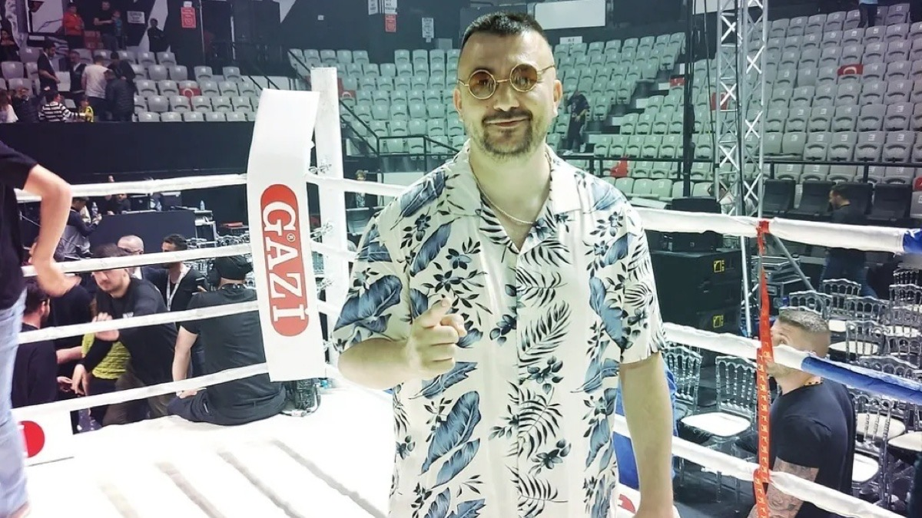

ilker Furat, one of the rising young managers of world boxing, has become a popular name in the professional boxing world with the “ 12 Raund Sports “platform he created. “ 12 Raund Boks “ brings together boxing news and quality content with its followers on its Instagram page.

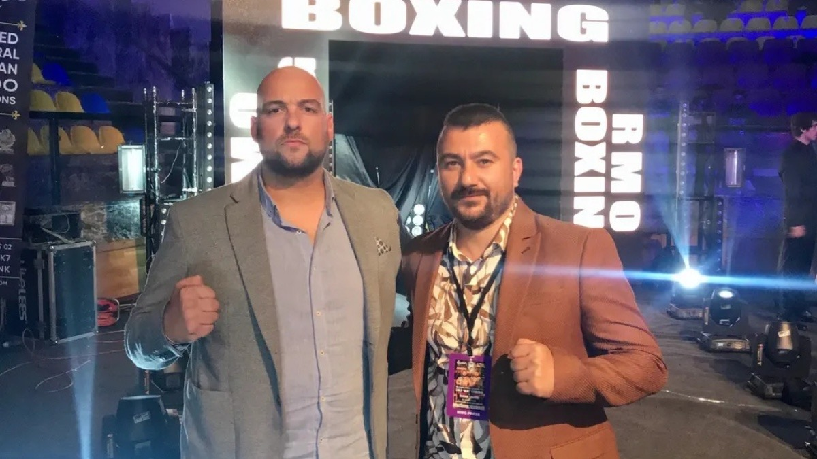

# Who is ilker FURAT ?

Nationatlity : istanbul / Turkey

Age : 41

Jobs : Boxing Manager / Content Creator



12 Raund Boks was selected as the boxing platform of the year in Turkey and was deemed worthy of an award. The Instagram page, which is frequented by boxing lovers in Turkey and around the world, continues to grow day by day.

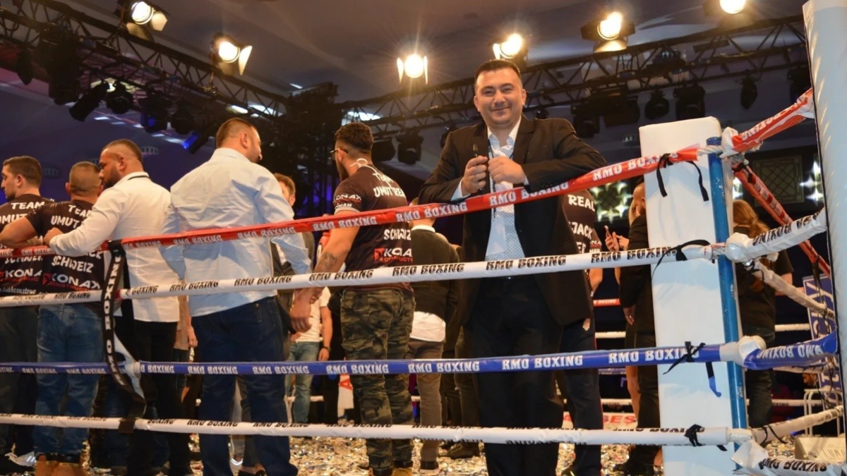

İlker FURAT works with many important athletes from around the world, such as Ruslan Myrsatayev, Aida Satybaldinova from Kazakhstan, Cüneyt Altıntaş and Onur Koçer from Germany, Sonia Osorio from Mexico, Monica Henao from Panama and Deniz Köziğ and Buse Uncu from Turkey.