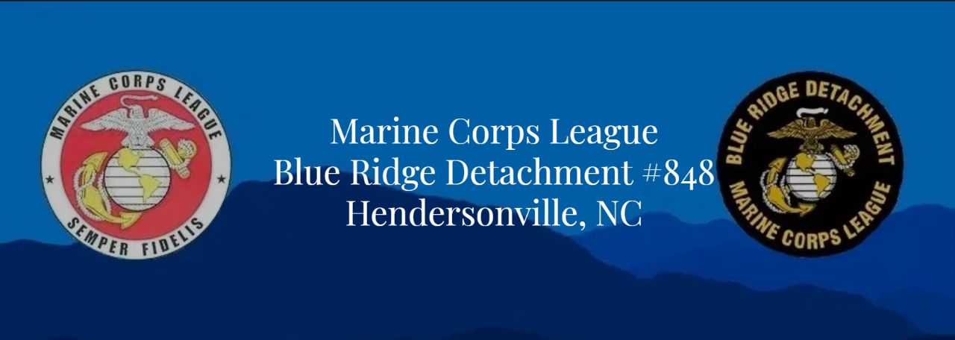

**The Blue Ridge Detachment of the Marine Corps League cordially invites all Marines and FMF Navy Personnel who have honorably served with Marine Units to attend the 250th Marine Corps Birthday Dinner to be held on Saturday, November 1, 2025, at the Kenmure Country Club, 100 Clubhouse Drive, Flat Rock, NC. Guests (family, friends, and other veterans) are welcome and encouraged to experience the tradition of the Marine Corps Birthday Celebration and Ceremony. We will start with Social Hour at 1700 hours (5 PM) and dinner will be served at 1815 (6:15 PM) hours. Raffle tickets will be available during the event. The raffle drawing will be November 10th.**

**Our speaker is Retired USMC Sergeant Major Yolanda Mayo. The Sergeant Major served for over 30 years in the Marine Corps with 3 overseas tours. Although retired, she continues to work with Marines as a civilian. In her words, “just because you take the uniform off, doesn’t mean your service stops.”**

**A buffet meal will be served consisting of Mixed Green and Vegetable Salad with choice of Ranch or Champagne Vinaigrette, Rolls, Mashed Potatoes, Green Beans, Chicken Marsala and Pork Loin with Apple Chutney**

**Coffee, Tea, Lemonade at the beverage table. Birthday Cake will be served at the Cake Cutting Ceremony after our speaker.**

**To attend please fill out the attached reservation and return it to the address noted by October 22th, 2025. Please RSVP ASAP because seating will be limited.**

***Social: 5 PM Silent Auction will start during Social Hour***

***6 PM: Colors, Opening and Missing Man Ceremony***

***6:15 PM: Dinner***

***7 PM: Speaker***

***7:45 PM: MOY and Donation Presentations***

***8 PM: 250th Birthday Cake Cutting Ceremony***

***Closing: 8:30 PM***

***Cost: $40 per person Early Bird; After September,15, $45 per person***

***Attire: Red Blazer or Coat and Tie, Semi-formal for Ladies, Dress Uniform optional***

---------**--Cut here and return by October 22th, 2025 ---------------------------------------------------------------------------**

**Name and number of attendees including self _________**

**Please make checks payable to MCL #848 and mail them to Attn: Blue Ridge Detachment, Post 77 American Legion, 216 4th Ave W, Hendersonville, NC, 28739. Or click QR for payment.**

**For further information, contact Marilyn Bower text 828-551-9372 or brdet848commandant@gmail.com**