STATE OF TEXAS

COUNTY OF BURNET

CITY OF DOUBLE HORN

On this the 8th day of August 2024, the City Council convened at 7:00 pm in the Council Chambers located at 103 Vista View Trail, Suite 100, Double Horn, Texas with notice of meeting giving time, place, date, and subject having been posted as described in Chapter 551 of the Texas Government Code.

1. Call Meeting to Order. Mayor Sereno called the meeting to order at 7:00 pm.
2. Roll call to Confirm Quorum. Mayor Cathy Sereno, Mayor Pro-Tem Millard and Aldermen Glen Stafford, Laura Rathe and John Osborne were confirmed present by City Secretary Christina McDonald.
3. Invocation. Alderman Osborne gave the invocation.
4. Pledge of Allegiance — U.S. & Texas. Mayor Sereno led the pledges.
5. Approval of Minutes of the June 13, 2024 Regular Council Meeting. Alderman Stafford moved to approve the minutes as presented. Alderman Osborne seconded the motion. The minutes were approved by a unanimous vote (4-0).
6. Citizen Comments. There were no citizen comments.
7. Regular Agenda.
   1. Treasurer's Report:

Monthly Financial Report. Mayor Sereno reviewed the July financial report with the Council. Alderman Osborne moved to sweep $297.94 from the Property Tax Account to the Operating Account. Alderman Rathe seconded the motion. The motion carried by a unanimous vote (4-0).

2024/2025 Budget/Tax Rate Schedule & Open Items to Finalize Proposed Budget. Mayor Sereno stated adoption of the FY 2024/2025 budget and tax rate is scheduled for the September 12 regular meeting.

* 1. Emergency Management Team update. Emergency Management Coordinator Harry Brunner did not provide an update.
  2. Zoning & Ordinance Committee Update

i. Progress update and discussion regarding the proposed Building Code and Building Permit Process. Mayor Pro-Tem Millard provided an update to Council stating the Building Code will be considered at a later meeting date followed by the building permit process.



* 1. Flock Safety (cameras) Installation Plan update. Alderman Stafford presented an update on the Flock Safety cameras.
  2. Discuss and consider action on projects recommended by the Water Conservation Partnership Committee, a joint committee between the City of Double Horn, Double Horn Creek Water Supply Corporation, and the Double Horn Improvement Association to promote water conservation and protect water service. No update was provided.
  3. Discuss and consider signage for No Solicitation in the City of Double Horn at each entrance. Mayor Pro-Tem Millard led the discussion regarding signage and the City's ordinance requirements. Posting signage educating the public that solicitation without a permit is prohibited per City Ordinance was discussed. No action was taken.
  4. Discuss and consider approval of a Contract for Election Services between the City of Double Horn and the Burnet County Elections Administrator. Alderman Rathe moved to approve the Contract for Election Services as presented. Mayor Pro-Tem Millard seconded the motion. The motion carried by a vote of 4-0.
  5. Discuss and consider approval of the 2024-2025 Joint Election Agreement for Burnet County Local Political Subdivisions. Mayor Pro-Tem Millard moved to approve the Joint Election Agreement. Alderman Stafford seconded the motion. The motion carried by a vote of 4-0.
  6. . Discuss and consider approval of Ordinance 2024-0RD044, an ordinance Ordering the November 5, 2024, City of Double Horn General Election for the purpose of electing three aldermen. Alderman Rathe made a motion to approve Ordinance 2024-0RD044 ordering the November 5, 2024 City of Double Horn General election. Alderman Stafford seconded the motion. The motion carried by a vote of 4-0.
  7. Discuss and consider action to recruit a City Treasurer. Mayor Sereno stated the City is continuing to recruit a City Treasurer.
  8. Distribute Monthly Office Hours Sign Up Sheet & DHIA/DHCWSC Meeting Sign Up Sheet. City Secretary Christina McDonald confirmed office coverage assignments for the month of August.
  9. Discuss and consider other matters for inclusion on the agenda for the next regular meeting of the City Council. Mayor Sereno stated the next regular meeting of the Council will be held September 12 at which time the FY 2024/2025 tax rate and budget will be considered for approval.

1. Adjournment. There being no further business to discuss, Alderman Rathe moved to adjourn. The motion was seconded by Alderman Osborne. The meeting was adjourned at 7:33 pm.

-

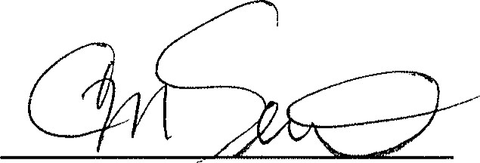

Cathy Sereno, Mayor

ATTEST:

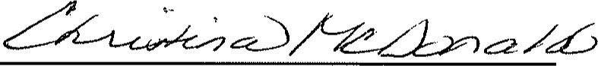

Christina McDonald, City Secretary

-