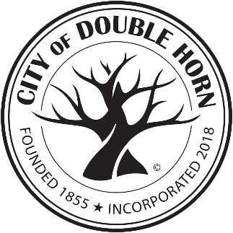

**CITY OF DOUBLE HORN**

**AGENDA**

**SPECIAL MEETING**

**CITY COUNCIL**

**WEDNESDAY, October 16, 2024**

**7:00PM**

**CITY OF DOUBLE HORN OFFICE**

**Located at 103 VISTA VIEW TRAIL, SUITE 100**

**DOUBLE HORN, TEXAS 78669**

*In compliance with the Americans with Disabilities Act, the City of Double Horn will provide for reasonable accommodations for persons attending City Council Meetings. To better serve you, requests should be received 24 hours prior to the meeting. Please contact Christina McDonald, City Secretary at (830) 201-4042.*

**Citizens will be given an opportunity to provide comments on any item listed on the regular agenda when the**

**agenda item is called. Comments should be limited to (3) three minutes.**

1. Call Meeting to Order
2. Rollcall to Confirm Quorum
3. Invocation
4. Pledge of Allegiance – U.S. & Texas

**Texas Pledge: *Honor the Texas flag; I pledge allegiance to thee, Texas, one state under God, one and indivisible*.**

1. Citizen Comments – This is an opportunity for the citizens to address the City Council concerning an issue of community interest not on the agenda. Any deliberation of an issue raised during Citizen Comments is limited to a statement of fact regarding the item; a statement concerning the policy regarding the item or a proposal to place the item on a future agenda Each citizen will be allowed 3 minutes to speak and must sign up before the meeting begins and indicate the subject the speaker wishes to address.
2. Regular Agenda – The Council will individually discuss, consider, and possibly take action on any or all of the following items:
   1. Discuss and consider taking action on the Vista View Trail monument sign plans provided by the Double Horn Improvement Association (DHIA) through their attorney, Mr. Edward (Teddy) Holtz

Note: A quorum of the DHIA Board is expected to be present to participate in the discussion

1. Adjournment

***The City Council reserves the right to adjourn into Executive Session at any time during the course of this meeting to discuss any matters listed on the agenda, as authorized by the Texas Government Code, including, but not limited to, Sections 551.071 (Consultation with Attorney), 551.072 (Deliberations about Real Property), 551.073 (Deliberations about Gifts and Donations), 551.074 (Personnel Matters), 551.076 (Deliberations about Security Devices), 551.087 (Economic Development), 418.183 (Deliberations about Homeland Security Issues) and as authorized by the Texas Tax Code, Section 321.3022 (Sales Tax Information).”***

I certify that the above notice of meeting was posted at 103 Vista View Trail, Suite 100, Double Horn, Texas by October 13, 2024, by 7PM.

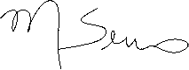

______________ ___________________________________

Cathy Sereno, Mayor

