**OC JACKSON III**

**BRAVERY Memorial Scholarship**

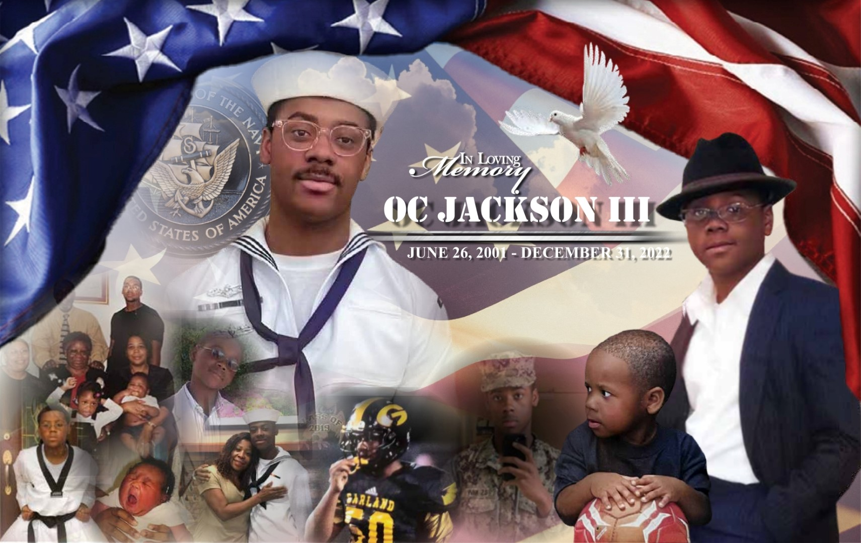

**The OC JACKSON III BRAVERY Scholarship** is awarded every year to an individual who represents the meaning of **BRAVERY**; being **Bold, Resilient, Assertive, Versatile, Educated, Respectful and Youthful.**

These attributes stick out and represent who OC was, and who he strove to be as he became older.

Being **Bold** allows one to take calculated risk and fully commit to it. There are many who cannot commit to a task wholeheartedly, but OC was one who could and did on many occasions.

**Resilience** was a way of life for OC. He never gave up easily on anything he set his mind to. There may be times in life where you must take a step back and reflect, and gain more knowledge, but after the assessment period is over, to get up again and fight is a reflection of one’s character.

**Assertiveness** demonstrates the ability to not only communicate what is needed but to do so in a respectful manner. You must be in control of your actions and your words. That shows who you really are on the inside.

**Versatility** is the ability to understand a given circumstance and adjust accordingly. Regardless of what came his way, OC found a new way to achieve the goal. He was going to find a way to get things done.

**Educated** individuals have an understanding of the topic and are able to inform others. OC made sure that when he spoke on any subject that he knew exactly what he was talking about and if not, he corrected himself and continued to inform.

A **Respectful** person is mindful of their tongue. You never heard OC address older adults disrespectfully. Whether OC was fond of you or not he always spoke to you in a respectful manner.

A **Youthful** individual represents the qualities of youth such as ambition, energy, drive. OC was a life-time student eager to take the world into his classroom.

**Who was OC Jackson III?**

OC Jackson III born June 26, 2001, and stood for excellence in every respect of the word. **BRAVERY** is the word that the family has chosen to best describe OC’s life.

At a young age OC was known to be a confident and inspirational young man; and with every encounter he made an impact. He began his adventure with public speaking and performed in the yearly oratorical competition at **Mt. Hebron Christian Academy** until the age of eight. OC later joined **The Bowtie Boys** organization and continued with public speaking throughout the country.

**The Bowtie Boys** was created to train young boys to be responsible, and hard working. OC, being a spokesman and one of the first **Bowtie Boys**, spoke for the organization on several occasions; Including the NAACP, Skillful Living in Dallas, Sims Chapel Baptist Church, St. Paul Baptist Church in Neylandville, Texas and much more. OC was able to travel and experience many historical places such as crossing The Selma Bridge in observance of the 50th anniversary, visiting Little Rock Central High School where many students were denied entry because of the color of their skin. OC also experienced The National Civil Rights Museum and The Lorraine Motel in Memphis where Rev. Dr. Martin Luther King was assassinated.

Upon graduating Garland High School in 2019 with a high GPA, OC decided to take his skills into the service of our country by joining the **U.S. Navy and accomplishing** many things in a short period of time. After graduating from boot camp in August of 2019, he was assigned his job in **cryptology**. In a matter of three years, OC earned the rank of 2nd class petty officer. Also, he was selected for the **U.S.** **Navy Expeditionary Intelligence Command** and given the job as a **Battle Force ELINT Analyst** while on deployment. While on deployment he completed many tasks and was pinned and received countless accolades for his service. After deployment he created a lesson plan to help other personnel familiarize themselves with specific equipment that they would need to know about in the future.

**OC JACKSON III BRAVERY MEMORIAL SCHOLARSHIP APPLICATION FORM**

[www.bravery scholarship.com](http://www.braveryscholarship.com)

214-907-9008

**Purpose:**

The purpose of the **OC Jackson III BRAVERY MEMORIAL SCHOLARSHIP** is to provide a college scholarship award to an African American male student who represents **BRAVERY**; being **BOLD, RESILIENT, ASSERTIVE, VERSATILE, EDUCATED, RESPECTFUL AND YOUTHFUL**. These attributes represent who OC Jackson III was as a young man.

**Award:**

Amount may vary.

**Eligibility:**

1. Applicant must be an African American male.
2. Applicants must be a high school senior, an undergraduate student, or a student in a trade program.
3. Applicants must be between the ages of 17-26 years old.
4. Applicants must be a part-time or full-time student attending a trade school or college/university student studying for an undergraduate degree.
5. Applicants must be US citizens.

**Selection Criteria:**

1. Demonstration of **BRAVERY** characteristics
2. Student essay
3. Letter of recommendation

**Application Requirements:**

To be considered for the OC Jackson III Scholarship Award, applicants must complete an application and return it to OC Jackson III BRAVERY Memorial Scholarship by August 1st. The application must include:

1. A completed application form. *Only completed application forms will be considered*.
2. One letter of recommendation from a teacher, school official or community member.
3. An official high school transcript for high school seniors or an official college transcript for undergraduate students.
4. An essay (at least 300 words) on **How Would You Practice the Ideals Represented by This Scholarship?**

***All four of the above items must be submitted before the application will be considered.***

**Submission of Application Form**

Completed printed applications may be emailed to: braveryscholarship@gmail.com

**Submission of Transcript**

Your registrar can email an official transcript to:

[braveryscholarship@gmail.com](mailto:braveryscholarship@gmail.com)

**Submission of Letters of Recommendations**

Letters of recommendation may be emailed to [braveryscholarship@gmail.com](mailto:braveryscholarship@gmail.com)

The letters should indicate the capacity in which the letter writer knows the applicant, e.g. as a student, employee, pastor, or other capacity.

Questions about the application process may be directed to [braveryscholarship@gmail.com](mailto:braveryscholarship@gmail.com) or 214-907-9008

**Please note all application materials must be received by August 1st.**

**General Scholarship Application Form**

1. **General Information**

First Name______________________ Last Name___________________

Home Address_________________________________________

City___________________ State______________ Zip/Postal Code____________

Phone_____________________ Email_____________________________

1. **Education Information**

Please Check One:

________High School Senior

________Undergraduate Student

________Trade School

Name of Institution__________________________________________________

School Address______________________________________________________

City________________ State ____________ Zip/Postal Code_________________

Area of Study________________________________________________________

Expected Graduation Date______________________________________________

Degree/Certification Expected___________________________________________

Cumulative grade point average__________________________________________

Status: Full-time_____ Part-time_____

Internship or work experience in which you have participated:

**Organization Duties/Activities Dates**

_______________________________________________________________________________________________________________________________________________________________________________________________________________

List the most significant extracurricular and community activities (sports, art, music, clubs, public service, etc.):

**Organization Duties/Activities Dates**

_______________________________________________________________________________________________________________________________________________________________________________________________________________

1. **Short Answer**
2. What book, teacher or class has changed the way you think? Explain how.

________________________________________________________________________________________________________________________________________________________________________________________________________________________________________________________________________________________________________________________________

1. Why did you apply for this scholarship?

________________________________________________________________________________________________________________________________________________________________________________________________________________________________________________________________________________________________________________________________

1. What are your opinions on African American men and women serving in the United States Armed Forces?

____________________________________________________________________________________________________________________________________________________________________________________________________________________________________________________

1. **Scholarship Essay**

**Please write an essay (at least 300 words) explaining how you would practice the ideals represented by this scholarship?**

I hereby certify that all of the information in this scholarship application is accurate and complete. I understand that all the information contained in this form will be treated confidentially. If awarded this scholarship, I understand that I must attend the scholarship awards banquet to be recognized by the scholarship donors.

Applicant Signature__________________________ Date____________________