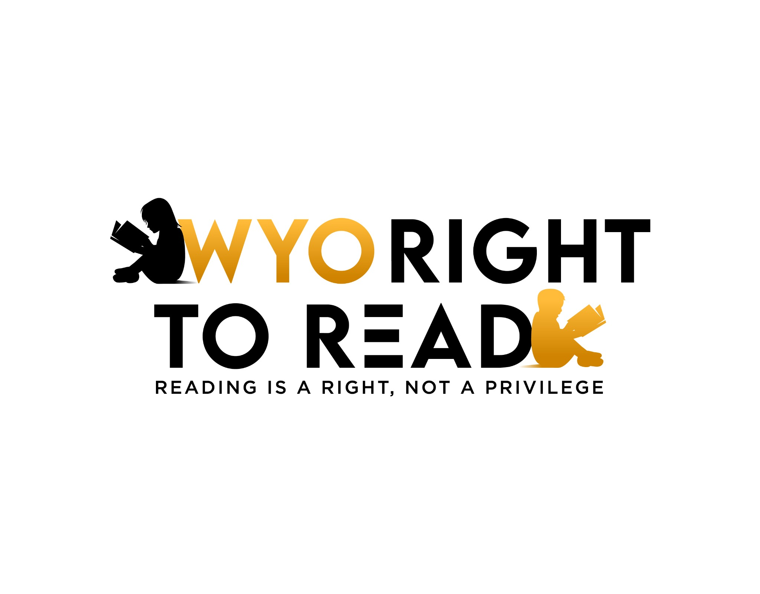

**What About the Older Kids?  
Child Find and Dyslexia Beyond Grade 3**

*WYO Right to Read | Wyoming Dyslexia Fact Sheet*

## 1. Wyoming’s K–3 Screening Law Sets a Minimum, Not a Limit

Wyoming law (W.S. § 21-3-401) and the Wyoming Department of Education (WDE) literacy rules require universal reading screening for grades K–3. This ensures early identification, but it does not exempt school districts from identifying older students.  
  
The law establishes the floor of what must occur, not the ceiling of what’s allowed.  
  
Even though Wyoming’s law does not explicitly require dyslexia screening beyond third grade, districts still have a continuing legal duty to identify all students who may have disabilities under the Individuals with Disabilities Education Act (IDEA) and Section 504 of the Rehabilitation Act of 1973. These federal laws cover all students ages 3 through 21.

## 2. IDEA’s “Ongoing Duty” to Identify

Under Child Find (34 C.F.R. § 300.111), every school district must “identify, locate, and evaluate” all children suspected of having a disability—including those “advancing from grade to grade.”  
  
If a fourth-grader or high-school student struggles with reading, spelling, or writing in ways that suggest a Specific Learning Disability (SLD) such as dyslexia, the district must:  
• Recognize the pattern of difficulty through teacher observation and reading data.  
• Refer for an evaluation without delay.  
• Use appropriate assessments to determine if the student has dyslexia or another SLD.  
  
There is no age or grade cutoff for Child Find. This duty exists throughout the school years—until the student graduates with a diploma or ages out at 21.

## 3. What Districts Should Do for Older Students

• Review historical data: If screening was missed earlier, evaluate now—don’t ignore persistent reading or spelling problems.  
• Use appropriate tools: Administer normed reading assessments for decoding, fluency, and phonological processing suitable for older students.  
• Train all teachers: Staff must be able to recognize dyslexia indicators beyond grade 3.  
• Provide intervention: Deliver instruction aligned with Structured Literacy once dyslexia is identified.

## 4. Consequences for Ignoring Older Students

Failure to act on evidence that a student may have dyslexia can constitute a Child Find violation under IDEA and Section 504. Consequences may include:  
• Compensatory education and independent evaluations at district expense.  
• Attorney’s fees and potential tuition reimbursement if parents seek private placement (Forest Grove Sch. Dist. v. T.A., 557 U.S. 230 (2009); Compton USD v. Addison, 598 F.3d 1181 (9th Cir. 2010)).  
• Corrective action or systemic monitoring ordered by the Wyoming Department of Education.

## 5. In Plain Terms

Even if Wyoming only mandates K–3 universal screening, federal law requires individual screening and evaluation anytime a disability is suspected—at any grade level.  
  
Older students who were “missed” in early grades still have the right to be evaluated for dyslexia if current performance, history, or teacher concerns suggest a reading disability.

## Call to Action: Protect Every Student’s Right to Read

Parents:  
• If your child in grade 4–12 continues to struggle with reading or spelling, put your request in writing asking for an evaluation under IDEA or Section 504.  
• Document patterns of difficulty and share with the district.  
  
Legislators:  
• Strengthen Wyoming’s literacy law to extend mandatory dyslexia screening and intervention through grade 12.  
• Ensure teacher training and WDE oversight include all grade levels, not just K–3.  
• Fund statewide access to Structured Literacy interventions for all ages.

**Every Wyoming child deserves the right to read—no matter their grade.  
Learn more: www.WyoRightToRead.org**