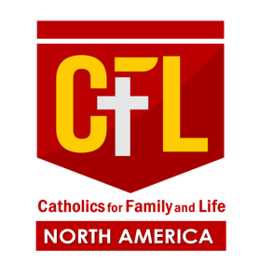

Greetings of love, peace and joy from Catholics for Family & Life North America!
We are pleased to announce that from June 24 to 26 2026, Catholics for Family and Life North America will hold its 4th Annual Community Conference at the Wildwood Convention Center at 4501 Boardwalk, Wildwood, NJ
To celebrate this special occasion, we will be publishing a Souvenir Program. This program is designed to be a cherished keepsake for all members, friends, and supporters of CFL North America.
The conference is expected to draw delegates from across North America, including California, Canada, Connecticut, New Jersey, Texas, and Washington, as well as representatives from the Philippines, Australia, Italy, Ireland, England, Finland, and Malawi.
In support of this significant event, we invite you to place an advertisement in our Souvenir Program. This opportunity allows you to showcase your services and products, helping us share information about your organization with our community during the conference and beyond.
We have enclosed our advertising contract for you to complete and return along with your advertising materials or details. Please ensure that your submission reaches us no later than April 15, 2026 .

Contact Information
We appreciate your support and look forward to featuring your advertisement. For further information, please contact:
- Bro Mel Sagcal (732 ) 331 5450
- Bro. Ronnie Flores ( 201) 759 9860
- Email: cflconferencenj2026@gmail.com

Sincerely yours,
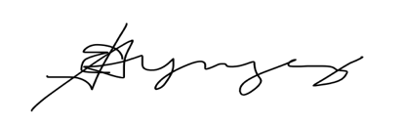

Bro. Joed Yngcong CC: Sis, Arlene Serina
CFL North America CFL Conference 2026
Continental Council of Elders Souvenir Program Coordinator

Advertising Contract
Full page advertisement cost $100.
For each advertisement, you will receive a souvenir program.
Please submit your advertisement in the following format by April 15, 2026:
PDF with fonts embedded (preferred)
High resolution JPF (300 dpi)
High resolution TIFF (300 dpi)
Email to CFLNorthAmConference.info@gmail.com
(where advertiser will send the artwork)

Advertisement Submission Guidelines
All advertisements must be submitted electronically in the specified formats outlined above. Please note that advertisements created in Microsoft Word are not accepted under any circumstances. It is the responsibility of the purchaser to ensure that the ad artwork is provided in the correct format as listed. Additionally, files must be high resolution; low resolution submissions will not reproduce well and may be rejected.

Name of Family/Business: _____________________
Contact Name/Title: __________________________
CFL member referred by: ______________________
Phone: _______________________________________
Email: ________________________________________

MAKE CHECKS PAYABLE TO:
Catholics for Family and Life New Jersey OR To Zelle Account:
Address: 53 W Park Ave cflconferencenj2026@gmail.com
Avenel NJ
07001
For Questions, please contact any of the following:
Bro. Mel Sagcal Email: melsagcal@yahoo.com Cellphone (732) 331 5450
Bro. Ronnie Flores Email: fflores0914@yahoo.com Cellphone (201) 759 9860

