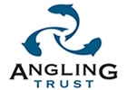 |  | 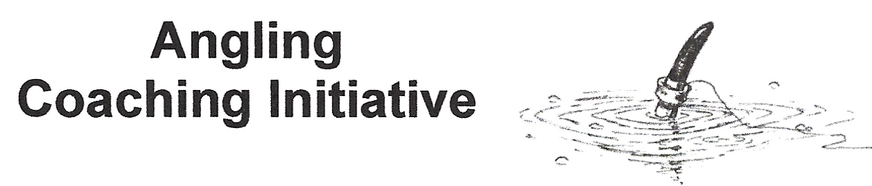
PARENT/GUARDIAN CONSENT & INFORMATION FORM
Information for Coaching Sessions 2020/2021

Child’s Name _____________________________Child’s Date of Birth __________________________

KDAA Member Y/N ________MAS member? Y/N_________CAPS member? Y/N_________

Can you swim? ____________ Left-handed or right-handed? _____________

Parent/Guardian’s Name _______________________________________________________________

Child’s Home Address _________________________________________________________________

________________________________________________________PostCode___________________

Parent/Guardian Email _______________________________ Tel Home_________________________

Parent/Guardian Mobile________________________

Alternative/Emergency Contact & Mobile___________________________________________________

Where did you learn of ACI please? _______________________________________________________

Relevant Medical Information (including Allergies, Dietary needs etc.) including ; sun cream, hand sanitiser, insect repellents, insect bite relief, plasters. All would be applied by the Student if needed.

___________________________________________________________________________________

Known medical conditions, a copy of the school health plan is ideal. Will be treated in confidence.

___________________________________________________________________________________

If own medication is needed here, we should be aware; we can remind but not administer.
Asthma attacks we automatically contact emergency on 112, other medical concerns as required

___________________________________________________________________________________

Other Information/Behavioural Issues that Coaches/Volunteers should be aware of;

___________________________________________________________________________________

___________________________________________________________________________________

We will adhere to the Angling Trust’s Child Protection Policy. I consent to my child taking part in activities with us. Especially younger pupils may be given a hand into their swim/platform for safety, and help given on tasks such as on casting, positioning the rod or pole, and “striking” to hook the fish.

We acknowledge that we will be liable in the event of accident only if they have failed to take reasonable steps in their Duty of Care.
I confirm that, to the best of my knowledge my child does not experience any medical issues other than those mentioned above. I consent to my child receiving medical treatment which, in the opinion of a qualified medical practitioner may be necessary.

Childs protective clothing of sun hat, waterproofs when appropriate, non-slip shoes or boots for any muddy conditions should be worn. Suitable food & drink (screw-top best, wasps can get in a can!) also to be provided.

For the purposes of coaching, all participants are automatically covered by the Angling Trust’s Insurance scheme

I consent to photographing or videoing my child on the understanding that any images will be used solely for the purpose intended. We will follow guidance for the use of any images as detailed in the Angling Trust’s Child Protection Policy.

Signature of Parent/Guardian _________________________________ Date ______________

Signature of Child (if 12 or over) _________________________________Date _____________
Consent for the Angling Trust & Environment Agency to contact you |  | Media Policy: Available and has been explained |  | Registered Disabled? |  | Been fishing before? |  | Has a long-term illness? |  | Black / Other minority ethnic background
Yes/No |  | Yes/No |  | Yes/No |  | Yes/No |  | Yes/No |  | Yes/No

EA Rod Licence’s

Temporary rod licences are sometimes issued for our initial one day introductory fishing days at no charge but unless this is shown on our publicity material for the day you are attending you will need an EA rod licence.
- Children under 12 however don’t need a licence.
- Licences for children aged between 12 and 16 are free but this can only be done online. Make sure you connect to the www.gov website as there are a few sites that come up on a search engine that make an extra charge for getting your rod licence.
www.gov.uk/fishing-licences/when-you-need-a-licence

Licence type | Trout and coarse 2-rod
Adult 1-day | £6
Adult 8-day | £12
Adult 12-month | £30
Adult 12-month - over 65 or disabled | £20
12-month - junior (13 to 16) | Free

Young Anglers Code of Conduct

- During both theory and practical sessions the programme is sharing facilities with other people who may require a quiet environment. We expect students to respect this and adopt appropriate behaviour.
- The use of offensive and/or discriminatory language is considered unacceptable.
- All staff and students will respect each other, the environment in which they are in, wildlife and members of the public at all times. Bullying of any description will not be tolerated
- Health and Safety procedures will be adhered to by all young persons and adults.
- Deliberate damage to any item of tackle or equipment belonging to the Young Anglers, the fishery, staff or other students will not be tolerated. This could result in the parents or carers of the student receiving a bill to replace the item(s).
- We reserve the right to exclude any young person from the programme for extreme cases of inappropriate behavior. All young persons and staff are expected to follow the Young Anglers Code of Conduct.

To bring on the day
- Plenty to drink (screw-top best, wasps can get into cans!)
- Food
- Waterproofs, & adequate clothing
- Boots, or shoes with ribbed anti-slip soles
- Antiseptic hand gel & clean rag/towel to use prior to eating
- Any medication required (but we cannot administer this)
- Due to the risk of disease transfer such as KHV please do not bring any keep-nets or landing nets
ALSO clean & dry boots/shoes, remove all damp mud

Angling experience; please tick; | Starter | Intermediate | Advanced

Please bring your own chair, tackle seat or other secure seat if you have one
Please be sure to be at the pick-up point on time

Signature of Parent/Guardian _________________________________ Date ______________

Signature of Child (if 12 or over) _________________________________Date _____________

Suggestions on how we could improve our days are very welcome!

Chris Burt  Angling Coach  3 Great Cob, Chelmsford CM1 6LA  chris@candjb.co.uk  M 07917 781299 | Angling Coach Level 2  Enhanced DBS Certificate  Red Cross Certificate  Safeguarding Certificate

ACI follows the Angling Trust Health & Safety Policy, Equality Policy (also covers Discrimination Harassment & Victimisation), & the Code of Practice for Sports Coach’s. Full details on www.anglingtrust.net/
Also please note that under the Terms of The Data Protection Act, we are holding participants details on a restricted access data-base.

