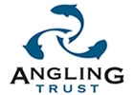 |  | 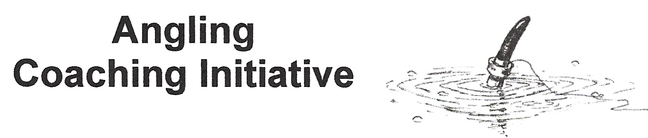
Volunteer Assistant Consent & Information Form
Coaching Sessions

Name _____________________________Date of Birth __________________________

KDAA Member Y/N ________MAS member? Y/N_________CAPS member? Y/N_________

Can you swim? ____________ Left-handed or right-handed? _____________

Home Address _________________________________________________________________

________________________________________________________PostCode___________________

Email _______________________________ Tel Home_____________________________

Mobile________________________

Alternative/Emergency Contact & Mobile___________________________________________________

Relevant Medical Information (including Allergies, Dietary needs etc.) including ; sun cream, hand sanitiser, insect repellents, insect bite relief, plasters. All would be applied by you if needed.

___________________________________________________________________________________

Known medical conditions. Will be treated in confidence.

___________________________________________________________________________________

If own medication is needed here, we should be aware; we can remind but not administer.
Asthma attacks we automatically contact emergency on 112, other medical concerns as required

___________________________________________________________________________________

Other Information/ Issues that Level 2 Coaches/Volunteers should be aware of;

___________________________________________________________________________________

___________________________________________________________________________________

We acknowledge that we will be liable in the event of accident only if they have failed to take reasonable steps in their Duty of Care.
I confirm that, to the best of my knowledge I do not experience any medical issues other than those mentioned above. I consent to receiving medical treatment which, in the opinion of a qualified medical practitioner may be necessary.

Protective clothing of sun hat, waterproofs when appropriate, non-slip shoes or boots for any muddy conditions should be worn. Suitable food & drink (screw-top best, wasps can get in a can!) also to be provided.

For the purposes of coaching, all participants are automatically enrolled into the Angling Coaching Scheme (ACI)

Signature ________________________________ Date _______________

I consent to photographing of me on the understanding that any images will be used solely for the purpose intended. We will follow guidance for the use of any images as detailed by the Angling Trust.

Signature _________________________________ Date ______________

Angling experience

Coverage I can give as a Volunteer Assistant

Club member KDAA, MAS or CAPS _____________________________________________________________________

Cover any venue of MAS, KDAA or CAPS or just own club?___________________________________________________

Number of days you’re likely to want to help at_____________________________________________________

Saturday only dates or mid-week in summer holidays?________________________________________________

Please advise availability against agreed coaching days once these are issued, to follow.

Level 1 qualification training but only if you wish, ACI will try to fund this. Please advise if you would you like to know more __________________________________________________________________________________

Please bring your own chair, tackle seat or other secure seat, as due to the space needed to transport seating these are NOT provided.

Due to the risk of disease transfer such as KHV please do not bring any keep-nets or landing nets
ALSO clean & dry boots/shoes, remove all damp mud

Suggestions on how we could improve our days are very welcome!

Volunteers Signature_________________________________ Date ______________

Chris Burt  Angling Coach  3 Great Cob, Chelmsford CM1 6LA  chris@candjb.co.uk  M 07917 781299 | Level 2 Angling Coach  Enhanced DBS Certificate  Red Cross Certificate  Safeguarding Certificate

Sign-off Chris Burt________________________________

ACI follows the Angling Trust Health & Safety Policy, Equality Policy (also covers Discrimination Harassment & Victimisation), & the Code of Practice for Sports Coach’s. Full details on www.anglingtrust.net/
Also please note that under the Terms of The Data Protection Act, we are holding participants details on a restricted access data-base.

