METHOD FEEDER
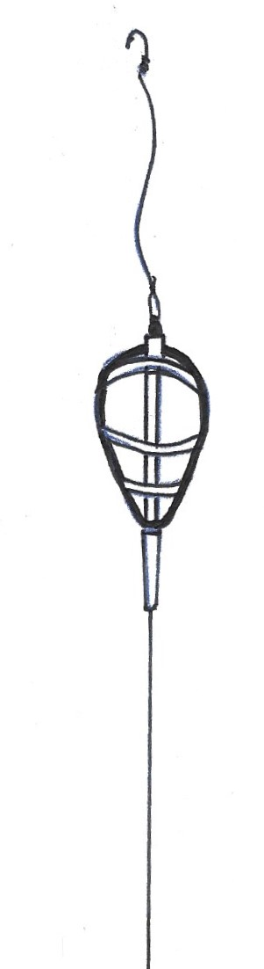
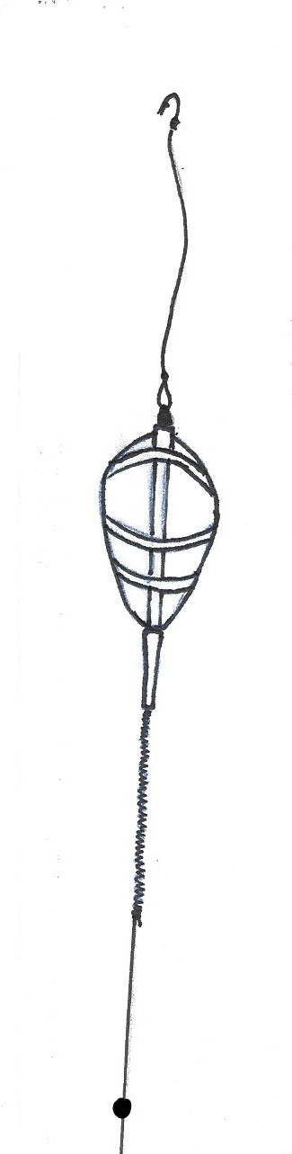

3 or 4” hook length
Swivel or quick
change bead

Feeder with tail rubber

6-10” twizzled line

Float stop
Some float stops fit more tightly than others, suggest a looser one as this can be pulled off easier by a fish if the line snaps above the stop.

STRAIGHT LEAD/FEEDER
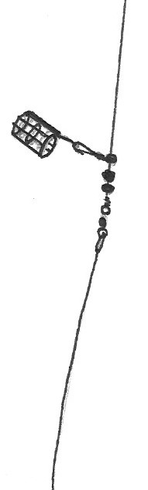
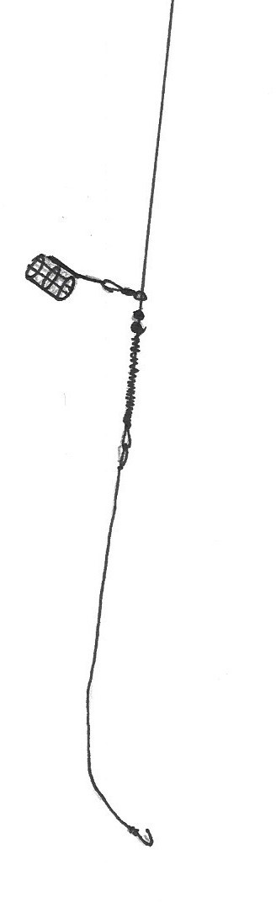

Feeder or leger weight attached by feeder bead connector

2 x No 8 shot
Optional, No8 swivel
1 or 2 x float stops
6” twizzled boom with optional swivel to connect hooklength

HELICOPTER RIGS
Main line at least 6lb B/S for this rig.
Hook length shorter than drop to feeder

Feeder attached by snap link swivel

Short hook length from 3” up
Tail rubber pushed over half the swivel

Swivel
To feeder
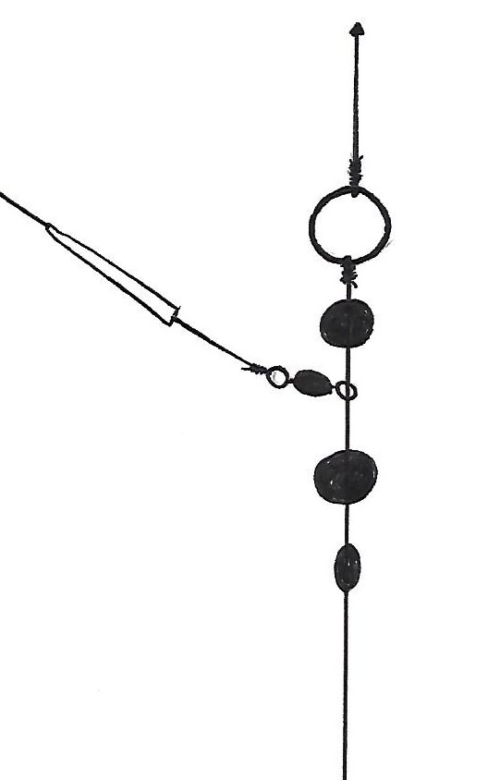
Small“O” ring
3 x float stops

Optional tail rubber or silicon tube
Rubber beads
Tail rubber pushed over half the swivel
Swivel or “O” ring

Alternative rig for large fish
Rig for light to medium sized fish

Alternative simplified rig

Float stop
2 x float stops
Feeder attached by snap link swivel
6 - 10” twizzled line
Short hook length
Swivel

