Grinner Knot
For tying braid to hooks, swivels etc
For nylon, see tucked half blood knot
Two turns through eye of hook or swivel | 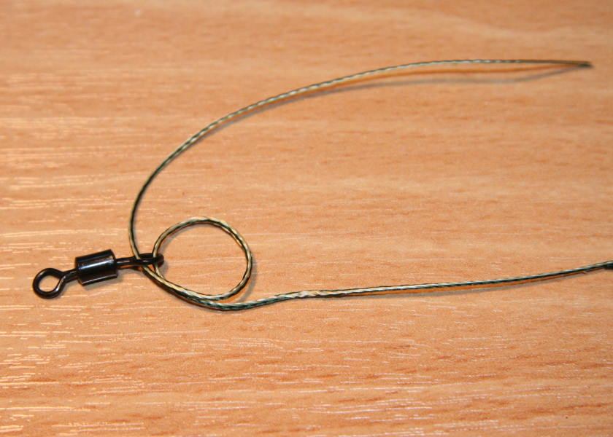
Form loop then tuck through loop 4 or preferably 5 times | 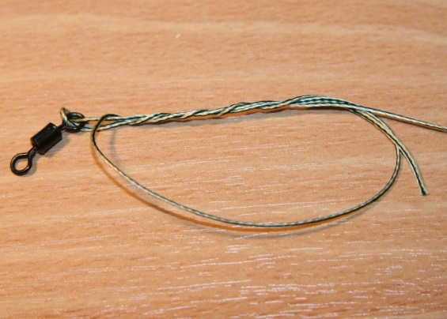
Tighten to secure
Knotless Knot
Tie a small loop onto the end of a length of braid or nylon.  Position along the shank of the hook, allowing the desired length of hair.  Whip with 6-12 turns of line to secure, and pass end of line back through the TOP of the hook eye as shown  Tighten and preferably secure with superglue | 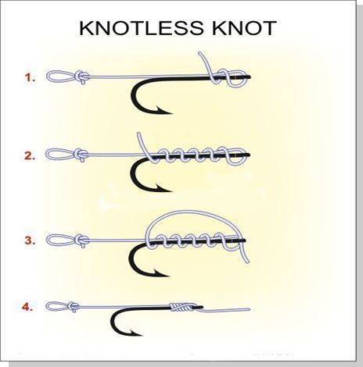
Line Aligner
Add shrink tube to form line aligner over finished hook as shown  Optional additional shrink tube near bend of hook to also align bait  Immerse in boiling water to shrink the tube tightly onto the hook, and to bend the protruding tube as shown | 