CREATING A TWIZZLED BOOM FOR FEEDER FISHING AND HOOK LENGTHS.
The standing end of your line is the line going to your reel, the tag end is the loose end. To create a twizzled boom, hold the standing end in one hand about 12” in from the tag end. Take the tag end in your other hand. Holding each piece of line between the thumb and first finger of the respective hands begin to roll the line between finger and thumb, with the left hand rolling in the opposite direction to the right hand. As you roll the line, gradually bring your hands towards each other and the line between them will begin to loop around itself to form the twizzle. When your boom has reached the desired length, hold both pieces of line with the standing and tag ends together and tie an overhand or figure of eight loop with the twizzled line. If you wish you can also tie another knot at the loop end of the twizzle. The twizzles should form as per the diagram below as you twist and bring your hands together.
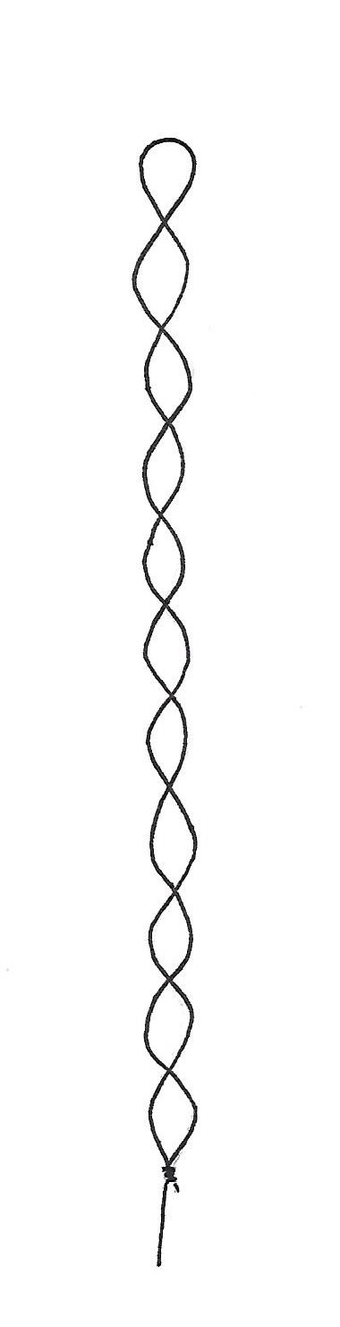
To reel or hook
Overhand or figure of eight knot
knot
A twizzle boom tied with 15lb line
Optional knot here

