COMMON WAGGLER RIGS
For these 4 rigs, 80% of the shot are positioned to lock the float in place, with one shot only up from the float.  Attach with a float adaptor so the float can be easily changed to another size or type. |  |  |  |  |  |  |  | Sliding waggler
 | Conventional shotting  To fish slowly “on the drop”, often set to the exact depth to catch bottom feeders too.  80% of shot to lock the float  Put a no 6 or no 8 shot every 2 foot down the line, “shirt button” style |  | Fast sinking shotting pattern  80% of shot to lock the float  BB  6  8 |  | Laying on  With the last shot often quite close to the hook  Can be set way over-depth to counteract heavy surface winds and drift  80% of shot to lock the float  BB  6  6 |  | Lift Method.  One large shot on the bottom very near the hook. When a fish takes the bait the fish lifts the shot off the bottom, the float in turn rises out of the water.  80% of shot to lock the float  One large shot, BB or larger | Diagrams overleaf show 2 methods of using a sliding float | This rig gives a metre or so drop from the rod-tip only regardless of the depth it is set for, so very useful if overhead branches restrict easy casting, or to fish water deeper than the rod length. Also good for an underarm cast in restricted swims.  Sliding stop-knot (see knots leaflet), to stop sliding float at desired depth. Leave cut ends of knot about 25mm long so stop-knot can run through rod-rings easily for retrieves and casting  Optional tiny bead between float & stop-knot  Waggler attached by metal eyed float adaptor so float runs freely on the line.  Resting on a shot, positioned slightly more than float length above bulk shot  Bulk shot  6  8 One or both these shot can be used to “lay on” if desired
Stop knot
Small bead (optional)
Bulk shot
Dropper shot spaced approximately 30cm apart
Final dropper 30cm from hook can be replaced by a micro swivel or hooklength connector
Loaded float needing 3AAA plus to settle
No 8 shot, micro swivel or hooklength connector
No6 or No8 shot
Bulk of shot about 3ft from the hook
Small bead (optional)
No 8 or No6 shot at least a float length above bulk
Stop knot
Slider rig as described using unweighted float.

Alternative float and shotting pattern. Minimum recommended line diameter is Ø.20.
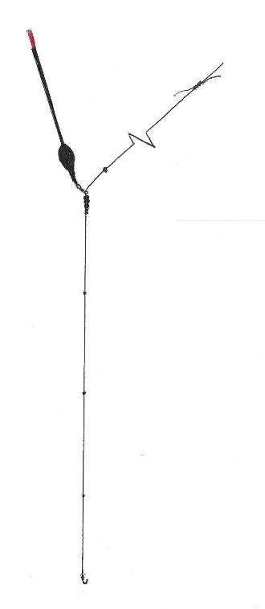

Fast water waggler. A clean, preferably gravel bottom is needed for this method to work effectively.
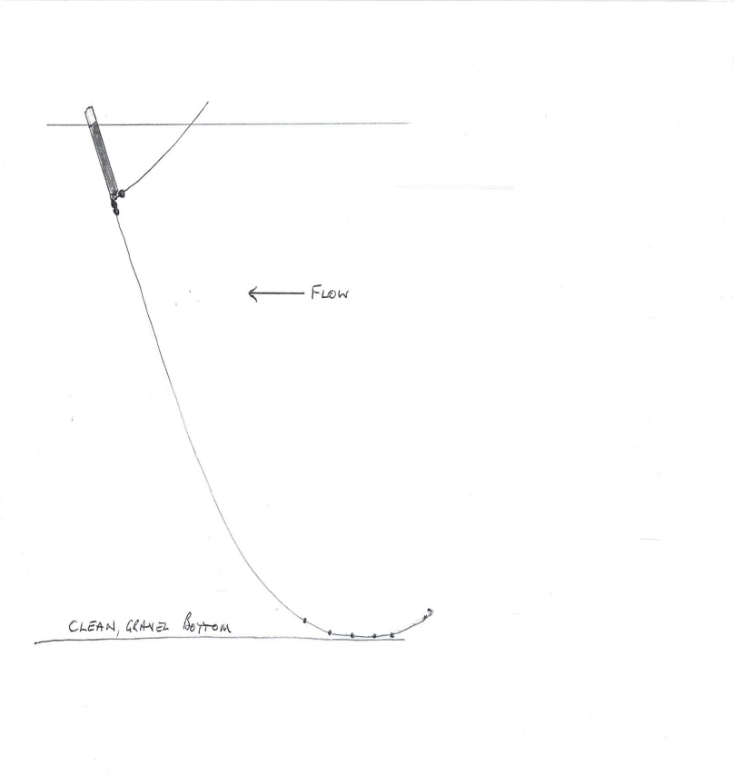
This method uses a thick bodied waggler undershotted by at least a BB. 3 to 6 x Number 8 shot are then spaced 2-6” apart starting about 6inches from the hook and allowed to drag on the bottom. This makes the float dip and rise as it trots through the swim. Bites will be sudden dips or the float not rising as expected.

