2026
2026
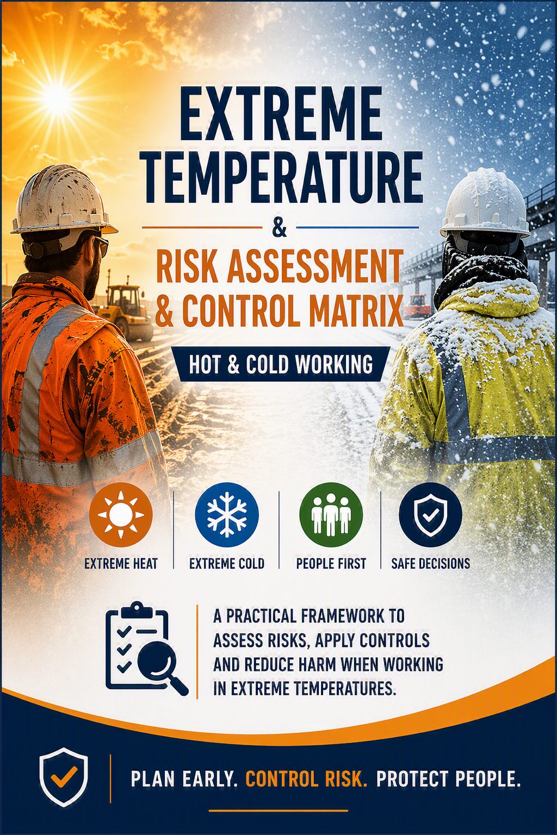


Extreme Temperature Risk Assessment & Control Matrix
Document Owner: Head of SHEQ
Applies To: All Bridges Operations, Projects, Sites and Work Activities
Related Documents:
- Extreme Temperature Working Policy
- Weather Alert Monitoring & Escalation Guide
- Project RAMS
- Dynamic Risk Assessment Process
- Occupational Health Arrangements

1. Purpose
This document provides a structured framework for assessing and controlling risks associated with working in extreme hot and cold weather conditions.
It is intended to support project teams, supervisors and operatives when planning work, reviewing RAMS, undertaking dynamic risk assessments and responding to adverse weather alerts. The matrix establishes minimum standards and identifies additional control measures required where weather conditions increase the risk of injury, illness or operational failure.
This document should be used alongside project-specific risk assessments and does not replace the requirement to undertake site-specific evaluation of hazards and controls.

2. T

emperature Risk Assessment Principles
Extreme temperature risk is determined by considering the interaction between:
- Environmental conditions
- The work activity being undertaken
- Individual worker vulnerability
- Duration of exposure
- Availability of controls
No single temperature alone determines risk.
For example:
- 28°C with high humidity and heavy physical work may present greater risk than 32°C with light duties.
- 2°C with driving rain and strong winds may present greater risk than -2°C in dry, calm conditions.
Assessment should therefore focus on overall exposure rather than temperature alone.

3. Environmental Risk Factors
Factor | Increased Risk Indicators
Air Temperature | High daytime temperatures or prolonged low temperatures
Humidity | High humidity reduces cooling through sweating
Direct Sunlight | Increased radiant heat exposure
Wind Speed | Increased heat loss and wind chill effects
Rainfall | Wet clothing significantly increases cold stress risk
Snow and Ice | Slip hazards and cold exposure
Ground Conditions | Frozen surfaces, mud and standing water
UV Exposure | Increased risk of sunburn and skin damage
Duration of Exposure | Extended periods without recovery breaks
Local Microclimate | Enclosed compounds, confined spaces, rooftops, chambers, excavations

4. Individual Vulnerability Factors
Certain individuals may be more susceptible to heat or cold-related illness.
The following factors should be considered:
Vulnerability Factor | Risk Consideration
New Starter / New to Site Work | Reduced acclimatisation
Young or Inexperienced Worker | Reduced awareness of symptoms
Older Worker | Reduced physiological resilience
Pregnancy | Increased sensitivity to temperature extremes
Cardiovascular Conditions | Increased heat and cold stress risks
Respiratory Conditions | Increased cold & hot weather impacts / susceptible to Thermal variance triggers, e.g going hot to cold environments or vice versa
Diabetes | Potential impairment of body temperature regulation
Medication Use | Some medications impair heat tolerance
Recent Illness | Reduced physical resilience
Fatigue | Increased susceptibility to illness
Dehydration | Increased likelihood of heat-related illness
Workers are not required to disclose confidential medical information to colleagues; however, any relevant restrictions identified through Occupational Health arrangements must be implemented.

5. Work Activity Risk Factors
Activity Characteristic | Heat Risk | Cold Risk
Heavy Manual Handling | High | Medium
Confined Space Entry | Very High | Medium
Working in Direct Sunlight | Very High | Low
Excavation Works | Medium | High
Water Industry Operations | Medium | Very High
Pressure Washing Activities | Low | High
Traffic Management Duties | High | High
Wearing Extensive PPE | Very High | Medium
Emergency Repair Work | High | High
Lone Working | High | High
Extended Working Hours | High | High
Remote Locations | High | High

6. Heat Control Hierarchy
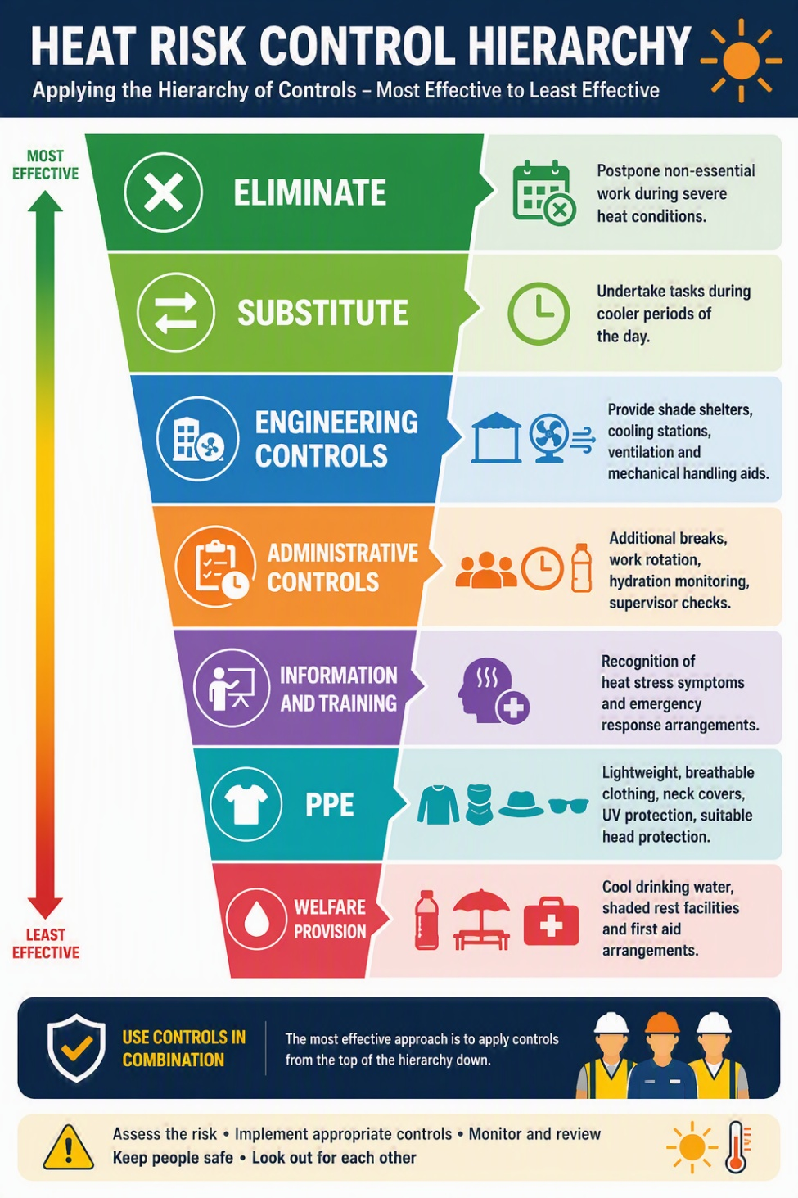

Additional Controls for Elevated Risk Activities
- Reduce task duration.
- Increase supervision.
- Implement buddy systems.
- Monitor vulnerable persons more closely.
- Suspend non-essential physically demanding activities during Emergency conditions.

7. Cold Weather Control Matrix
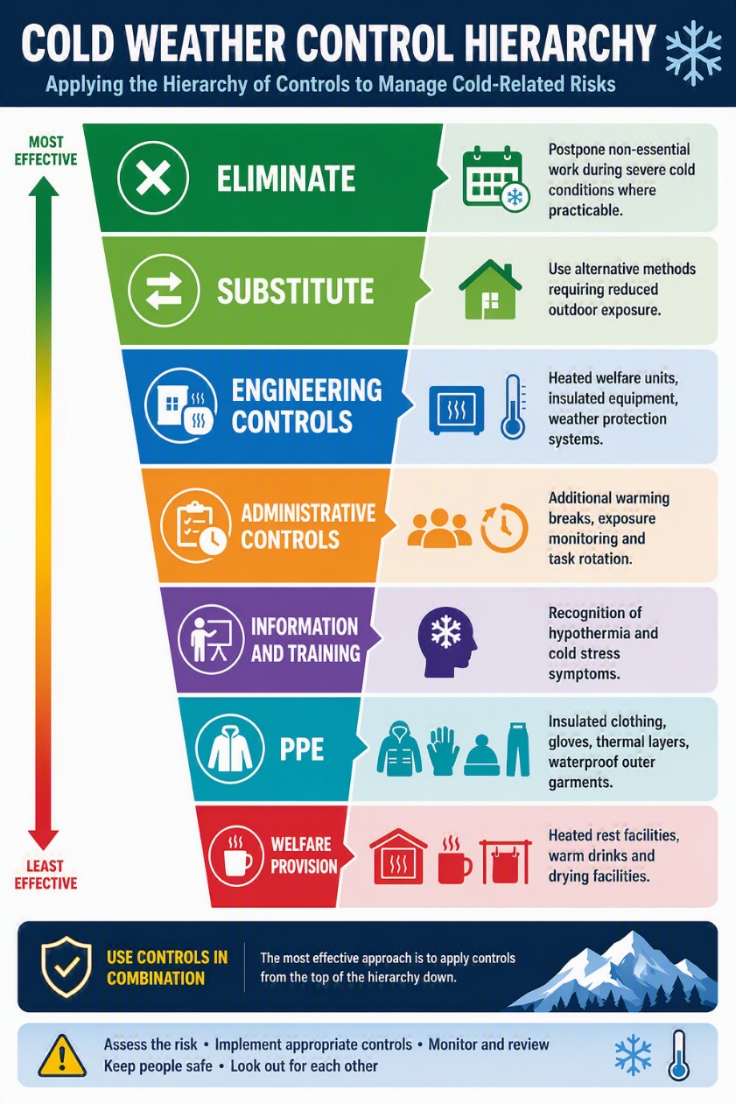

Additional Controls for Elevated Risk Activities
- Limit exposure periods.
- Increase warming opportunities.
- Improve weather monitoring.
- Suspend activities where icy conditions create uncontrolled risks.
- Implement additional travel and vehicle safety checks.

8. Residual Risk Evaluation
After controls have been implemented, supervisors should assess residual risk as follows:
Residual Risk Level | Definition
Low | Conditions adequately controlled and monitored
Medium | Additional supervision required
High | Significant controls required before continuing
Intolerable | Work must not proceed
Where residual risk remains High or Intolerable, work shall not commence or continue until further control measures are implemented.

9. Minimum Control Requirements by Alert Level
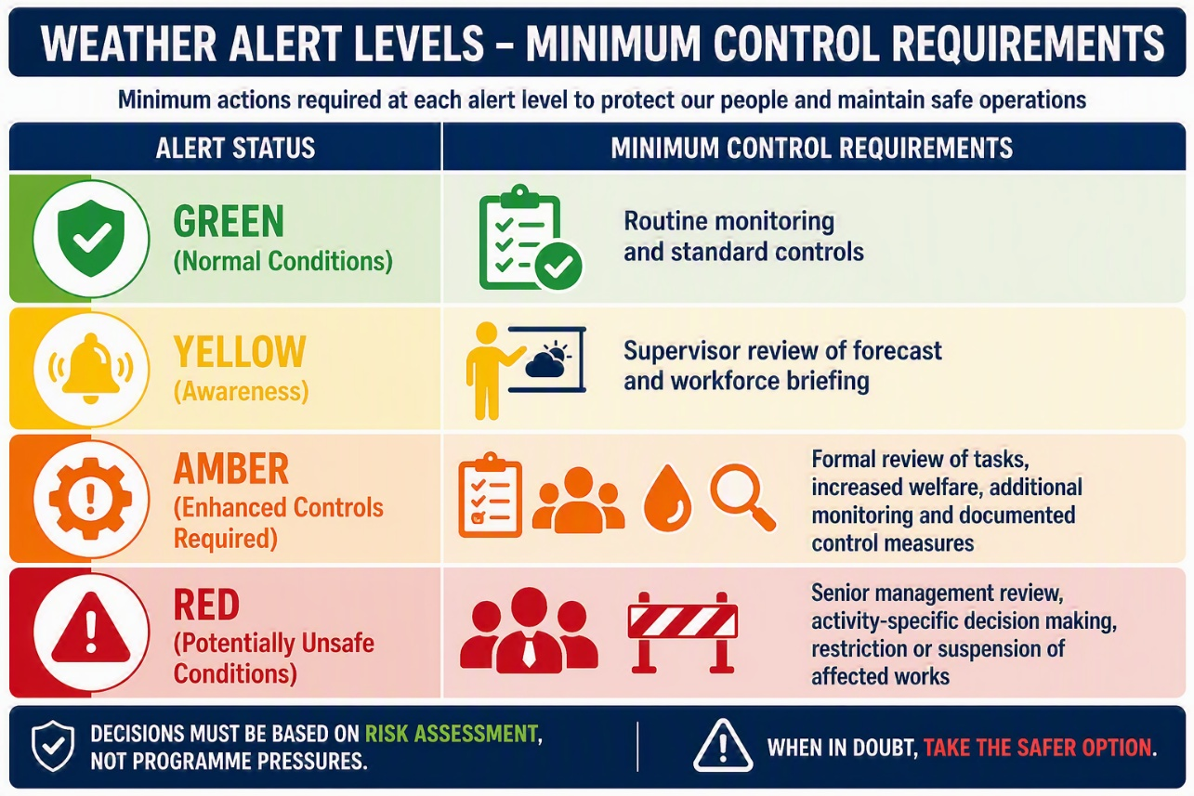
The decision to continue work during an Emergency weather situation must be based on risk assessment rather than programme pressures.

10. Review and Reassessment Triggers
Risk assessments should be reviewed whenever:
- A Yellow, Amber or Emergency weather alert is issued.
- Temperature conditions change significantly.
- Work activities change.
- Personnel changes introduce new vulnerability factors.
- Control measures prove ineffective.
- A weather-related incident or near miss occurs.
- Concerns are raised by operatives, supervisors or SHEQ personnel.
Supervisors should treat extreme weather as a dynamic hazard requiring continual reassessment throughout the working day rather than a one-off planning consideration.

Appendix A – Examples of Conditions Requiring Immediate Review
