
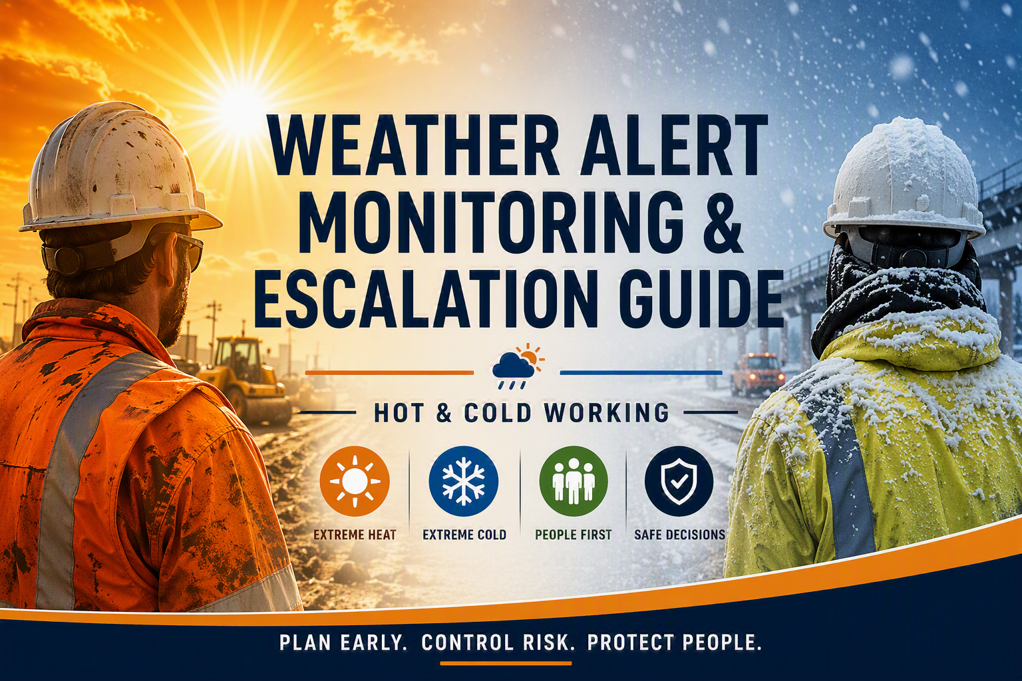
2026

WEATHER ALERT MONITORING & ESCALATION GUIDE

Extreme Temperature & Adverse Conditions Management
Document Status: Controlled Guidance Document
Applies To: All Bridges Operations
Supporting Policy: Extreme Temperature & Adverse Conditions Policy

1. Purpose
This guide establishes the requirements for monitoring weather-related risks and managing the escalation of controls during periods of extreme heat, extreme cold and adverse weather conditions.
The purpose is to ensure that operational decisions are made consistently, proportionately and before workers are exposed to foreseeable risk.
This guide supports the Company's principle of:
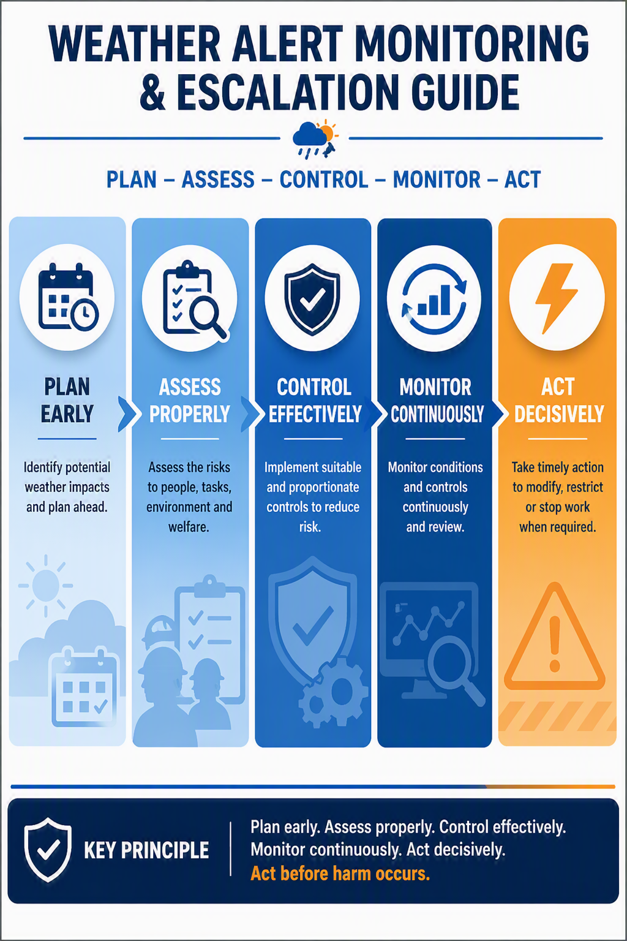

2. Responsibility for Monitoring
Weather conditions shall be monitored by Project Managers, Site Managers and Supervisors throughout the planning and delivery of works.
Monitoring should include:
- Met Office Warnings
- UK Health Security Agency (UKHSA) Weather-Health Alerts
- Site-specific conditions
- Local forecasts
- Client communications
- Emerging environmental conditions on site
Weather alerts must be considered during:
- Pre-start planning
- Daily briefings
- RAMS reviews
- Dynamic risk assessments
- Shift changeovers

3. Escalation Principles
Weather warnings and health alerts do not automatically stop work. However they shall trigger a structured management review.
The following hierarchy shall always be applied:
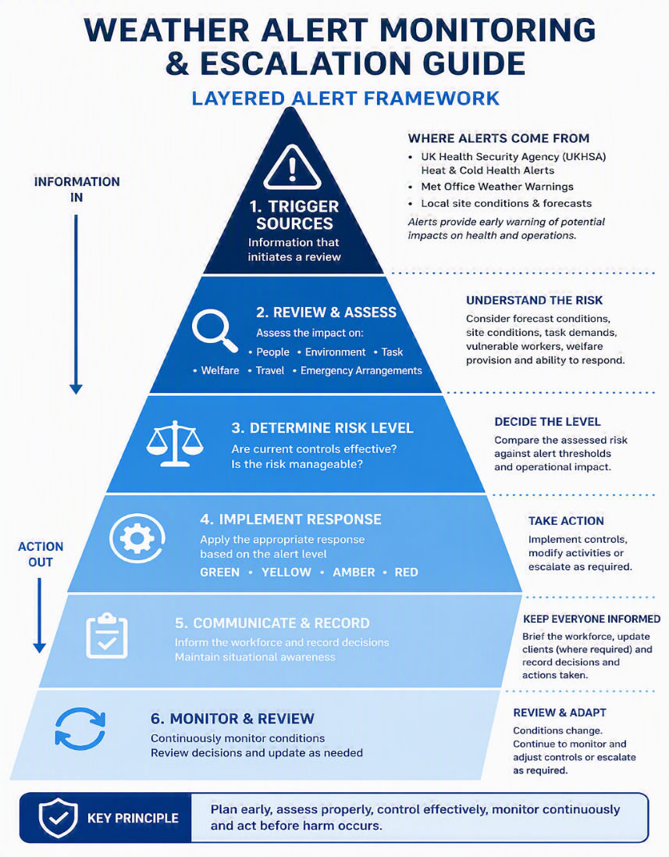
Fig 1 – Weather Alert Monitoring & Escalation Guide

4. Amber Alert Response

Purpose of an Amber Alert
An Amber Alert is intended to provide an early management trigger before conditions become intolerable or create an immediate threat to life.
The purpose of an Amber Alert is to ensure that foreseeable risks associated with extreme heat, extreme cold or adverse weather are identified, reviewed and controlled through a structured management process before work proceeds.
Amber Alerts should not be viewed as an automatic stop-work instruction. Rather, they require managers and supervisors to pause, assess the potential impact on people, activities and welfare arrangements, and determine whether work can continue safely with enhanced controls or requires modification.
The principal objective of an Amber Alert is to prevent work activities deteriorating into an emergency situation by ensuring that appropriate decisions are made early, communicated effectively and continually reviewed as conditions develop

Trigger
Any of the following:
- UKHSA Amber Heat Health Alert
- UKHSA Amber Cold Health Alert
- Met Office Amber Warning
- Significant site-specific conditions creating elevated risk
Examples include:
- High temperatures
- Severe cold
- Snow
- Ice
- Strong winds
- Thunderstorms
- Flooding

Management Expectations
A documented review shall be completed before affected work proceeds.
The review should consider:

Personnel
- Worker competency
- Worker vulnerability
- Fatigue levels
- New starters
- Young persons
- Pregnant workers
- Existing medical conditions

Environment
- Forecast conditions
- Site exposure
- Shade availability
- Wind chill
- Water accumulation
- Surface conditions

Task
- Exposure duration
- Physical workload
- Lone working
- Confined spaces
- Emergency arrangements
- Rescue capability

Welfare
- Drinking water
- Cooling measures
- Heating measures
- Rest facilities
- Toilet provision
- Drying facilities

Typical Amber Controls
Examples include:
- Additional supervision
- Enhanced toolbox talks
- More frequent breaks
- Increased hydration monitoring
- Task rotation
- Modified working hours
- Additional welfare facilities
- Temporary work restrictions

Required Outputs
The following should be completed:
✓ Supervisor briefing
✓ Workforce communication
✓ Review adequacy and applicability of RAMS
✓ Welfare inspection
✓ Management decision record

5. RED ALERT RESPONSE

Purpose of a Red Alert
A Red Alert is intended to provide a formal intervention trigger where conditions have deteriorated to a point that presents a significant and foreseeable risk to health, safety, welfare or operational resilience.
The purpose of a Red Alert is to ensure that activities exposed to extreme heat, extreme cold or adverse weather are subject to enhanced management scrutiny before work proceeds and that risks are reduced so far as is reasonably practicable.
Red Alerts should not be viewed as an automatic stop-work instruction. However, they establish a presumption that work activities will require significant modification, increased control measures, partial restriction or suspension unless it can be clearly demonstrated that the risks remain adequately controlled.
The principal objective of a Red Alert is to prevent personnel, contractors or members of the public from being exposed to conditions that have the potential to result in serious injury, ill health, significant operational disruption or an emergency situation.

Trigger
Any of the following:
• UKHSA Red Heat Health Alert
• UKHSA Red Cold Health Alert
• Met Office Red Warning
• Significant site-specific conditions creating a severe or intolerable level of risk
Examples include:
• Exceptional temperatures
• Extreme cold conditions
• Significant snowfall
• Widespread ice formation
• Storm conditions
• Extreme wind conditions
• Severe thunderstorms
• Flooding affecting access, egress or emergency response
• Failure of critical welfare arrangements
• Site conditions creating a foreseeable risk of serious injury or ill health

Management Expectations
A documented senior management review shall be completed before affected work proceeds.
The review should consider:

Personnel
• Worker competency
• Worker vulnerability
• Fatigue levels
• New starters
• Young persons
• Pregnant workers
• Existing medical conditions
• Availability of suitable supervision
• Workforce resilience and wellbeing

Environment
• Forecast conditions
• Actual site conditions
• Duration of adverse conditions
• Site exposure
• Wind chill effects
• Solar loading and radiant heat
• Flood risk
• Safe access and egress
• Emergency vehicle access

Task
• Exposure duration
• Physical workload
• High-risk activities
• Lone working
• Confined spaces
• Lifting operations
• Rescue capability
• Emergency response arrangements
• Ability to safely suspend activities if conditions worsen

Welfare
• Drinking water availability
• Heating arrangements
• Cooling arrangements
• Rest facilities
• Toilet provision
• Drying facilities
• First aid arrangements
• Recovery facilities

Typical Red Alert Controls
Examples include:
• Increased management oversight
• Direct senior management involvement
• Additional supervision
• Enhanced workforce communications
• Increased welfare provision
• Further reduction of exposure periods
• Significant modification of working methods
• Restriction of high-risk activities
• Suspension of non-essential activities
• Delayed starts or early finishes
• Reduction in workforce numbers
• Postponement of planned works
• Temporary closure of work areas

Required Outputs
The following should be completed:
✓ Senior management review
✓ Workforce communication
✓ Review adequacy and applicability of RAMS
✓ Welfare inspection
✓ Management Decision Record
✓ Client notification where appropriate
✓ Defined review and reassessment point

6. Authority to Stop Work
Any employee, subcontractor, supervisor or manager who believes that environmental conditions present an immediate and uncontrolled risk to health and safety is authorised to stop work and seek further guidance from Site Manager in first instance, with escalatory route to regional SHEQ Advisor and ultimately if further escalation is required to either Head of SHEQ (East) or Head of SHEQ (West) dependent on project location.
No individual shall be criticised or disadvantaged for exercising this authority in good faith.
Work may only recommence once the risk has been reassessed and suitable controls have been confirmed.

7. Alert Escalation Flow
The following flow diagram shows the routes for escalation / advice .
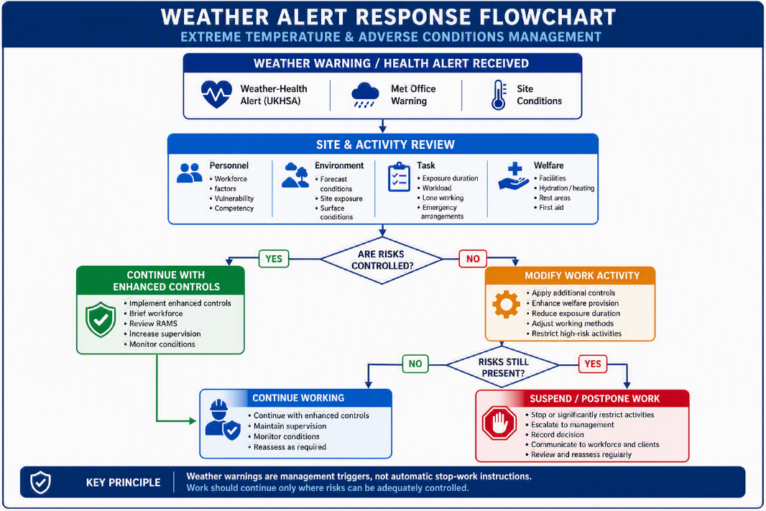
Fig 2 – Weather Alert Response Flow Chart

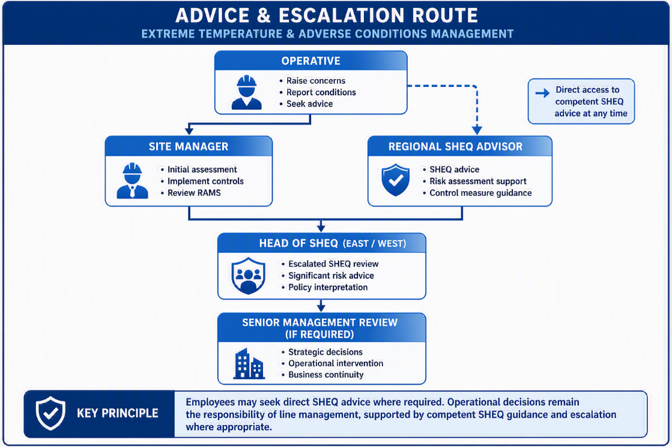
Fig 3 – Routes for advice, support and escalation

8. Documentation Requirements
The following records should be retained where Amber or Red alerts influence operational decisions:
- Management Decision Record
- Site Briefings
- Toolbox Talks
- RAMS Amendments
- Client Communications
- Welfare Inspections
- Dynamic Risk Assessments
These records provide evidence that the Company assessed and managed foreseeable risks in a structured and proportionate manner.

Key Principle
Weather warnings are not simply information; they are management triggers requiring review, decision-making and, where necessary, intervention.

