2026
2026
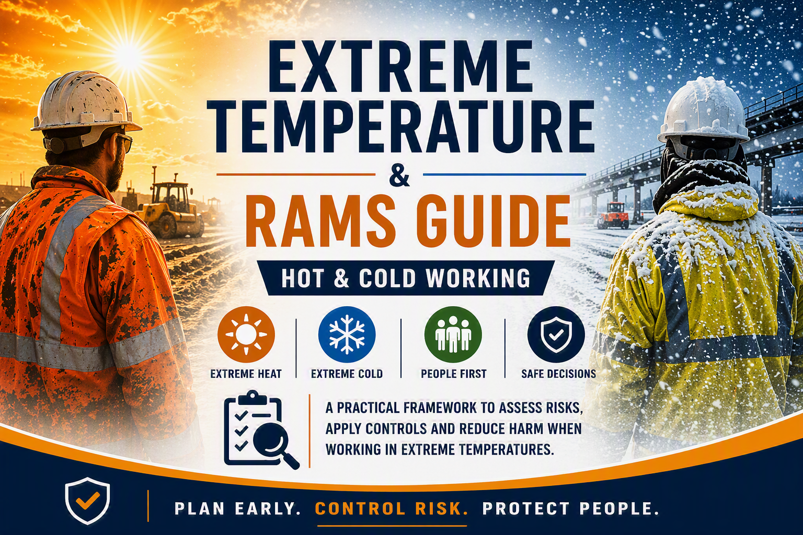


Hot & Cold Working

A Practical Framework for Assessing Risks, Applying Controls and Reducing Harm When Working in Extreme Temperatures

Document Owner: Head of SHEQ
Applies To: All Bridges Projects, Sites and Operational Activities
Primary System Documents:
- Extreme Temperature & Adverse Conditions Policy
- Weather Alert Monitoring & Escalation Guide
- Extreme Temperature Risk Assessment & Control Matrix
Related Systems:
- Bridges On Line (BoL)
- Risk Assessment & Method Statement Procedure
- Dynamic Risk Assessment Process
- Occupational Health Arrangements
- Site Welfare Standards

1. Purpose
This document provides guidance for incorporating extreme temperature and adverse weather considerations into Risk Assessments and Method Statements (RAMS) developed within Bridges On Line (BoL).
This guide does not alter the Company's standard RAMS development process, nor does it apply to routine day-to-day weather conditions that would normally be expected and controlled through standard project planning.
The guide is intended to be used where forecast, actual or emerging conditions indicate that extreme heat, extreme cold or adverse weather may present a foreseeable additional risk to health, safety, welfare or operational delivery.
Typical triggers for applying this guide include:
- Prolonged periods of hot weather.
- Prolonged periods of cold weather.
- UKHSA Weather-Health Alerts.
- Met Office Weather Warnings.
- Significant site-specific environmental conditions.
- Activities where thermal stress may be increased due to the nature of the work, environment or PPE requirements.
The primary purpose of this document is to assist RAMS authors, reviewers and approvers in determining whether existing RAMS remain suitable and sufficient under extreme conditions or whether additional controls, amendments or management interventions are required.
This guide supports the implementation of the following core documents:
- Extreme Temperature & Adverse Conditions Policy.
- Weather Alert Monitoring & Escalation Guide.
- Extreme Temperature Risk Assessment & Control Matrix.
It does not replace those documents. Rather, it explains how their requirements should be incorporated into project-specific RAMS developed within Bridges On Line (BoL). The guide should therefore be viewed as an implementation document sitting beneath the wider Extreme Temperature Management System.

2. The Bridges Extreme Temperature Management System
The following documents form a single integrated management system for how Bridges as a business will manage extremes of temperature and working safely in them:

Document 1

Extreme Temperature & Adverse Conditions Policy
Defines:
- Company expectations
- Legal duties
- Roles and responsibilities
- Planning requirements
- Welfare requirements
- Intervention principles

Document 2

Weather Alert Monitoring & Escalation Guide
Defines:
- Weather monitoring arrangements
- Alert levels
- Amber response requirements
- Red response requirements
- Escalation routes
- Stop work authority

Document 3

Extreme Temperature Risk Assessment & Control Matrix
Defines:
- Environmental risk factors
- Vulnerability factors
- Activity risk factors
- Heat controls
- Cold controls
- Alert-level controls
- Review triggers

Document 4 (this document)

Extreme Temperature RAMS Guide
Defines:
- How requirements are incorporated into project RAMS
- How RAMS should be developed within BoL
- Minimum expectations for RAMS authors
- Quality standards for weather-related assessments

This document should always be read and applied in conjunction with the three core system documents.

3. Bridges On Line (BoL) – The Starting Point
All RAMS shall be developed using Bridges On Line (BoL) unless alternative arrangements have been formally approved. Approval shall only be granted in extraordinary circumstances and only by review and approve of a member of the ELT and/or in conjunction with Heads of SHEQ.
The availability of standard risk libraries, controls and templates within BoL does not remove the requirement for competent assessment. All Hold points and referrals to SME’s must be maintained.
RAMS authors remain responsible for ensuring that:
- Hazards are site-specific.
- Controls are activity-specific.
- Environmental conditions are considered.
- Vulnerable persons are considered.
- Welfare arrangements are assessed.
- Weather alerts are reviewed.
- Escalation arrangements are defined.
- Review triggers are identified.

RAMS must demonstrate genuine project-specific assessment and must not rely solely upon generic controls or copied wording from previous projects.
The quality of a RAMS is determined by the quality of the risk assessment process that sits behind it.

4. Core RAMS Development Principles
Weather-related hazards shall be treated as foreseeable risks whenever they have the potential to affect:
- Health.
- Safety.
- Welfare.
- Productivity.
- Emergency arrangements.
- Access and egress.
- Travel.
- Operational resilience.

RAMS authors must therefore assess the interaction between:

Environmental Conditions
Including:
- Temperature
- Humidity
- Wind speed
- Rainfall
- Snow
- Ice
- Solar radiation
- UV exposure

Work Activities
Including:
- Physical workload
- Exposure duration
- PPE requirements
- Confined spaces
- Lone working
- Emergency works

Personnel
Including:
- Young persons
- New starters
- Vulnerable workers
- Pregnant workers
- Existing medical conditions
- Occupational health restrictions

Welfare Arrangements
Including:
- Drinking water
- Shade
- Cooling arrangements
- Heated welfare
- Drying facilities
- First aid arrangements

The RAMS should demonstrate how these factors have been considered before work begins.

5. Using the Extreme Temperature Risk Assessment & Control Matrix
The Extreme Temperature Risk Assessment & Control Matrix is the primary technical reference document supporting the development and review of RAMS where extreme temperature conditions may reasonably be expected to affect the safe execution of work. It should be consulted whenever a RAMS author identifies the potential for elevated risk arising from heat, cold or adverse environmental conditions.

The purpose of the Matrix is to provide a consistent approach to identifying relevant risk factors, evaluating the significance of exposure, selecting suitable controls and determining when reassessment or escalation may be required. RAMS authors should therefore use the Matrix as the principal source of guidance when considering environmental conditions, worker vulnerability, task-specific exposure and the selection of control measures.

The Matrix is not intended to replace project-specific risk assessment. Rather, it provides a framework to support consistent decision-making across the business. Controls included within RAMS should always reflect the actual conditions, activities, workforce and operational constraints associated with the specific project being assessed.

When reviewing or developing RAMS, authors should ensure they have considered the environmental risk factors, vulnerability factors, activity-specific risk considerations, control hierarchies, minimum alert-level requirements and review triggers contained within the Matrix. The resulting assessment should then be translated into practical, site-specific controls within the RAMS rather than copied directly into the document.
Where conditions change, forecasts deteriorate or site circumstances differ from those originally expected, the Matrix should be revisited to confirm that the controls identified within the RAMS remain suitable and sufficient.
A useful rule of thumb for RAMS authors is:
Use the Risk Assessment & Control Matrix to determine what should be considered and controlled; use the RAMS to describe how those controls will be implemented on the specific project.

6. Using the Weather Alert Monitoring & Escalation Guide
The Weather Alert Monitoring & Escalation Guide is the Company's primary reference document for monitoring weather conditions, understanding alert levels and managing escalation where extreme temperatures or adverse weather may affect the safe delivery of work. RAMS authors should review the Guide whenever there is a reasonable likelihood that weather conditions could influence the activity being assessed.

The purpose of the RAMS is not to replicate the alert levels, trigger criteria or management processes contained within the Guide. Instead, RAMS should demonstrate that foreseeable weather-related risks have been considered and that suitable arrangements are in place to monitor conditions, review controls and respond appropriately if conditions deteriorate.

Particular consideration should be given to activities involving prolonged outdoor exposure, physically demanding work, extensive PPE requirements, confined spaces, remote locations, water industry operations, lifting activities and any task where deteriorating conditions may affect the safety of personnel or the effectiveness of existing controls.

Where weather warnings, Weather-Health Alerts or significant site-specific conditions arise during the course of the works, the RAMS should be reviewed to ensure that the assessment remains suitable and sufficient and that any additional controls, restrictions or management interventions have been considered.

Rule of Thumb: Use the Escalation Guide to determine when review or intervention may be required; use the RAMS to explain how the project will respond if those triggers are reached.

7. BoL RAMS Development Process
The following process should be followed when developing weather-sensitive RAMS.
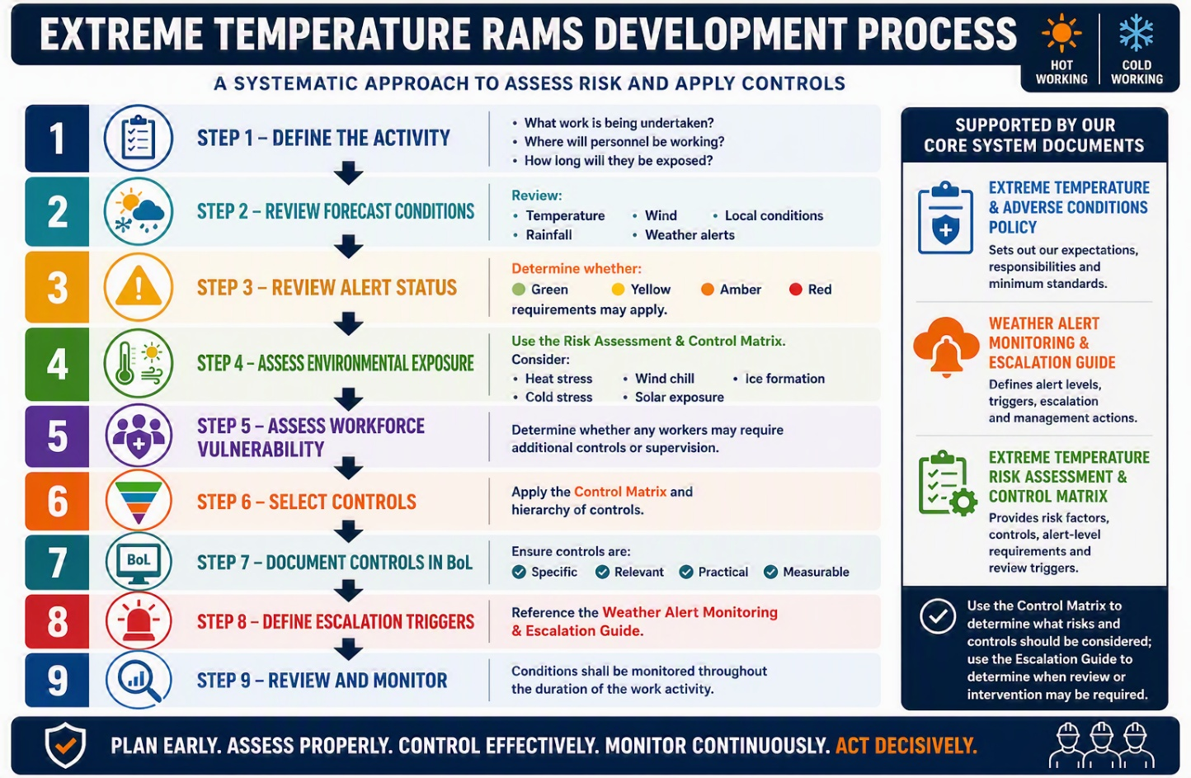

8. What Good Looks Like
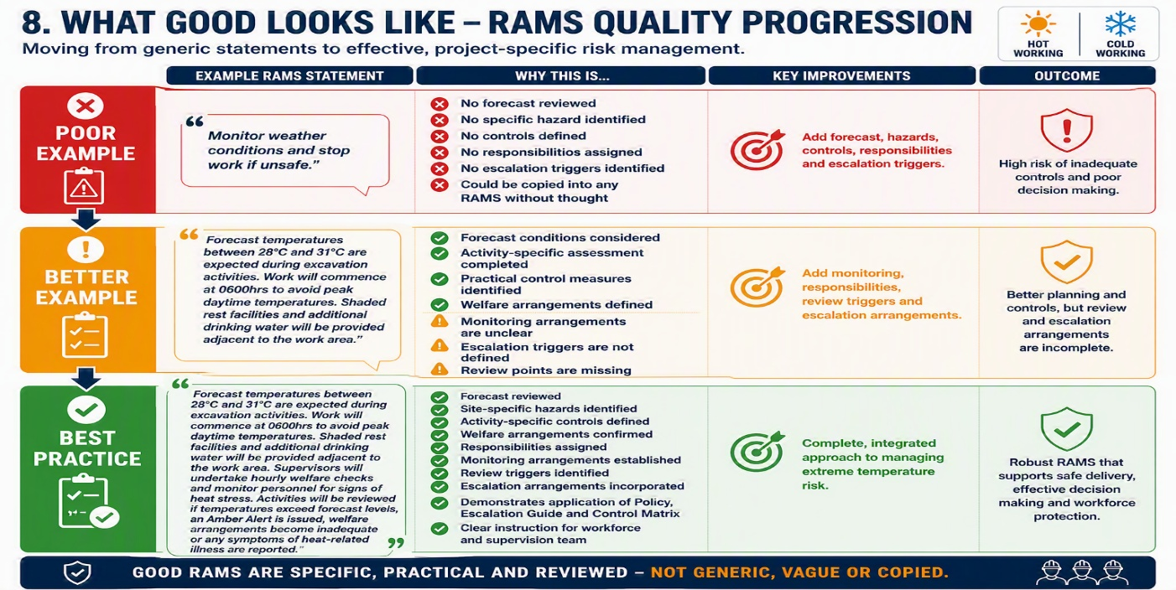

9. Common RAMS Failings
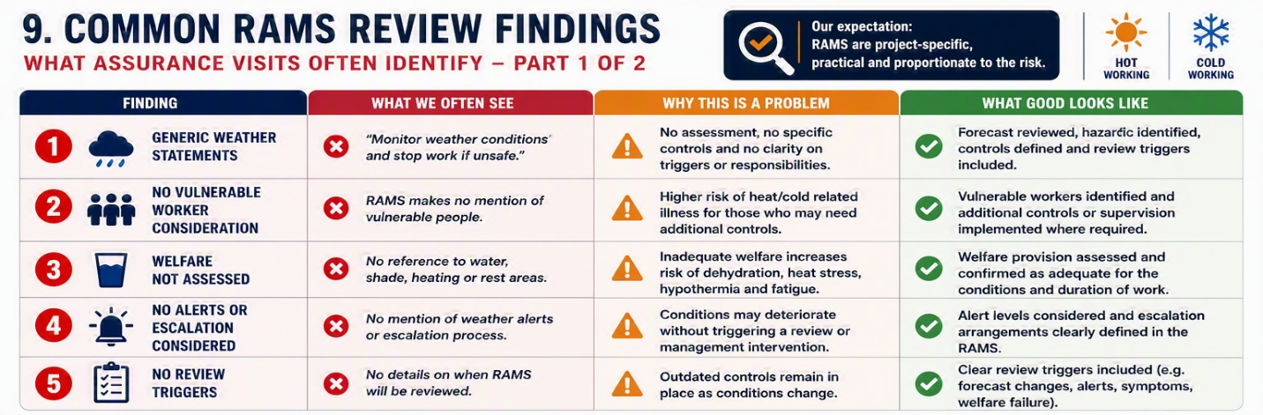
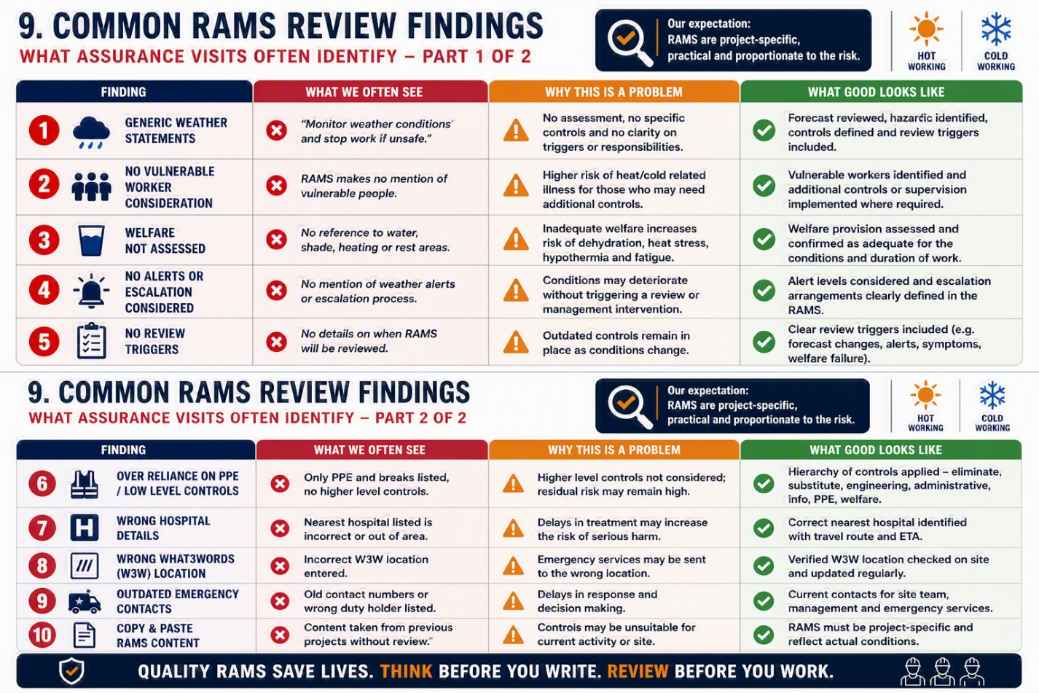

10. Extreme Temperature RAMS Quality Checklist
Before approval, the RAMS author should confirm:
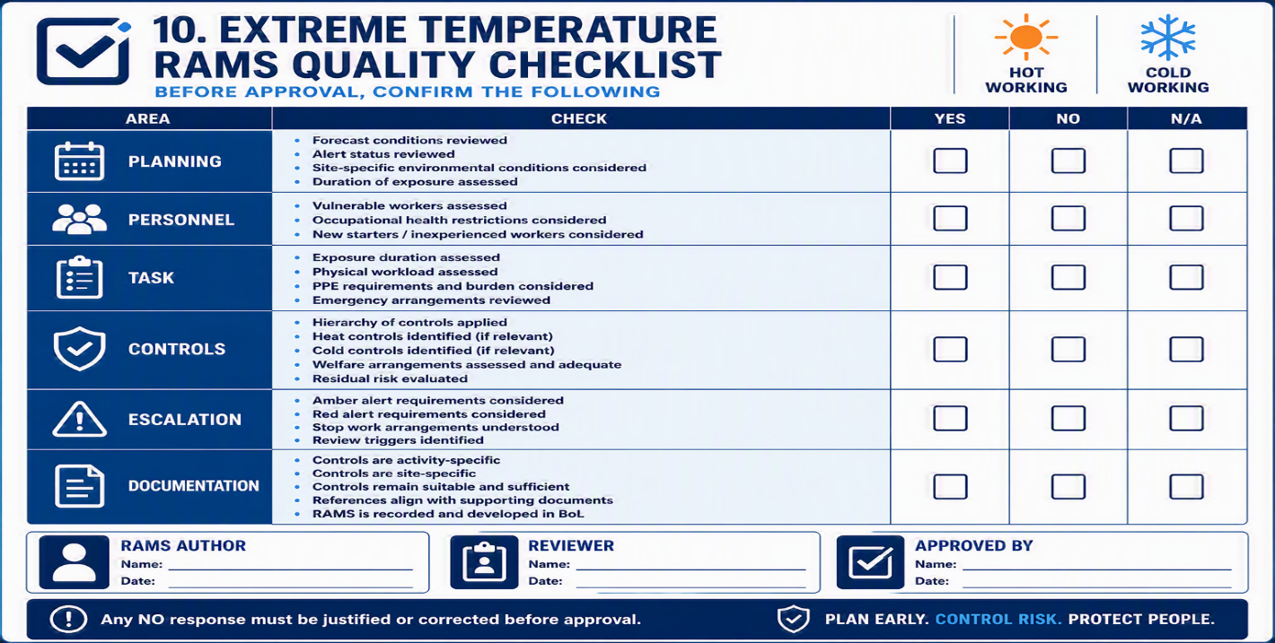

11. Review Triggers
RAMS shall be reviewed where:
- Weather alerts are upgraded.
- Forecast conditions change significantly.
- Work activities change.
- Personnel changes introduce new vulnerabilities.
- Welfare arrangements become inadequate.
- Existing controls become ineffective.
- Heat or cold-related symptoms are reported.
- An incident or near miss occurs.
- Site management considers conditions to have deteriorated.

Review triggers should be documented within the RAMS and communicated to the workforce during briefings.

12. Key Principle
The purpose of a RAMS is not simply to document a task.
Its purpose is to demonstrate that foreseeable risks have been identified, assessed and controlled before work begins.
Extreme temperature and adverse weather conditions are foreseeable hazards that require active planning, competent assessment and continual review.
Evidence of consideration of all factors is key to a robust and legally defensible set of RAMS.
