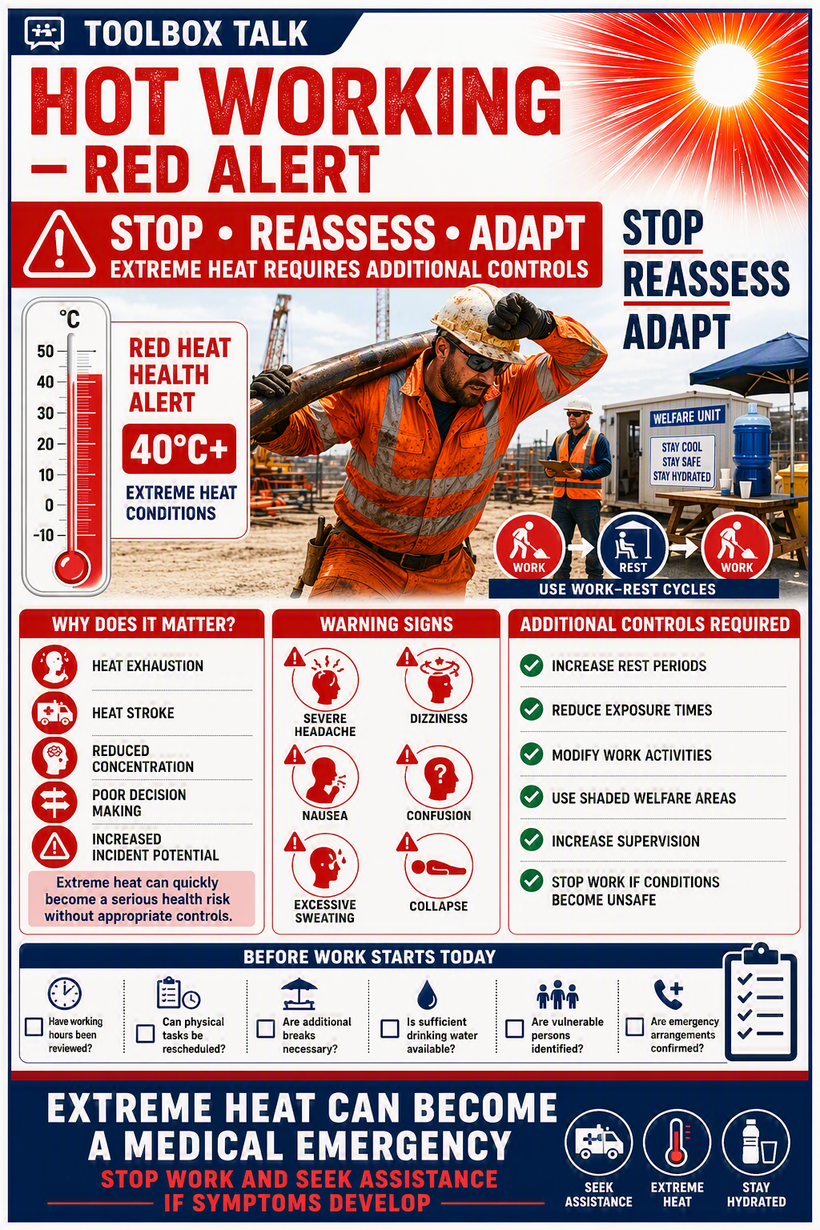


RED HEAT ALERT TOOLBOX TALK RECORD

Topic
Hot Working – Red Alert

Reference
TBT-EXT-TEMP-HOT-RED

Date

Site

Project

Delivered By

Briefing Duration

Key Messages Discussed
☐ Effects of hot weather on safety and wellbeing
☐ Importance of hydration
☐ Recognition of heat stress symptoms
☐ Welfare arrangements
☐ Dynamic risk assessment requirements
☐ Individual responsibilities
☐ Reporting concerns

Name | Signature

