2026
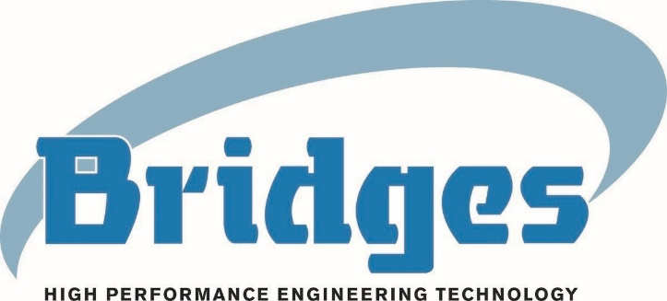
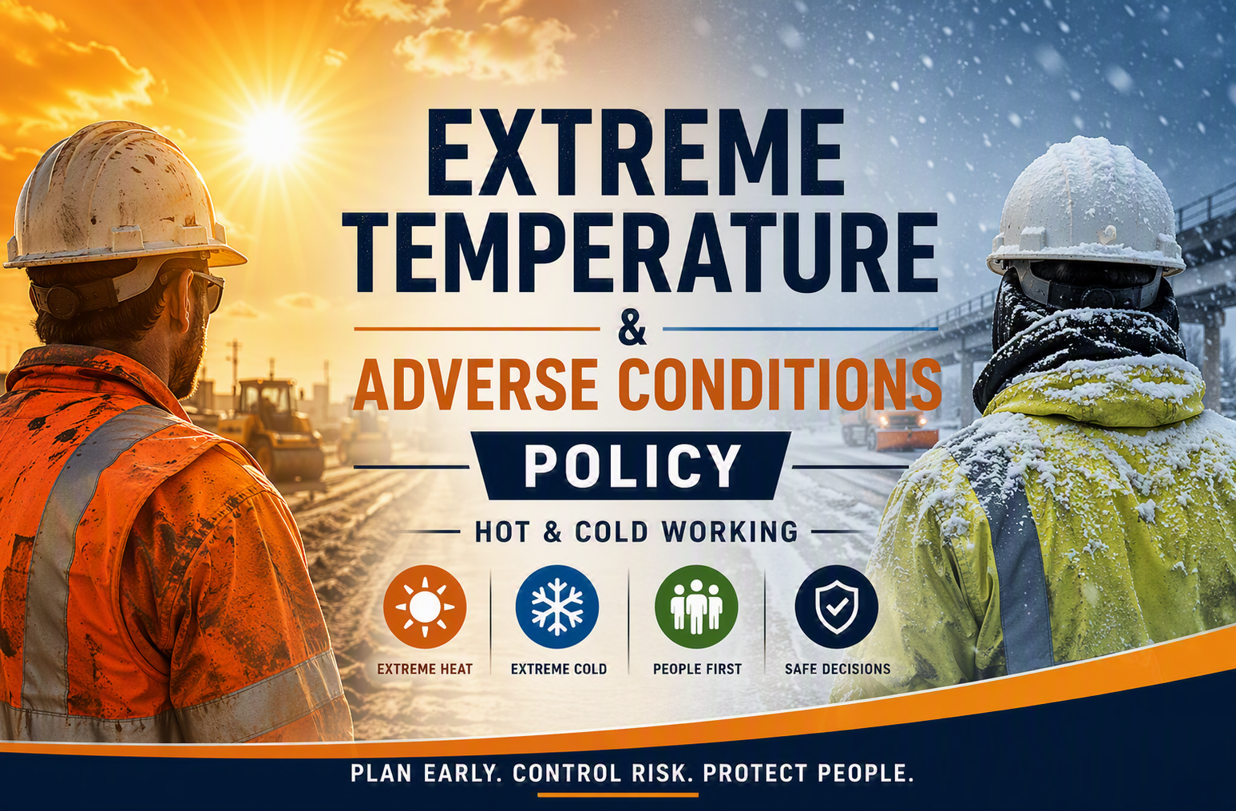

1. Introduction
Bridges recognises that extreme temperatures, whether heat or cold, represent a significant and foreseeable risk to health, safety, and operational performance. These conditions are not matters of discomfort but present real physiological hazards, including heat stress, heat stroke, hypothermia, cold-related injury, fatigue, and impaired decision-making.
In parallel, adverse weather conditions can affect not only work activities but also the ability of employees to travel safely, access sites, and return home without unnecessary risk.
This policy establishes a clear, integrated approach to managing both the physical risks of working in extreme temperatures and the wider operational and behavioural decisions required during adverse conditions. It sets out how Bridges will plan, assess, control, and, where necessary, restrict or stop work to ensure that risks are reduced so far as is reasonably practicable.
The increasing frequency and severity of extreme weather events associated with climate change means that heat, cold and adverse weather can no longer be treated as exceptional or unforeseeable events. Bridges will therefore manage thermal and weather-related risk as part of normal business resilience, project planning and operational decision-making, ensuring that foreseeable conditions are identified early and that proportionate controls are implemented before exposure occurs.
This document aligns with the requirements imposed by the following principal legislation.
- Health and Safety at Work etc. Act 1974 (HSWA)
- Management of Health and Safety at Work Regulations 1999 (MHSWR)
- Workplace (Health, Safety and Welfare) Regulations 1992

2. Policy Statement
Bridges will adopt a proactive and structured approach to managing extreme heat and cold. Work will be planned and controlled, not simply reacted to, with decisions taken early based on credible information and clear escalation criteria.
The Company will ensure that suitable and sufficient risk assessments are in place, that appropriate control measures are implemented, and that welfare arrangements are proportionate to the level of risk. At the same time, the business recognises that no activity should proceed where the risk to employees, whether during work or travel, cannot be adequately controlled.
Employees are expected to exercise judgement and take reasonable care for their own safety and that of others, including recognising when conditions make work or travel unsafe.

3. Scope
This policy applies to all employees, agency workers and subcontractors across all Bridges operations. It covers both extreme heat and extreme cold, including associated factors such as humidity, wind chill, solar radiation, ice, and snow. It applies equally to site-based activities, travel to and from work, and business-critical operations.

4. Legal & Compliance Framework
Bridges has a legal duty to protect the health, safety and welfare of employees and others who may be affected by its work activities. This includes the duty to identify foreseeable risks arising from temperature, weather and environmental conditions; assess those risks in a suitable and sufficient manner; and implement controls that reduce risk so far as is reasonably practicable. The absence of a fixed maximum workplace temperature does not remove the need to assess and control heat stress, cold stress, fatigue, welfare, supervision, travel and emergency arrangements where these risks are reasonably foreseeable.
This policy should be read alongside Bridges’ RAMS arrangements, welfare standards, emergency arrangements, occupational health processes and any client or site-specific requirements. Where client requirements set a higher standard, or where site conditions create a higher level of risk, the more protective standard must be applied.

5. Planning, Risk Assessment and Decision-Making
All work that may be affected by extreme temperature or adverse weather must be supported by a suitable and sufficient risk assessment, integrated into the RAMS process. This assessment must consider environmental conditions, task demands, duration of exposure, PPE requirements, and workforce vulnerability.
Risk assessments must consider the combined effect of forecast conditions, actual on-site conditions, work intensity, duration of exposure, PPE burden, humidity, solar gain, wind chill, night-time temperature recovery, access and egress, lone working, worker vulnerability, emergency response capability and the adequacy of welfare provision. The assessment must not rely on temperature alone, as the risk to health will often be determined by the interaction between environmental conditions, the nature of the task and the ability of the worker to recover.
Planning must extend beyond the work activity itself and include whether the work should proceed at all. This includes consideration of forecast weather conditions, travel risks, access limitations, emergency arrangements, and the ability to maintain adequate supervision and welfare.
Where severe conditions are forecast, decisions must be made in advance regarding modification, postponement, or suspension of work. This reflects the principle that risk is best controlled before exposure occurs, rather than during deteriorating conditions.

6. Managing Working in Extreme Heat
Exposure to high temperatures can lead to dehydration, heat exhaustion, heat stroke, reduced concentration and impaired decision-making, all of which increase the likelihood of error and incidents. Heat stroke is a medical emergency and may be fatal if not recognised and acted upon promptly.
The management of heat risk must focus on reducing both exposure and physiological strain. This includes adjusting working hours to avoid peak temperatures, reducing task intensity, and implementing task rotation where appropriate. Adequate hydration is critical, with a clear expectation that workers drink regularly rather than relying on thirst. Welfare arrangements must include access to cool drinking water, shaded or cooled rest areas, and sufficient recovery time.
Clothing and PPE must be appropriate to the conditions, balancing protection with breathability, and incorporating sun protection where required. Supervisors must actively monitor for early signs of heat stress and intervene promptly, with a clear expectation that work will be stopped where symptoms are identified.
Worker understanding is critical, and all personnel must recognise the importance of early reporting and intervention.
Where heat risk is elevated, particular attention must be given to physically demanding work, enclosed or poorly ventilated locations, work in direct sunlight, work involving impermeable or heavy PPE, and activities where stopping mid-task may introduce additional risk. Supervisors must ensure that work/rest arrangements, hydration, shaded recovery, first aid response and escalation arrangements are confirmed before work starts and reviewed as conditions change.

7. Managing Working in Extreme Cold
Cold environments present risks including hypothermia, frostbite, reduced dexterity, and increased slip hazards associated with ice and snow.
Cold risk must be managed through careful control of exposure duration and environmental protection. Work should be organised to limit prolonged exposure, with task rotation and scheduling aligned to minimise time spent in the most severe conditions.
Appropriate clothing is essential and must include layered thermal protection, windproof and waterproof outerwear, and suitable gloves and footwear. Welfare provision must include access to heated shelters, warm drinks, and facilities to dry clothing, recognising that wet conditions significantly increase cold risk.
Supervision must include active monitoring of individual condition, particularly for those more vulnerable to cold stress. Surface conditions must also be controlled through gritting, clearance, and safe access arrangements to prevent slips and falls.
As with heat, work must not continue where the level of risk cannot be effectively controlled
Cold weather controls must also address the wider hazards created by reduced visibility, reduced manual dexterity, delayed reaction times, frozen or slippery surfaces, wind chill, wet clothing, safe driving, and the potential for plant, equipment and materials to behave differently in low temperatures. Where cold exposure may affect critical tasks, manual handling, access, rescue or emergency arrangements, the work must be reassessed before it proceeds.

8. Adverse Weather, Travel and Attendance
The Company recognises that extreme weather conditions may affect an employee’s ability to travel safely to and from work. Employees are expected to make reasonable efforts to attend work; however, they must not place themselves at unnecessary risk in doing so.
Where employees are unable to attend due to severe conditions, they must inform their manager at the earliest opportunity. Managers will determine appropriate arrangements, including home working where feasible, alternative duties, annual leave, or other agreed arrangements.
Decisions regarding early closure of sites or release of employees will be made based on risk, taking into account weather severity, travel conditions, and operational requirements.
For business-critical roles, additional arrangements such as transport or local accommodation may be implemented where necessary to ensure safe continuity of operations.

9. Escalation, Triggers and Work Intervention
Bridges will adopt a structured escalation approach to ensure that responses to extreme conditions are consistent and timely. Conditions will be monitored continuously using reliable sources such as weather forecasts and on-site observations.
As conditions escalate, controls will be increased, working methods adjusted, and, where necessary, activities reduced, modified, or stopped. The key principle is that work will not continue simply to maintain programme where risk has become unacceptable.
Escalation decisions must be visible, documented, and based on clear reasoning, ensuring that supervisors and managers act decisively and consistently.
Alert / Condition | Expected Management Response
Amber Weather-Health Alert or Amber Met Office Warning | Formal review of planned work, confirmation of enhanced controls, supervisor briefing, welfare check, communication to affected teams and subcontractors, and documented management decision where work continues, is modified or is postponed.
Red Weather-Health Alert or Red Met Office Warning | Presumption that non-essential work will be suspended, postponed or significantly modified unless a documented senior management decision confirms that the work is essential and can proceed safely with effective controls, supervision, welfare and emergency arrangements in place.
Weather alerts and warnings are an input into risk assessment and decision-making, not a substitute for local judgement. Site-specific conditions may require escalation even where no formal Amber or Red alert has been issued, particularly where heat, cold, access, travel, confined locations, PPE, fatigue or vulnerable workers create a higher local risk profile.

10. Management Decision Records
Where work is continued, modified, suspended, postponed or restarted during Amber or Red alert conditions, or where site conditions create an equivalent level of risk, the decision must be recorded. The record must identify the relevant alert or site condition, the activity affected, the decision made, the person accountable for the decision, the controls relied upon, any residual risk, the communication issued to the workforce and the point at which the decision will be reviewed.

11. Welfare as a Critical Control
Welfare is recognised as a primary control measure in managing extreme temperatures, not a secondary consideration. Provision must be appropriate to the level of risk and include access to drinking water, suitable rest facilities, and facilities to change or dry clothing.
The adequacy of welfare must be reviewed continuously, particularly as conditions change, and deficiencies must be addressed without delay.

12. Communications, Toolbox Talks and Briefings
Clear communication is essential during periods of extreme heat, extreme cold or adverse weather. Managers must ensure that relevant alerts, expected impacts, control measures, escalation routes and any changes to work arrangements are communicated promptly to supervisors, employees, agency workers and subcontractors. Where Amber or Red alerts are issued, or where local site conditions create equivalent concern, a focused toolbox talk or site briefing must be delivered before affected work proceeds.
Communications must be practical and unambiguous, setting out what is changing, why the change is required, who has authority to stop or modify work, what symptoms or concerns must be reported, and how workers should escalate issues if conditions deteriorate. Infographics, trigger-point summaries and briefing templates should be used to support consistent understanding across the business.

13. Roles and Responsibilities
Senior leaders are responsible for ensuring that this policy is implemented consistently and that operational delivery does not override health, safety and welfare requirements during extreme temperature or adverse weather events.
Managers are responsible for ensuring that work is properly planned, that risk assessments are in place, and that appropriate decisions are made regarding the continuation, modification, or suspension of activities.
Supervisors are responsible for implementing controls on site, monitoring conditions, and intervening at an early stage where risks increase or workers show signs of distress.
The SHEQ function is responsible for providing competent advice, reviewing the effectiveness of arrangements, supporting the development of risk assessment tools and briefing materials, and identifying learning where controls, decisions or communications require improvement.
Employees are responsible for taking reasonable care of their own safety, following control measures, and reporting concerns or symptoms promptly.
Subcontractors are required to comply with this policy and any site-specific controls, including participation in briefings, provision of suitable welfare for their workforce where applicable, and cooperation with Bridges management decisions during adverse conditions.

14. Training and Awareness
Managers, supervisors and employees must be made aware of the risks associated with extreme heat, extreme cold and adverse weather, including the symptoms of heat stress, heat exhaustion, heat stroke, hypothermia and cold-related injury. Training and awareness arrangements must also cover the use of weather alerts, the application of risk assessment controls, welfare expectations, vulnerable worker considerations, stop-work authority and the need to record significant management decisions.

15. Climate Resilience, Monitoring and Review
Bridges will review its arrangements for extreme heat, extreme cold and adverse weather on a seasonal basis and following significant events. Reviews should consider the adequacy of welfare provision, the effectiveness of communication, the suitability of risk assessments, the consistency of management decisions, the availability of supervision, and any learning identified through incident reports, near misses, assurance activity or workforce feedback.

16. Key Principle
Bridges will manage extreme temperatures and adverse conditions through a simple but robust principle:
Plan early, assess properly, implement effective controls, monitor continuously, and act decisively before harm occurs.

17. Supporting Documents and Tools
Extreme Heat Risk Assessment
Extreme Cold Risk Assessment
Heat Infographic and Trigger Points
Cold Infographic and Trigger Points
Weather Alert Monitoring and Escalation Guide
Toolbox Talk Template
Management Decision Record
Adverse Weather Communication Template
Risk and Method Statement Procedures
Model Suggested Control Measures – Hot and Cold Working

