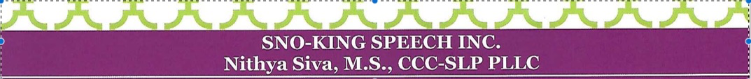

**Social skills groups for adolescents/young adults**

**What**: evaluation and structured intervention by an experienced SLP to teach social skills required for success at school, work and life

**Who**: young adults **ages 14-40 years** old with developmental disabilities.

All levels of communication abilities encouraged to apply.  Grouping will be based on age, common abilities and interests.

**When**: every Friday for six weeks, late January to early March, 2019

8-9:15 a.m. or 4:30-5:45 p .m.

**Where**: Bothell Country Village, Museum of Special Art

**Other details**: Four enrollees per group maximum (three minimum required to run the group). Parents of participants are invited to participate in a free, SLP-facilitated 20-minute training each Friday during the six weeks to facilitate carryover and address concerns/questions. This will occur at the same location in the same window of time as the group itself.

Topic(s) covered will depend on abilities and interests of those who want to participate. A phone consultation is required prior to enrollment if not enrolled in a Sno-King Speech Inc. 1:1 or group program in 2018. Our goal is to individualize the sessions to meet the needs of participants.

If a group is not appropriate at this time based on interested participants and/or needs, 1:1 sessions may be recommended.

**Cost**: $50 for an initial phone consultation; $750 for six group sessions. Payment due in full January 25, 2019. You will be provided with an insurance compliant invoice at the end of the six-week session. Only one absence can be made up in a future social skills group offering. No refunds for absences.

Please contact Nithya Siva at Sno-King Speech to enroll.

