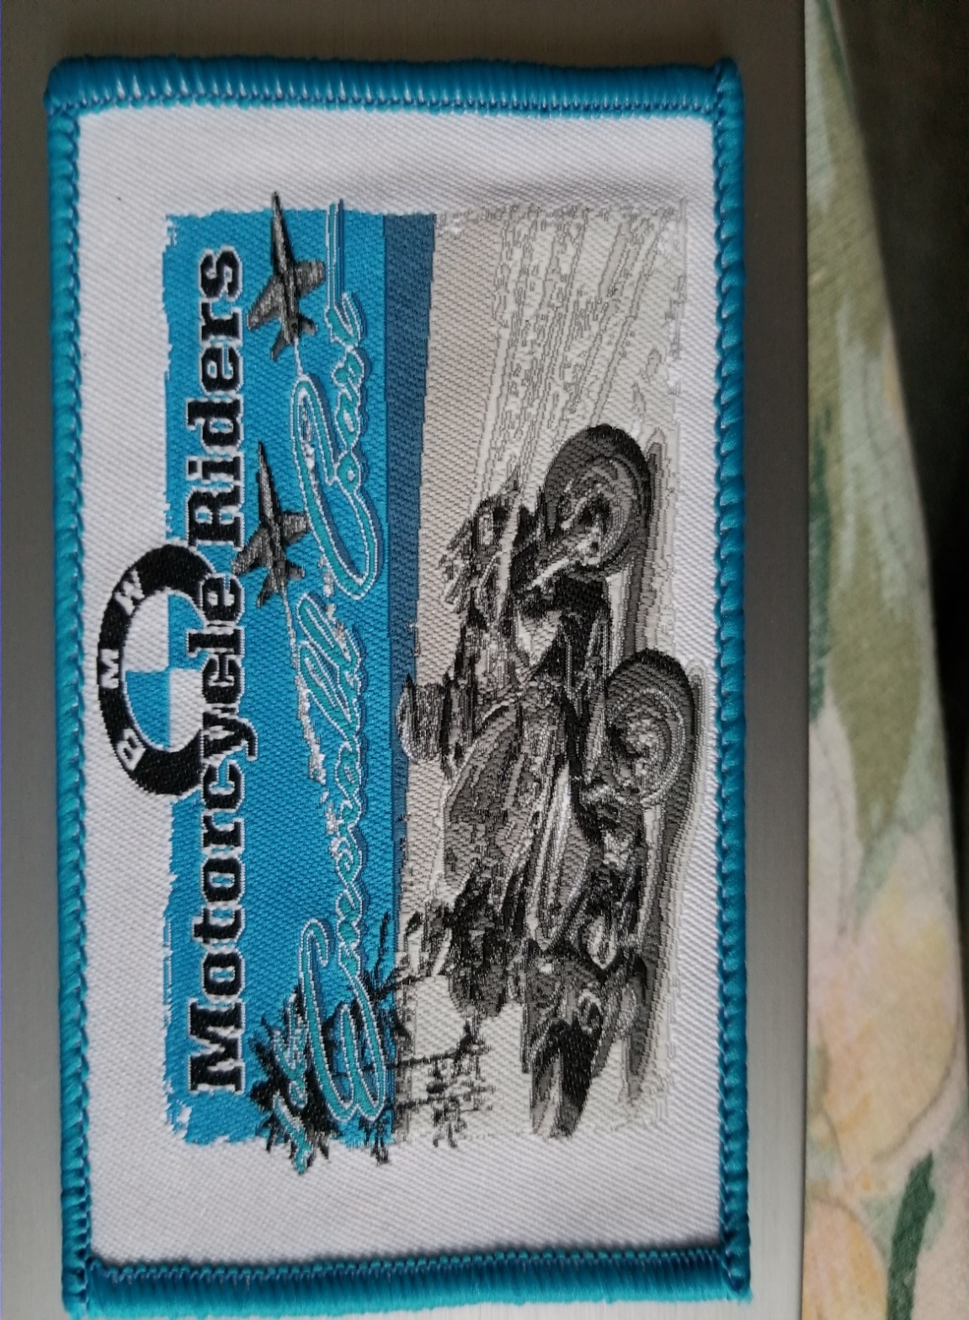

BBQ Cookout & Silent Auction @ Adventure Motorsports of NW Florida Date: 10/27/18. Time: 11:00am to 4pm.

* Event is to support the Patriot Guard Riders efforts to provide funds for the education of children of our fallen military heroes.
* \*Cost of a lunch is $15.00 a plate, served between 11am-2pm. Door prize ticket given for each lunch purchased.
* 3pm the Silent Auction begins. We are looking for donations of new and/or unique items for the auction.
* The Patriot Guard Riders is a 501 (c)3, tax deductible organization.
* Please support our effort and share lunch and the auction with us!
* Support our Military!!
* Live music provided during the BBQ.
* For more info, please contact Ron Winn @ 850.712.8935