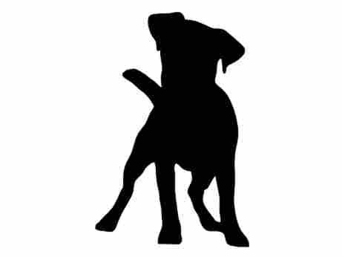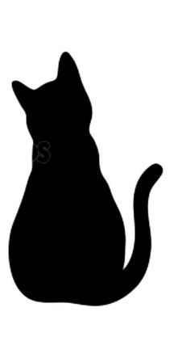**All Paws Rehab - General Data Protection Regulation (GDPR)**

**Personal information collection**

As of spring 2018 changes have been made to the Data Protection Act (1998), to the General Data Protection Regulation (GDPR). These changes ensure you as a client have more control over your personal data.

**What Is Personal Data? (This does not include your animal’s data)**

Personal data is the information that relates to your identification as a person. For example:

Name

Age

Gender

Contact details

**Why Do I need your personal information?**

All Paws Rehab will only collect and hold information that is necessary to provide physiotherapy treatment to an animal. This includes contact details of the owner/guardian and vet.

In order for me to contact your veterinary surgeon I need information that allows you to be identified on their data base as well as my own, this would be your surname and address. I require a contact number or email so I can arrange appointments with you and to keep you up to date on your pet’s treatment plans and progress.

**Data Retention**

Please note that the RCVS advise record keeping for a minimum of 7 years.

**Third party**

All data collected is confidential and will not be shared with any third party.

All Paws Rehab may however need to discuss some treatment with the vet, we will also provide your vet with a written report on our clinical findings and treatment plan.

In some cases where the animal is receiving care from paraprofessionals such as hydrotherapist or massage therapist, it may be required that current treatment information is shared with these services to ensure optimum continuity of care.

We will never sell, distribute or lease your personal information to third parties.  We will only pass on your personal information if we are required by law to do so.

If you wish to have your data removed, as you no longer require treatment services, you can contact All Paws Rehab at any time via:

**email: Helen@allpawsrehab.com**

***or***

**Telephone: 07971 2827485**

You will be sent confirmation that this has been done by either text or email.

**Please carefully read the statements below, and tick where appropriate:**

[ ] I give consent to All Paws Rehab to obtain and hold my contact details and other necessary data/information needed to provide physiotherapeutic treatment to my animal for a minimum of 7 years.

[ ] I am happy for All Paws Rehab to share my animals records with other veterinary professionals involved directly with my animals care. These include paraprofessionals such as hydrotherapists, massage therapists etc.

[ ] I am happy to receive text message appointment reminders and rescheduling appointments from All Paws Rehab.

[ ] I understand that All Paws Rehab will contact me via email for all necessary correspondence with regards to services and invoices.

[ ] I understand I can request removal of such data/information at any time.

**Students**

From time to time there may be students present at All Paws Rehab, Although they will have access to look at your notes, to allow them a better understanding of your pets treatment and care, at no point will they be allowed to take your notes from the premises or contact you.

[ ] I understand and am happy for students to review my pets file

**Website and Social Media**

We may take photographs or videos of your pet receiving treatment, from time to time, do you consent for us to use these for our website and social media.

[ ] I understand and am happy for my photographs to be use as stated above

Signed…………………………………………………………. Date………………………

Print name: …………………………………………………