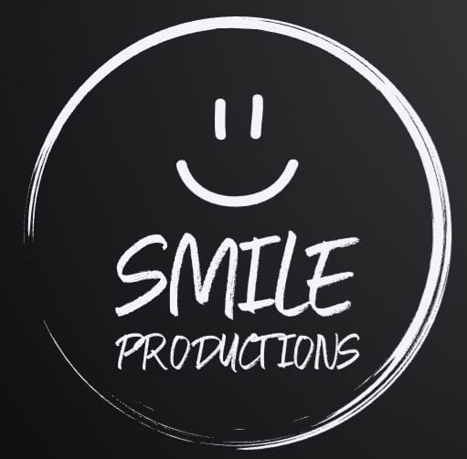

**SMILE PRODUCTIONS CIC**

**Environmental Policy**

At Smile Productions CIC, we are committed to promoting a sustainable and environmentally responsible approach in all aspects of our operations. This Environmental Policy outlines our commitment to minimising the environmental impact of our activities, with a specific focus on amateur dramatics, theatre productions and catering to additional needs.

1. Environmental Awareness:

We recognise the importance of environmental awareness and will strive to educate our volunteers, performers and audience members about the significance of sustainability and the role they can play in reducing our environmental footprint.

2. Energy Efficiency:

We will actively seek ways to improve energy efficiency in our facilities, including theatres and rehearsal spaces. This includes using spaces that have energy-efficient lighting, heating, ventilation and air conditioning systems to reduce overall energy consumption.

3. Waste Reduction

We are committed to minimising waste generation by promoting the use of reusable and recyclable material in our productions. We will encourage the separation of waste at source and work towards implementing recycling programs for props, costumes and other materials used in our performances.

4. Sustainable Practices in Productions:

In all amateur dramatics and theatrical productions, we will prioritise the use of sustainable and eco-friendly materials. This includes sourcing costumes and props responsibly, as well as exploring alternative and recycled materials whenever possible.

5. Accessibility and Inclusivity for Additional Needs:

Recognising the importance of inclusivity, we are committed to providing an accessible and welcoming environment for individuals with additional needs. This includes ensuring that our facilities comply with accessibility standards, offering assistance when required and providing inclusive programming that caters to diverse audiences.

6. Transportation:

We will encourage the use of public transportation, cycling or walking for commuting to our facilities and events. Additionally, we will explore the possibility of carpooling initiatives for rehearsals and performances to reduce the carbon footprint associated with travel.

7. Continuous Improvement:

We will regularly review and assess our environmental performance, seeking opportunities for improvement. This may include adopting new technologies, staying informed about sustainable practices and collaborating with like-minded organisations to share best practices.

8. Compliance:

We will comply with all relevant environmental laws, regulations and standards, striving to exceed minimum requirements wherever possible.

By implementing and promoting these environmental initiatives, Smile Productions CIC aims to be a responsible steward off the environment while fostering creativity, inclusivity and enjoyment for all involved in our amateur dramatics and theatrical productions.

This policy will be communicated to all of our volunteers and cast members to help encourage their active participation in achieving our environmental objectives.

**Declaration**

On behalf of Smile Productions CIC I, Mitchell Carter, hereby agree to oversee the implementation of and upholding of the Environmental Policy:

MITCHELL CARTER

Printed:

MITCHELL CARTER

Signed:

21/02/2025

Date:

21/02/2026

Next Review date: