Hercule Audition
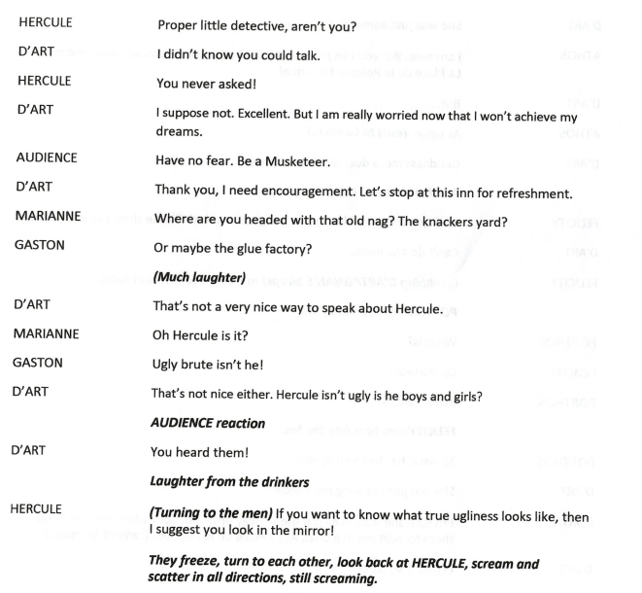
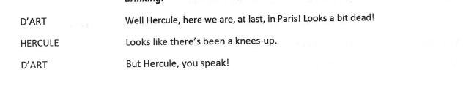
Song – Burning Love

