Athos/Porthos/Aramis Audition
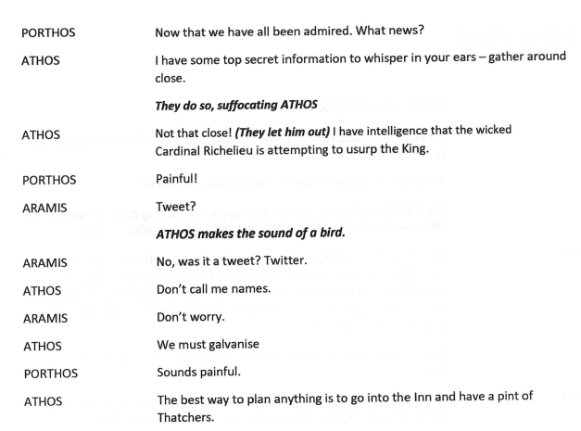
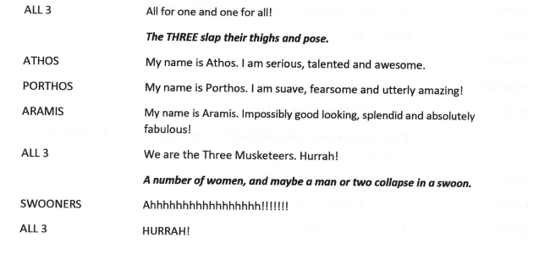
Song – Swords of 1000 Men

