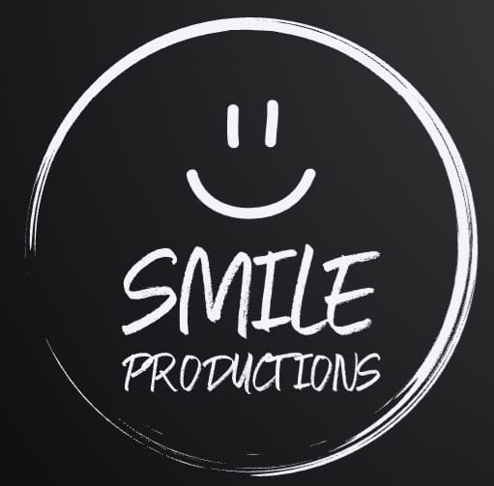

**SMILE PRODUCTIONS CIC**

**Equality, Diversity and Inclusion Policy**

Smile Productions CIC is committed to promoting equality, diversity and inclusion in all aspects of its operations. We recognise the value and importance of creating an inclusive environment that respects the rights and dignity of every individual, irrespective of their background, characteristics or abilities.

This policy applies to all volunteers, contractors and participants involved in Smile Productions CIC activities, including but not limited to amateur dramatics, and covers all areas of our operation.

1. Equal Opportunities:

* Smile Productions CIC is dedicated to providing equal opportunities for all individuals, regardless of race, sexual orientation or any other protected characteristic.
* All individuals will be treated fairly and with respect throughout their engagement with Smile Productions CIC.

2. Amateur Dramatics:

* Smile Productions CIC is committed to promoting diversity and inclusion in our amateur dramatic activities.
* Casting decisions, roles and opportunities will be determined based on merit, skill and ability, without discrimination.

3. Additional Needs:

* Smile Productions CIC acknowledges and respects the diverse needs of individuals with disabilities or additional needs.
* We are committed to making reasonable adjustments to ensure that everyone can participate fully in our activities.

4. Safeguarding:

* Smile Productions CIC is dedicated to creating a safe and secure environment for all participants, especially vulnerable individuals such as children and adults at risk.
* All volunteers will receive appropriate training on safeguarding procedures and any concerns will be promptly addressed and reported following our safeguarding policy.

Implementation

1. Training and Awareness

* Smile Productions CIC will provide training to all of our volunteers and contractors to increase awareness of equality, diversity and inclusion issues.
* Regular training updates will be provided to ensure ongoing understanding and commitment.

2. Communication

* Smile Productions CIC will communicate it’s commitment to equality, diversity and inclusion through various channels, including it’s website, official documents and in-person interactions.

3. Monitoring and Review

* Smile Productions CIC will regularly monitor the implementation of this policy and assess its effectiveness.
* Feedback from participants and stakeholders will be considered in the ongoing review and improvement process.

4. Responsibility:

* The Smile Productions CIC board of Directors are responsible for the overall implementation and effectiveness of this policy.
* All volunteers have a responsibility to adhere to this policy and contribute to creating an inclusive environment.

Smile Productions CIC is committed to creating a diverse, inclusive and equal environment where everyone is treated with dignity and respect. This policy will be reviewed regularly to ensure its continued relevance and effectiveness.

**Declaration**

On behalf of Smile Productions CIC I, Mitchell Carter, hereby agree to oversee the implementation of and upholding of the Equality, Diversity and Inclusion Policy:

MITCHELL CARTER

Printed:

MITCHELL CARTER

Signed:

21/02/2025

Date:

21/02/2026

Next Review date: