**St. Teresa’s Episcopal Church**

**Monday, April 6th, 2020**

**7:00 P.M.**

**Evening Prayer, Rite 2**

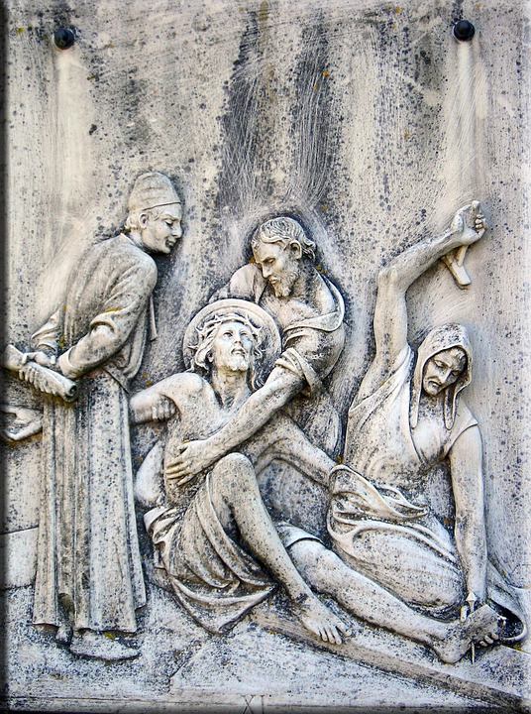

**5725 Fords Road**

**Acworth, Georgia 30101**

**770-590-9040** **www.stteresasacworth.com**

Salutation BCP p109

Short scripture BCP p 109-110

Prayer for Light (Lenten Collect) BCP p111

*Phos hilaron* BCP p 112

Confession of Sin BCP p 116

Invitatory and Psalter BCP p 117

Psalm 69:1-23 BCP p 679

The Lessons

Lamentations 1:1-2, 6-12

2nd Cor. 1:1-7

Mark 11:12-25

The Sermon The Rev Canon Dr A. Gordon Okansanya

The Creed BCP p120

The Prayers: BCP p121

The Lord’s Prayer

Suffrage set B BCP p 122

The Collect of the Day:

Almighty God, whose most dear Son went not up to joy but first he suffered pain, and entered not into glory before he was crucified: Mercifully grant that we, walking in the way of the cross, may find it none other than the way of life and peace; through Jesus Christ your Son our Lord, who lives and reigns with you and the Holy Spirit, one God, for ever and ever. *Amen.*

Intercessory Prayer(s) BCP p 124-125

The General Thanksgiving BCP p 125

A Prayer of St. Chrysostom BCP p 126

Concluding Prayer BCP p126