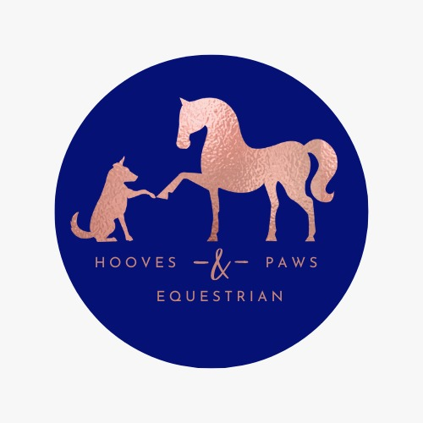

HOOVES & PAWS EQUESTRIAN CENTRE
PONY PARTY BOOKING FORM

Date Required..............................................
NB: WE MAINLY RUN OUR PONY PARTIES ON A SATURDAY FROM 12 NOON/2PM. HOWEVER, WE ARE FLEXIBIBLE WITH SOME DATES, SUBJECT TO AVAILABILITY.

Name of Party Child……………………………………………

Age ………………………. DoB ……………………….Boy/Girl……………………….

Contact Details
Name.........................................................
Tel ...........................................................
Email …………………………………………………………………………………….…..
Address……………………………………………………………………………………….
……………………………………………….............................................
Postcode……………………………………

How many children for Party (max 12/min 8):...............................

Info of each child attending party:
NAME | AGE | HEIGHT | WEIGHT  (stones) | RIDING ABILITY  (basic, general)
1
2
3
4
5
6
7
8
9
10
11
12

Party Food Options:

Sandwiches & Cake tray serves Max 12. (All food is freshly home-made).
Selection of Sandwiches on a mix of White and Brown Bread and Crisps.

Please choose food options for catered party Sandwiches:
White / Brown Mixed Fillings (pick two):

Cheese
Jam
Cream Cheese
Ham
Honey

Dessert:
Small selection of Cakes OR Yogurts

Juice:
Diluting (orange & blackcurrant),

NB: Please alert of us any dietary requirements in advance.

PRICE PACKAGES/PRICES

PACKAGES:

PARTY OF 12 - £420
PARTY OF 8 – £280
EXTRAS ADDED - £35 PER CHILD
(extras added no later than 2 days before party)

£50 deposit required on Booking, Non-refundable.
(Please phone to check availability before sending in deposit)
Settlement required 1 week in advance via:
Cheque / Debit card / Credit card / Bank Payment

Please make cheques payable to: Hooves & Paws Equestrian Centre
Sort Code Account No Payment Ref: party/date/time

Amount: £....................................................
Date............................................................

Signed.............................................Name ..............................

WHAT'S INCLUDED:

- Cabin with tables/chairs - Cabin will be decorated with Banners & Party Decorations
- Picnic area – tables/chairs
- Free Parking for Party of 12 (max)
- Portable Toilet on site
- Fully Staffed NB: Adult Member from Party must be on site at all times with Children
- Hand Sanitising Area
- Food (pre arranged): Sandwiches/Crisps/Cakes/Juice (cutlery/plates/napkins)
- Indoor Arena
- Ponies with Tack / Dressing Up Props
- Riding Hats
- Dress Up Clothes
- Downloadable Party Invitations
- Party Bags / Main Birthday Cake / Candles are NOT SUPPLIED by Hooves & Paws. Please organise that in advance.

Hooves & Paws Equestrian Centre
Procedures For Pony Parties

- The parent in charge of the party must have registered all riders on the party guest list stating their name, age, height, weight and riding ability.
- The Booking form/procedures must be signed to confirm that they have been read and agreed with.
- Payment for the party is as follows. £50 non-refundable deposit to be paid upon booking of the party, the balance is due 1 week prior to the party. If a cheque sent to us is returned unpaid from the bank a £15 administration charge will apply to cover bank costs.
- Riding hats may be borrowed for the party. If the child’s own riding hat is bought they must be of the correct standard PAS015 or BSEN 1384 with a British Standards Kitemark.
- Wellies or Jodhpur boots to be worn on feet.
- By signing this you confirm that neither you nor any party guests have never made a claim against a riding school. We will at times have to touch the children in suitable places to reposition legs and hands etc. by signing you agree to this.
- We are fully staffed. However, an adult with the Party must supervise all children at all times.
- At no time must the children be left on their own or in the care of the Hooves & Paws Equestrian Centre staff.
- Please meet your guests at the Hooves and Paws Equestrian Centre Cabin (at main Car Park).
- All guests must park at the parking area beside the Cabin at Hooves & Paws Equestrian Centre.
- DO NOT enter the horse yard without an instructor present.
- Do not bring dogs on to the farm.
- No smoking at all times.
- Whilst Hooves and Paws Equestrian Centre will take all reasonable care to ensure safety of the riders it must be remembered that you may fall off. Horse Riding is a high-risk sport; if you are unable to accept this please do not ride.
- No jewellery to be worn whilst riding. This includes ear studs.
- Arms must be covered to the elbows and no shorts or 3/4 length trousers allowed.
- Long hair must be tied back. P
- Please control siblings and friends behaviour whilst watching.
- Please keep them in your sight we are a working farm and unfortunately they cannot go exploring.
- Please note that for self catering parties the room must be left as found. Catered Parties, please do not bring in food for the adults, we can provide cakes and sandwiches, see above.
- Please note that you will be charged the party admission fee to the Hooves & Paws Equestrian Centre for all children at the party
- Final numbers for the party are required at least two days before the party date. If on the day guests do not turn up you may still be charged for them – this is at the manager’s discretion.
- All parties are subject to availability
- Terms and Conditions Apply

