

Iron Thunder Motorcycle Club invites your business to the 17th Annual 5-State Run in Guymon, Oklahoma. This year we expect many more to ride and overcome nature's elements here in the Oklahoma Panhandle. We would like your business to be a part of this growing event. Participating vendors will not only be exposed to potential customers across the 5-state region but also customers from various other states.

Iron Thunder is a non-profit organization. Every year Iron Thunder donates all the proceeds from the 5-State Run to charitable organizations and families with drastic needs, such as sickness, loss due to a house fire, etc.

If you decide to showcase your business you will be able to set up your booth Friday, May 10th starting at 10:00am. The building will not be available until that time. If you are not able to set up Friday, the building will open at 6:00am the following morning. Run registration begins at 7:00am. The last bike will head out at 9:00am. Bikes will start to return at 1:00pm; however, throughout the day visitors/potential customers will pass through.

One vending space measures 10' x 10' and costs $25.00. You have the option of buying more than one space. Hopefully the mentioned information will give you an idea of what to expect. Please feel free to contact me if you have any further questions.

Do not think Saturday is your only opportunity to make money. Friday May 10, 2019, Main Street Guymon will host Guymon Outback. For only $5.00 anyone can come for burgers, beer, bands and bikes. Starting at 5:30pm Outback will take place at 5th and Main Street, Guymon, Oklahoma. Main Street Guymon has shown interest in vendors setting up business that evening. If you are interested in setting up shop Friday evening, you can contact Main Street Guymon at 580-338-6246.

Please fill out the "Exhibitor Information Sheet" and mail, along with your total amount due by April 30th, 2018. Please make check payable to Iron Thunder Motorcycle Club.

Mail completed sheet to:

Iron Thunder MC
Attn: Rose Whisennand
PO Box 10116
Texhoma, TX, 73960

If you have any further questions, you may contact Rose by phone or email.

Cell phone: (580) 518-1700
Email: dukesgram@gmail.com

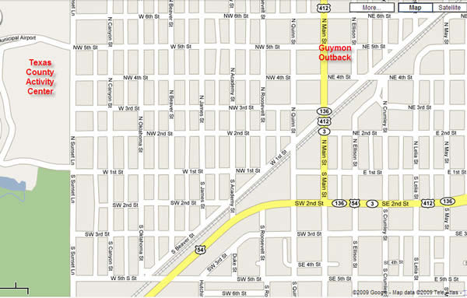
5-State Run starts and ends at the Activity Center, 5th & Sunset..
Guymon Outback held Friday night at 5:30pm, 5th & Main

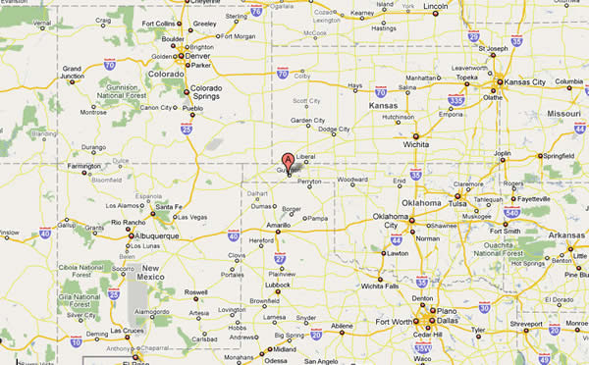
5-STATE MOTORCYCLE RUN
Exhibitor Information Sheet

The undersigned, referred to as "We" or "Exhibitor" submit our application for the reservation of display space with 5-State Motorcycle Run, at the Texas County Activity Center (5th and Sunset, Guymon, Oklahoma) for the event known as 5-State Motorcycle Run, subject to the conditions and regulations detailed below. Failure to comply with any part of this agreement will result in immediate closure of exhibitor's display and forfeiture of any and all monies paid. A deposit equal to the total amount due for the space exhibitor requests to reserve, made payable to Iron Thunder Motorcycle Club must accompany this contract. Deadline for payment in full is April 30th, 2019. Exhibitor's deposit is non-refundable.

Exhibitor Information: (Please fill out completely and legibly)

Name of Company: ____________________________________________ Phone: ________________________

Address: ____________________________________________________ Fax: __________________________

City: ______________________________________ State: ____________ Zip: __________________________

Email address: _______________________________________________________________________________

Contract Authorized By (please print) ______________________________ Title: _________________________
(Signature acknowledges review and acceptance of terms of this agreement)

Oklahoma Tax ID#

Display Size and Rental Fee (Check One)
10' x 10' _____ $25.00
20' x 10' _____ $50.00
30' x 10' _____ $75.00
40' x 10' _____ $100.00

Iron Thunder will attempt to assign spaces in order of registration, giving those who registered first preferential locations. Final decisions regarding space assignments is at the sole discretion of Iron Thunder Motorcycle Club.

The following item or items will be displayed and/or sold in the Exhibitor's space(s):

____________________________________________________________________________

____________________________________________________________________________

____________________________________________________________________________

Please mail this completed form and check made payable to Iron Thunder Motorcycle Club to:

Iron Thunder MC
Attn: Rose Whisennand
PO Box 10116
Texhoma, TX, 73960
Cell Phone: 580.518.1700
Email: dukesgram@gmail.com

