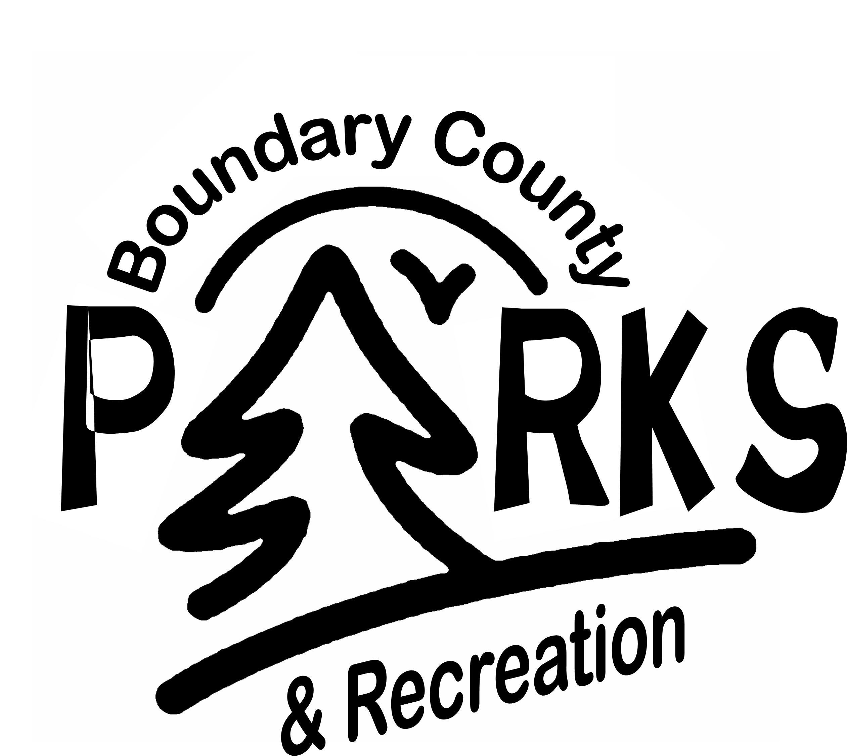

**Boundary County Parks and Recreation Sports Program**

**SPONSORSHIP INFORMATION**

Dear Sponsor:

We need sponsorships for our sports, which include: Basketball, Softball, Baseball, Flag Football, Volleyball, Tee-Ball, and Soccer. We are offering three different sponsorship levels this year.

These levels are listed below.

***BRONZE LEVEL***

$100

Team Sponsor-

A team will receive shirts with your name on the front or back.

***SILVER LEVEL***

$200

Program Sponsor- a 3 x 6 banner will be made with your business on it and displayed at ball parks from April to October and business name will be displayed on our website.

***GOLD LEVEL***

***$300***

All in Sponsor-All of Bronze and Silver Level. Plus a link from our website for your business. If you purchase this level the following year you will also receive $50 off

In order to insure delivery of team uniforms prior to the first game of the season, it is important that the shirts be ordered at least two weeks prior to the start of games. Please provide all your information in the area below. The recreation department will order your shirts. Please do not hesitate to call 208- 304-3603, if you have any questions about the program or sponsorship.

Sincerely,

Sarah Skinner

Boundary County Parks and Recreation Sports Director

**BOUNDARY COUNTY PARKS AND RECREATION SPONSORSHIP INFORMATION**

Sport Being Sponsored: **Basketball Fast pitch Baseball Babe Ruth T-Ball Flag Football Soccer Volleyball** Sponsor or Team Name

Sponsor Address City Zip

Contact Person’s Name Phone Number

If there is specific child’s team you are sponsoring please indicate the name and age. _______________________________________

Total teams sponsored at: Bronze Level ____ Silver Level ____ Gold Level ____

Total Sponsorship: $______

Please send completed form and payment to: Bo. Co. Parks and Recreation Attn: Sarah Skinner

P.O. Box 3044

Bonners Ferry, ID 83805

***\*\*Scholarship Opportunity*** – If you would like to pay the registration fee for a child who cannot afford to participate in one of our programs, please check the box. **□** We will contact you when the need arises. Thank you.