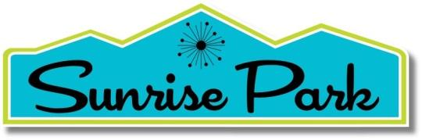

NEIGHBORHOOD ORGANIZATION

Agenda

Tuesday, September 15, 2026, 9:00 a.m. – 10:30 a.m. (PDT)
- Review and Approve the Agenda
- Approval of the Minutes of the 7/21/26
- Business

Donations - $1,750 each to Mizell and Cultural Center – short debrief.

Approve and distribute survey.

Annual Meeting- change from 3/6/27 discussion.

Discuss Fall Social – October 15th. Where?

By Law discussion

IDA-compliant – update. How is this going to be rolled out?

Board member items.
- Update Banner
- Food Bank – we should promote this more.
- Festival of Lights - upcoming
- Adjourn

