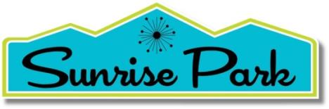
NEIGHBORHOOD ORGANIZATION
Board of Directors Zoom Meeting

September 18, 2021, 9:00 -10:30 A.M.
sunriseparkno@gmail.com

AGENDA

- Review and Approve Order of the Agenda

- Public Comments

III. Business

A. Revisit possible activities and projects given the continued restrictions

B. Modernism Week status

C. Events: Committee Report re: the 7/6/21 meeting with PS Cultural Center, Tim Rains & Eric Smith
1. CANCELLED: SPNO Social- Happy Hour and Film – 9/12/21
Volunteers – finalize the details social
Save the Date and invitation
2. COD developments
3. 2nd meeting CANCELED DUE TO ACCIDENT

D. Finance report

IV. City and ONE-PS updates

A. Status of City Events

1. National Night Out : CANCELED
2. Gay Pride Nov. 6-7: Scheduled and planned, but dependent on COVID conditions
3. Veterans Day Parade, Thurs., Nov. 11
4. Festival of Lights, Sat., Dec. 4 (Do we want to request to wrangle a balloon?)

B. ONE-PS – Meetings and Informative Speaker Series

1. Membership Meetings: 2nd Tuesdays, 5:00, Zoom and/or PS Pavolion
September 14 (Zoom); October 12, November 9, December 14.
Sept. Policy Recommendation to City Council: Amplified Music at Public Events

2. Talk of the Town (TOTT)

CV's Independent Publishers: Building Personal Connections: Mark Talkington, Editor, the Palm Springs Post and Jimmy Boegle, Editor, the Coachella Valley Independent, Sept, 21, 5:30 – 6:30 (Zoom)

Conserving Water During a Drought, DWA Ashley Metzger, October 19, 5:30 – 6:30

V. Proposed Next Board Meeting 11/13/21, 9:00 a.m. (Kathy will be on a plane on Nov. 20

VI. Non-Agenda Board Member Comments

VII. Adjourn

