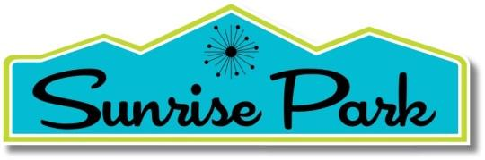

**NEIGHBORHOOD ORGANIZATION**

SPNO Board Meeting

Tuesday, June 3, 9:00 a.m. – 10:30 a.m. {PDT)

1. Review and Approve the Agenda
2. Approval of the Minutes of the 4/5/2025
3. Business

## Donations for PS Parks & Rec Summer Youth Camp, Others?

## Invitation: PS Library Tour

* June 9 at 9:00 a.m.
* June 16 at 9:00 a.m.
* June 23 at 9:00 a.m.
* July 1 at 9:00 a.m.
* July 9 at 5:00 p.m.
* July 15 at 5:00 p.m.

## Recommendations for At-Large One-Year Board Member(s)

## Approve Insurance Policy Renewal

## Modernism update

## Board member items

G. Debrief on Spring Social @ Palm Springs Play Lounge and Cafe

1. Next Board Meeting
2. Adjourn