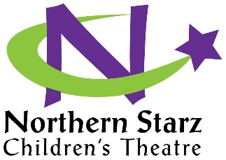
Scholarship Opportunity
Northern Starz Children’s Theater is dedicated to providing theater education for all interested students and is awarding a scholarship to three (3) deserving students that will cover the cost of registration. All interested students are encouraged to apply. Up to three (3) Applicants from the cast will be announced and their participation fee will be returned.
How to apply
All scholarship applicants must submit the following:
- Completed application form below

- Scholarship statement – create an essay (approximately 200 words) stating:

What role the performing arts have played and will play in your life.
And
Why you are most deserving of the scholarship

- Letter of recommendation from someone other than a family member
*Only those applicants submitting all 3 items listed above will be considered*
Deadline for submission is the day of your audition.
(please bring all required documents to your audition).

Scholarship Application

Last Name: ___________________________________ First Name: _____________________________

Address: __________________________________________________________________________________________

City: __________________________________ State: _______________ Zip: _______________

Telephone#: (________)________________________________

Email Address: ______________________________________________________ Date: ______________

