Progress Award & 252 award scheme qualifying scores
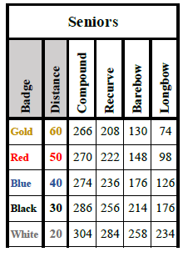

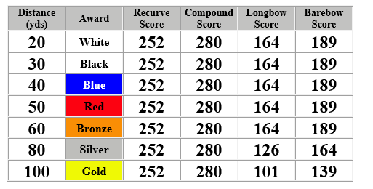

You will require :
2 x qualifying scoresheets for the 252 award scheme - scored on different days
3 x qualifying scores for the progress award
Both can be run consecutively (only three score sheets need to be submitted) as long as the qualifying scores are achieved – so please take note of the slight differences for each distance in the Progress award.

