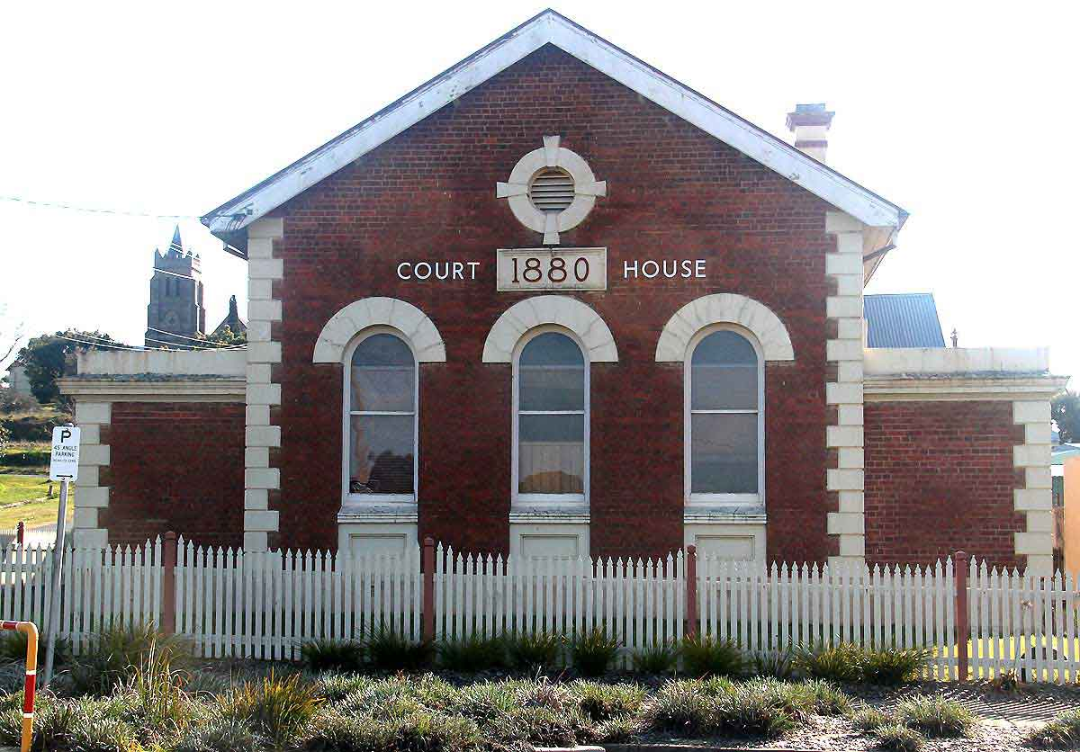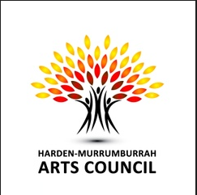

Exhibition Showing
10am- 4pm
Sat 17th & Sun 18th October
Sat 24th October
10am- 2pm Sun 25th October

Harden Murrumburrah Arts Council
invites you to the
32nd Annual
Festival of Art Exhibition & Sale
Opening Night
7pm Friday 16th October, 2026
Harden Murrumburrah Arts Council
(The Old Courthouse)
Cnr. Albury & Vernon Streets, Murrumburrah
Opening and presentation of awards at 8pm
$5 entry
Supper and refreshments will be served

