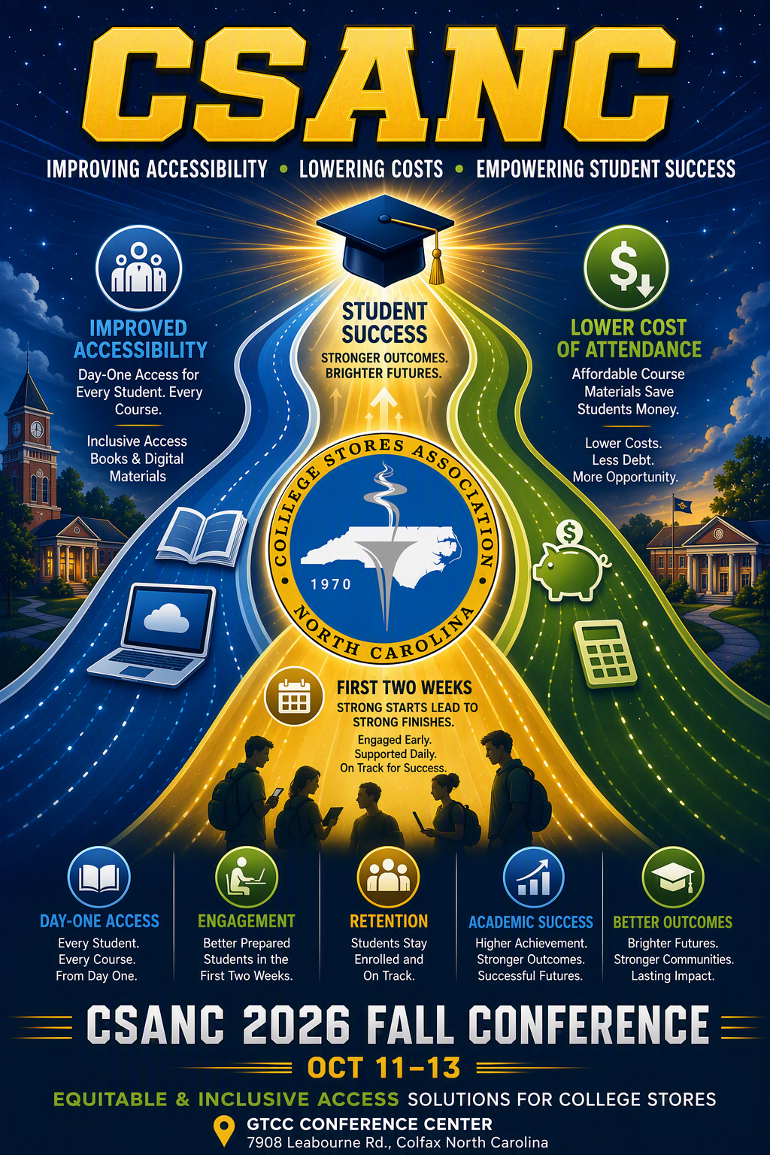
Welcome to the 2026 CSANC Tradeshow and Meeting
in beautiful Greensboro, NC at
Guilford Technical Community College

The Conference Center at GTCC (Conference Event):
7908 Leabourne Rd, Colfax, NC 27235

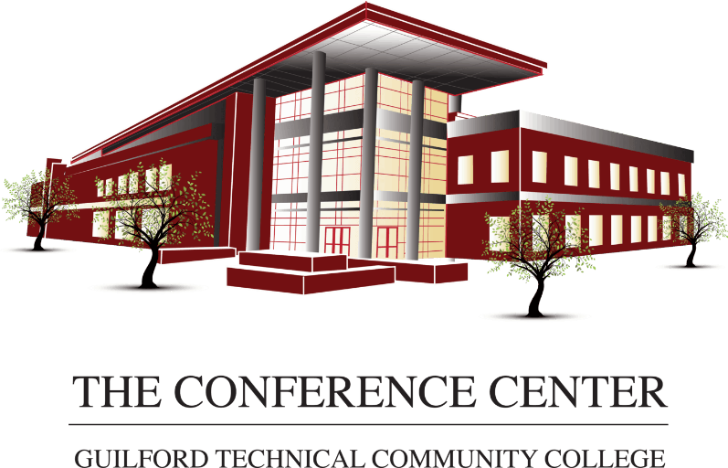
Nearby Hotels:
Embassy Suites - Greensboro Airport
(7 min drive to Conference Center – No Room Block Reserved)
*** Join us for the Sunday Evening Reception at the Bar of Embassy Suites**
Embassy Suites by Hilton – (Old Host Hotel) – 204 Centreport Dr, Greensboro, NC
Courtyard by Marriott Greensboro Airport – 7811 National Service Rd. Greensboro NC
Home 2 Suites by Hilton – 7801 National Service Rd, Greensboro, NC
Holiday Inn Express & Suites – 645 S Regional Rd, Greensboro, NC
Hampton Inn Greensboro – 7803 National Service Rd, Greensboro, NC

Top Golf (Monday Night Event):
609 Guilford College Rd, Greensboro, NC 27409
(8 min drive from hotel) -(12 min drive from Conference Center)


Local Nearby Dining/Shopping:
Hyw.68/Eastchester Dr.: (5-10 mins from most hotels)
Dining: Ruby Tuesday, Starbucks, Boulders’ Bar and Grill, Kickback Jack’s, Buffalo Wild Wings, Yamato Japanese, Applebee’s, Texas Longhorn, Basil Leaf Thai, Duck Donuts, Dunkin Donuts, City Barbeque, Chop House, Steak Street, Fire & Sticks (Hibachi), and Waffle House.
Palladium Area Shopping: Walgreens, Belk, Harris Teeter, Wake Forest Baptist- Urgent Care, Office Depot, UPS Store, the Natural Dog, Palladium Movie Theatre.
West Wendover Ave (10 min Drive): McDonalds, Cook Out, Outback, Walmart, and Target.

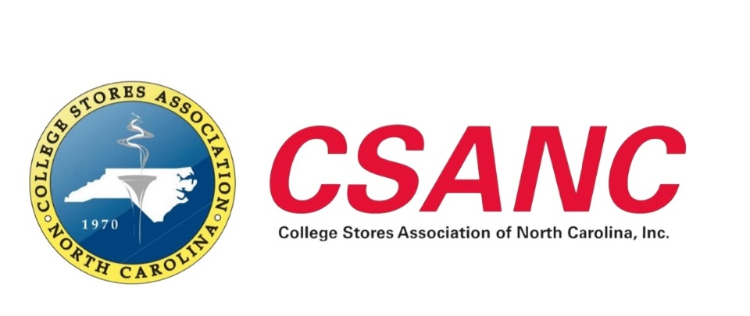

CSANC Annual Meeting & Trade Show Agenda

Sunday, October 11

Hotel Registration & Check-In
4:00 PM - 5:00 PM

Welcome Reception & Meet-and-Greet.
5:00 PM - 7:00 PM
Location: Embassy Suites - Bar Area
204 Centreport Drive
Greensboro, NC 27409

Monday, October 12

Conference Location
The Conference Center at GTCC, 7908 Leabourne Rd., Colfax, NC
All Sessions in the Truist Bank Oak Ridge Room

8:00 AM - 9:00 AM

Motivational Breakfast
Welcome Remarks
Shawn Dee, CSANC President - Guilford Technical Community College

8:15 AM - 9:00 AM

Networking Breakfast & Roundtable Discussions
Vendors and Stores Networking Session
Choose One Focus Group Topic:
- Food Services, Food Trucks & Marketing
Ensuring Your Store Reflects Your College Brand and Image
- Inclusive Access (IA) / Equitable Access (EA) Integration
Billing, Cashier, Point-of-Sale, and IT Integrations with VitalSource and Other Software Providers
- Technology on Campus
Expanding Your Technology Offerings and Best Practices for IA/EA Success

9:10 AM - 10:00 AM

Opening Session

NACS Update
Jill Ayres, NACS Marketing Director
National Association of College Stores

10:10 AM - 11:00 AM

Session 2

Overcoming Barriers to Total Access: A Launch Playbook for Independent Stores
John Creed - Senior Account Executive – Independent College Bookstore Division
VitalSource

11:10 AM - 12:00 PM

Session 3

Maintaining Your Independence: Strategies to Limit and Prevent Outsourcing
Denise Walsh – Vice President of Programs and Services
Independent College Bookstore Association

12:00 PM - 1:30 PM

Lunch & CSANC Board Elections
Election of New CSANC Board Members

1:30 PM - 4:30 PM

Vendor Trade Show

6:00 PM - 9:00 PM

Networking Event at Topgolf Greensboro

Dinner Provided (Mexican)
609 Guilford College Road
Greensboro, NC 27409

Tuesday, October 13

Conference Location

The Conference Center at GTCC

8:00 AM - 9:00 AM

Networking Breakfast & Roundtable Discussions
Choose One Focus Group Topic:
- Food Services, Food Trucks & Marketing
Ensuring Your Store Reflects Your College Brand and Image
- Inclusive Access (IA) / Equitable Access (EA) Integration
Billing, Cashier, Point-of-Sale, and IT Integrations with VitalSource and Other Software Providers
- Technology on Campus
Expanding Your Technology Offerings and Best Practices for IA/EA Success

9:10 AM - 10:00 AM

Session 5

Building Your Store's Brand: The Imperative Opportunity
Denise Walsh – Vice President of Programs and Services
Independent College Bookstore Association

10:10 AM - 11:00 AM

Session 6

Campus Retail Pulse Check: Industry Signals and Trends
Jill Ayres, NACS Marketing Director
National Association of College Stores

11:10 AM - 12:00 PM

Closing Session

Easy Outreach: Supporting Athletics and Student Life on Campus
Shawn Dee
CSANC President

12:00 PM - 1:00 PM

Closing Lunch
- Swearing-In of New Board Members
- Closing Remarks
- Door Prize Drawings

1:30 PM - 2:30 PM

CSANC Board Meeting

Thank You for Attending the CSANC Annual Meeting & Trade Show
We appreciate the participation of our member stores, exhibitors, sponsors, and industry partners and look forward to another successful year serving college retail professionals throughout the Carolinas.

