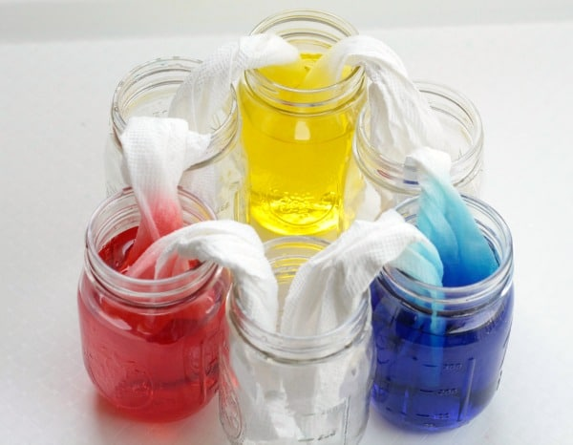
Mystery Island VBS Day 1 Experiment (Walking Water)

Supplies Needed:
-6 cups/bowls
-Water
-Red, Blue, Yellow food coloring
-Paper Towels

Instructions:
- Fill up every other cup/bowl with water
- Put 3-5 drops of yellow food coloring in one cup/bowl with water
- Put 3-5 drops of blue food coloring in another cup/bowl with water
- Put 3-5 drops of red food coloring in the last cup/bowl with water
- Roll up paper towels and fold in half to make a “bridge”
- Place a bridge end in each cup (shown above)
- Wait 1 hour
- Look at how water walked from the cup/bowls with water to the empty cup/bowls. Also look at what colors were created!

Mystery Island VBS Day 1 Craft (Your Own Mystery Island)
1.Take brown pipe cleaners and put the wood beads on (keeping the brown pipe cleaners bent)
2.Then slide all the green pieces up the middle of the brown pipe cleaner. The green pieces should be at the point of all 3 brown pieces)
3.Then twist the brown pieces by holding the green pieces and twisting like cork screw. This will create the trunk of the tree with coconuts at the top (wood beads)
4.Then bend the green pieces however they'd like to make the palm tree leaves
5.Now take the clay and shape into an island to sit on the "x" on the blue paper
6.Once island shape has been created put little shells in clay
7.Then add the tree by poking the bottom of the "trunk" into the clay
8.The clay will dry overnight and they will have their own Mystery Island.

*You may want to glue the island to the blue paper once it's dried so it becomes one piece.

